[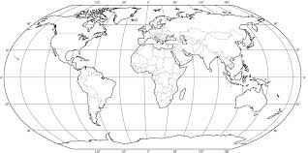](http://www.google.co.uk/url?sa=i&rct=j&q=&esrc=s&source=images&cd=&cad=rja&docid=ApjOzz9Is3dBaM&tbnid=jRyOt7wpsFwO3M:&ved=0CAUQjRw&url=http%3A%2F%2Fwww.stonesoferasmus.com%2F2010%2F05%2Fblank-world-map-for-printing-with.html&ei=UQDLUpahGOWX1AXW3IAo&bvm=bv.58187178,d.ZG4&psig=AFQjCNGMWstQAY0uNJe_cTymdmmO3K_wOg&ust=1389121899581561)

[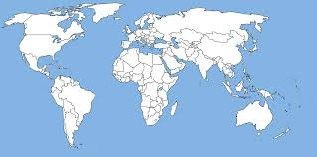](http://www.google.co.uk/url?sa=i&rct=j&q=&esrc=s&source=images&cd=&cad=rja&docid=ct9Ykw6KndG4FM&tbnid=wJmeQu2avHIOMM:&ved=0CAUQjRw&url=http%3A%2F%2Fvectorya.com%2Fgallery%2Fimg65.search.htm&ei=yADLUqeIKLSo0wXlsIDgAQ&bvm=bv.58187178,d.ZG4&psig=AFQjCNGMWstQAY0uNJe_cTymdmmO3K_wOg&ust=1389121899581561)

[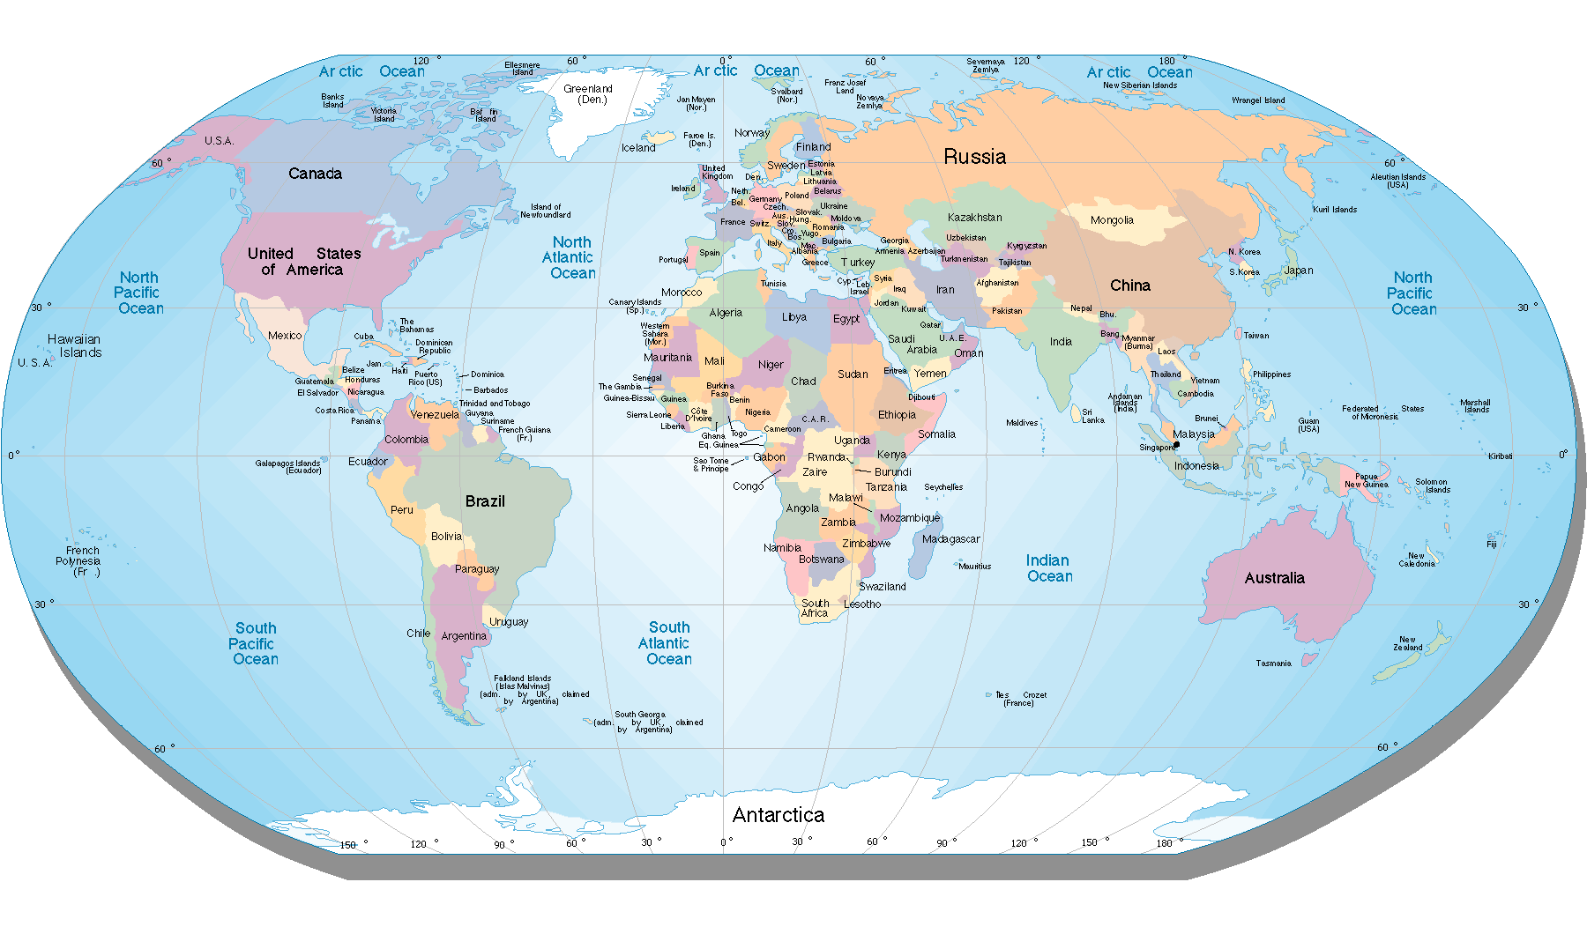](http://www.google.co.uk/url?sa=i&rct=j&q=&esrc=s&source=images&cd=&docid=4-ppusGL-42xVM&tbnid=YwhnU9Ar51UyJM:&ved=0CAUQjRw&url=http%3A%2F%2Fwww.hdwallpapers3d.com%2Fworld-map%2F&ei=RQHLUvGjOaad0QWMsoGoDg&psig=AFQjCNETMdv0HdQ1oeqivhP_F8XnPYAsnw&ust=1389122173774624)