USA food

[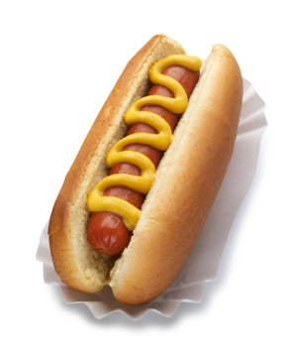](http://www.google.co.uk/url?sa=i&rct=j&q=&esrc=s&source=images&cd=&cad=rja&docid=TXiNX9PbuSur1M&tbnid=HtJqz29S4pf42M:&ved=0CAUQjRw&url=http://www.frugalcouponliving.com/2013/07/22/national-hot-dog-day-2013-free-and-discount-deals/&ei=ERoPU4bDKLGZ0AXWr4DAAg&bvm=bv.61965928,d.d2k&psig=AFQjCNFuUzk-UjndDAxLgP_7Z4cPLX7cSQ&ust=1393585015305803)

[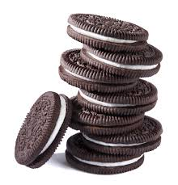](http://www.google.co.uk/imgres?biw=1366&bih=595&tbm=isch&tbnid=eINMMcZ6PbLOeM:&imgrefurl=http://investorplace.com/2013/10/oreo-cookies-addictive-as-cocaine-study/&docid=A4w3nOc5Oczr5M&imgurl=http://investorplace.com/wp-content/uploads/2013/10/oreo.jpg&w=2344&h=2448&ei=FhsPU_OCIMbL0AXb4IDYAg&zoom=1&ved=0CI4BEIQcMAs&iact=rc&dur=223840&page=1&start=0&ndsp=12)

[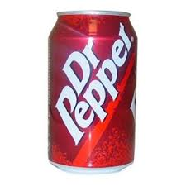](http://www.google.co.uk/imgres?biw=1366&bih=595&tbm=isch&tbnid=jYyB_E2OFUJVvM:&imgrefurl=http://www.ajwholesale.co.uk/index.php/featured/dr-pepper-can.html&docid=cWDKTiJZz4ZX8M&imgurl=http://www.ajwholesale.co.uk/media/catalog/product/cache/1/image/800x800/9df78eab33525d08d6e5fb8d27136e95/d/r/dr_pepper_can.jpg&w=800&h=800&ei=sRoPU4j5C67K0AW_j4CQBg&zoom=1&ved=0CLQBEIQcMBY&iact=rc&dur=114578&page=2&start=15&ndsp=20)

[](http://www.google.co.uk/url?sa=i&rct=j&q=&esrc=s&source=images&cd=&docid=4gFwo4E0Y_pxbM&tbnid=oO01_qqnau5UWM:&ved=0CAUQjRw&url=http://www.sodahead.com/fun/do-you-buy-popcorn-at-the-movies/question-2635519/&ei=oxkPU6rZJoHU0QWln4D4CQ&psig=AFQjCNG967q2e9LxYXDZVkO8x7q51HhLNw&ust=1393584924428483)

[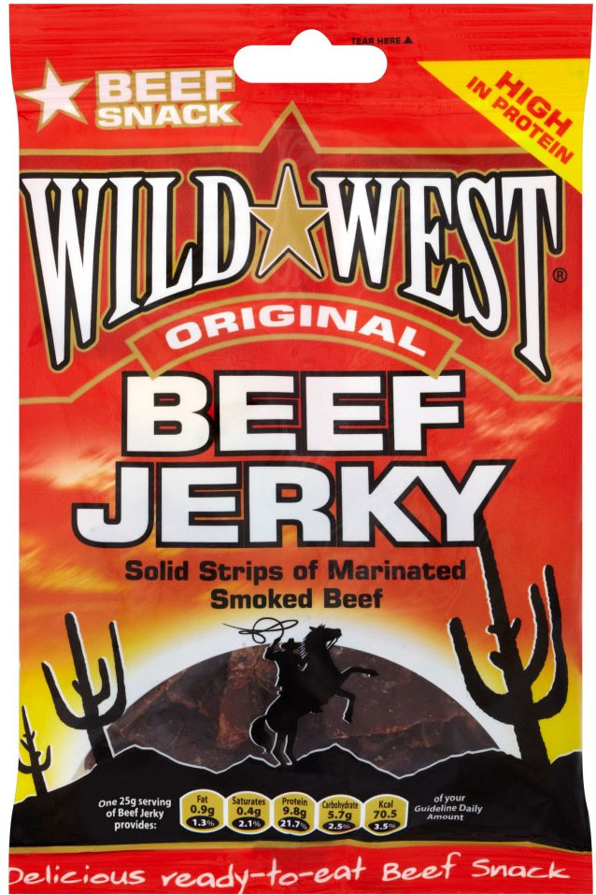](http://www.google.co.uk/url?sa=i&rct=j&q=&esrc=s&source=images&cd=&cad=rja&docid=BFpS2smaihkUAM&tbnid=X_UuYG-xiSSWAM:&ved=0CAUQjRw&url=http://www.mysupermarket.co.uk/asda-compare-prices/Deli_Meat/Wild_West_Original_Beef_Jerky_50g.html&ei=ORoPU5v_G4_K0AX8h4CwCQ&bvm=bv.61965928,d.d2k&psig=AFQjCNF5KXvKO5kEe0SomdXHKN2IWUoWyw&ust=1393585072964115)[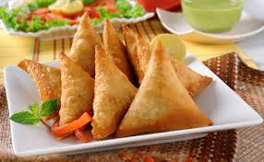](http://www.google.co.uk/url?sa=i&rct=j&q=&esrc=s&source=images&cd=&cad=rja&docid=e2Vjy5tdzRpP6M&tbnid=psZncBpHiXZThM:&ved=0CAUQjRw&url=http://www.fizafamilydiner.com/?_escaped_fragment_=samosa/zoom/mainPage/image1xil&ei=eujOUvDbMoGs0QWl6YHQBg&bvm=bv.59026428,d.ZG4&psig=AFQjCNFkGT3_JB-XWsgwx8d9UeNASa41VA&ust=1389378021347080)

[](http://www.google.co.uk/url?sa=i&rct=j&q=&esrc=s&source=images&cd=&cad=rja&docid=e2Vjy5tdzRpP6M&tbnid=psZncBpHiXZThM:&ved=0CAUQjRw&url=http://www.fizafamilydiner.com/?_escaped_fragment_=samosa/zoom/mainPage/image1xil&ei=eujOUvDbMoGs0QWl6YHQBg&bvm=bv.59026428,d.ZG4&psig=AFQjCNFkGT3_JB-XWsgwx8d9UeNASa41VA&ust=1389378021347080)

[](http://www.google.co.uk/url?sa=i&rct=j&q=&esrc=s&source=images&cd=&cad=rja&docid=e2Vjy5tdzRpP6M&tbnid=psZncBpHiXZThM:&ved=0CAUQjRw&url=http://www.fizafamilydiner.com/?_escaped_fragment_=samosa/zoom/mainPage/image1xil&ei=eujOUvDbMoGs0QWl6YHQBg&bvm=bv.59026428,d.ZG4&psig=AFQjCNFkGT3_JB-XWsgwx8d9UeNASa41VA&ust=1389378021347080)

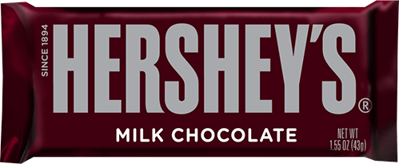

**[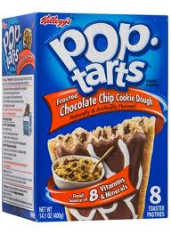](http://www.americangoodies.co.uk/pop-tarts-c-16_18/pop-tarts-chocolate-chip-cookie-dough-8-pack-400g-p-229)**

