[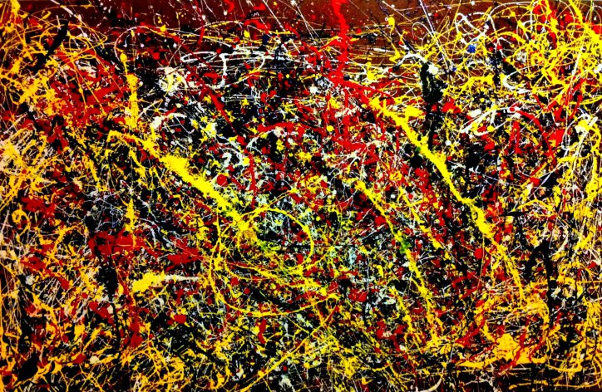](https://financialrisk.wordpress.com/2014/06/26/rich-1-art-paintings-jackson-pollock-brain-mit/pollock/)

[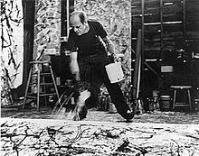](http://en.wikipedia.org/wiki/File:Namuth_-_Pollock.jpg)

