6th form 2 Class - Monday and Tuesday
Weeks beginning: 22nd February & 1st March 2021
Subject | Activity | Links
Monday am (week 1)  Monday am  (week 2 ) | Shop, Cook and Eat  In half term it was Shrove Tuesday – Pancake day. Research the ingredients on the Tesco direct website .What is needed to make ‘pancakes’? Find the ingredients needed, write down the prices of each ingredient and add up the cost at the end.  Then:  Make yourself some pancakes. Follow the link to make ‘pancakes’ (or find your own preferred recipe). Find all the food items needed and the utensils and make the snack with appropriate support. Try some tasty toppings on your pancake! Tidy up, clean and wash up at the end of your snack.  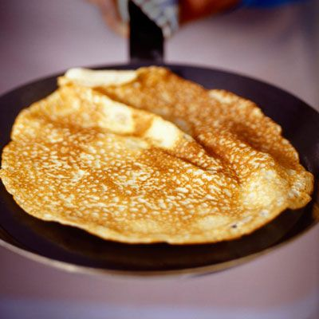  https://www.bbcgoodfood.com/recipes/easy-pancakes  Shop, Cook and Eat  Choose a simple meal to make for lunch or dinner (jacket potato with a choice of toppings). Find all the food items needed and the utensils and make the snack with appropriate support. Tidy up, clean and wash up at the end of your lunch. | When setting the table:  - Wash your hands  - Clean the table  - Decide which cutlery you will need and find the cutlery from the drawer  - Count out the people in your family - count out individually how many knifes/spoons/forks you will need  - Count out the mats and place them on the table with the cutlery  - Count how many drinks you will need for each family member and make the drinks. Maybe you could take an order for drinks? Like in a café.  - What else do you need for the table? Sauces/ spoons to serve food out etc  Making your meal  - Wash your hands  - Look at your recipe or chosen lunch  - Decide what items you will need to make it  - Find all the ingredients in your kitchen  - Find all the utensils you will need – knifes/chopping board/graters etc  - Make your chosen lunch with support from a family member  Once everyone has finished, don’t forget to wash up and clean the table!!  When setting the table:  - Wash your hands  - Clean the table  - Decide which cutlery you will need and find the cutlery from the drawer  - Count out the people in your family - count out individually how many knifes/spoons/forks you will need  - Count out the mats and place them on the table with the cutlery  - Count how many drinks you will need for each family member and make the drinks. Maybe you could take an order for drinks? Like in a café.  - What else do you need for the table? Sauces/ spoons to serve food out etc  Making your meal  - Wash your hands  - Look at your recipe or chosen lunch  - Decide what items you will need to make it  - Find all the ingredients in your kitchen  - Find all the utensils you will need – knifes/chopping board/graters etc  - Make your chosen lunch with support from a family member  Once everyone has finished, don’t forget to wash up and clean the table!!
Monday pm  (week 1 )  Monday pm  (week 2) | Enterprise  PP: Take part in planning an identified mini- enterprise project  Its Mother’s day on March 14th. Using the internet or Pinterest, research some ideas for cards and gifts that you could make for your mum. Make a list of the different types of cards and gifts you like.  Looking at your list from last week, choose one card that you are going to start to make and a gift. Start to make your card and gift. | Ideas:  https://www.pinterest.co.uk/  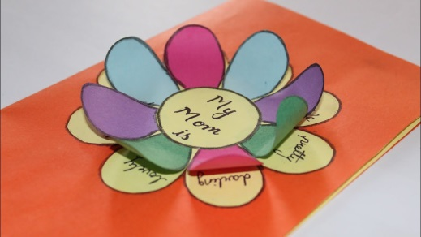  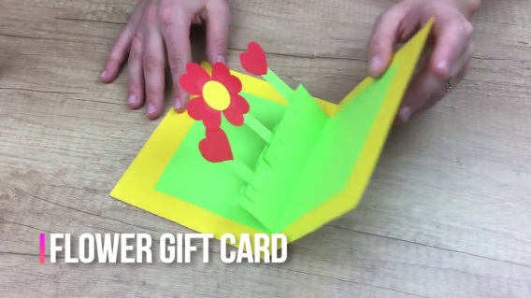  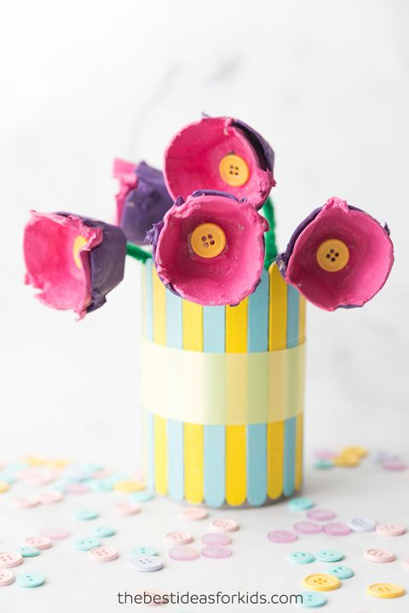
Tuesday am  (week 1)  Tuesday am  (week 2) | Vocational – Recycling  Continue to sort your families recycling into different sections (e.g plastic, tins, food, and cardboard). Familiarise yourself and look again at your ‘Recycling symbols and their meaning 2’ sheet. Remember to check the symbols on the items against your families recycling so you know what can and can’t be recycled.  Continue to sort your families recycling into different sections (e.g plastic, tins, food, and cardboard).  Have a look at the ‘Recycling Poster Activity’ sheet. Can you design a poster to encourage your family to recycle? | Resources  ‘Recycling symbol and their meaning 2’ sheet  Recycling poster activity
Tuesday pm  (week 1)  Tuesday pm  (week 2) | Vocational Studies - Gardening  Using some of your recycled plastic bottles, follow the link to make some feeders for the feathered friends in your garden. Why not keep a list of all the birds that visit the feeder?  Brighten up your winter garden by designing and decorating some pebbles. Use the internet to research some ideas. You can varnish the pebbles once you have painted them to make them last longer and withstand the weather. | Resources  Bird feeder  https://www.youtube.com/watch?v=7yV6V6rtpyc  Pebble art ideas  https://www.youtube.com/watch?v=yL_AwJ3KiSM  https://www.youtube.com/watch?v=iu29srJPjWw  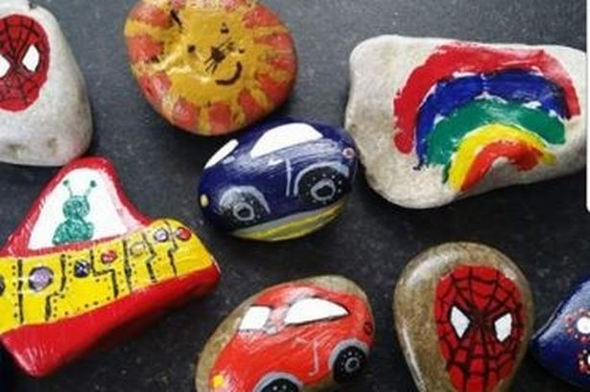
- Please refer to annual reviews for your child’s personalised targets.

I would love to see and hear about what you have been doing, send emails and photos to Beth - batherton@parklane.cheshire.sch.uk

