Creativity Week
Our theme for Creativity Week this year is “The Show Must Go On!”
We hope that you can use some of inspiration using some everyday things you might find around the house. Here are some ideas to help you get creative and have some fun in Lockdown!
After all home is where the art is!
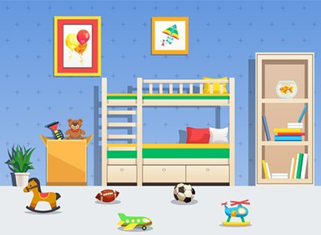
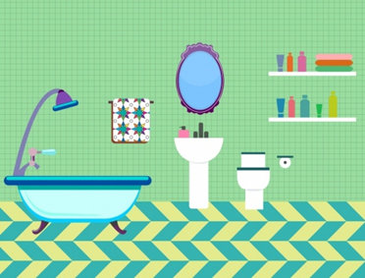
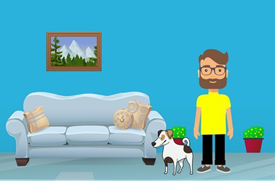
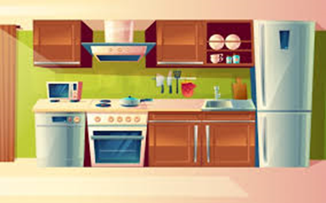
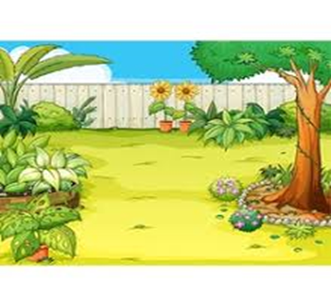
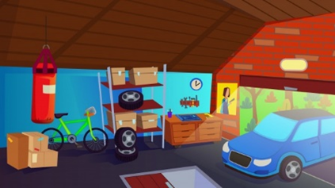
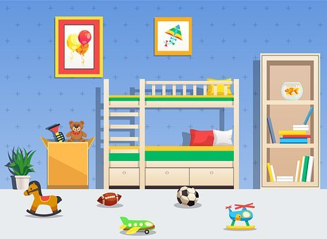
The bedroom
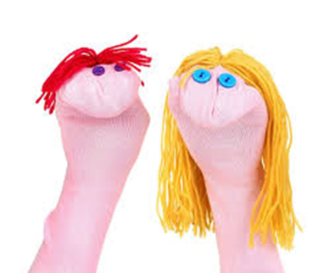
Raid the sock drawer!
Make a no-sew sock puppet
You will need:
A sock
Wool
Googly eyes / buttons / pompoms for the eyes
Any crafty bits and pieces to decorate
Card
Scissors and glue

Cut a circle out of the card. Fold it in half and put it inside the sock. Push the toe of the sock into the fold. This gives your puppet a mouth.
Add some wool for hair and stick on the pompoms or buttons for eyes.

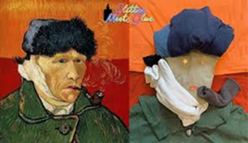
Find the Masterpiece lurking in you laundry
You will need:
Clothes and picture to copy

See https://www.timeout.com/newyork/art/top-famous-paintings-in-art-history-ranked
Take some clothes and arrange them to recreate a famous masterpiece
Make up a picture with make-up pads
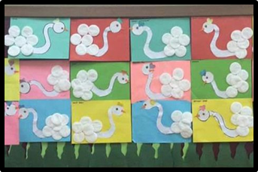
You will need:
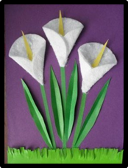
Cotton make-up pads
Coloured paper or card
Paint or food colouring
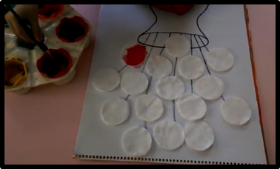
Glue stick

Use cotton make-up pads to create some beautiful artwork. Stick them onto card in different designs to make flowers, clouds or animals. Add paint or food colouring or leave them white.

Design a Den
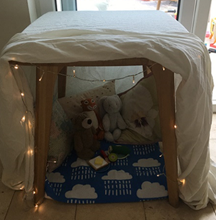
Create the perfect space to hide away, read a story, listen to music or play on you r Ipad
You will need:
A big box,
Washing line or chairs with sheets/blankets
Pillows

You could make pictures for the walls of your den or ask someone help you add lights to it.

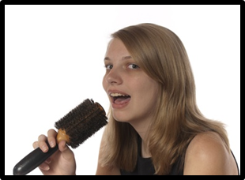
Rock it Out!
You will need:
A hairbrush
A Mirror
A costume e.g. a hat, scarf, tie, waistcoat, beads or make-up.

Either perform in front of your family/friends, or ask someone to help you set your iPad up so you can record yourself singing.

Be brave and bust some moves!
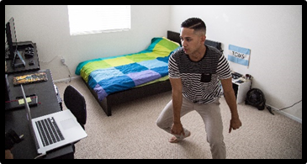


Watch the dance moves to your favourite track – try YouTibe or get some ideas from TikTok. Learn a routine or create your own dance moves. Practise the danec and then prefrom it to your family/friends
Here are some suggestions to get you moving!

Reach for the Stars
https://www.youtube.com/watch?v=wAmfODyaIV8

Zumba Kids (easy dance) - I like to move it - YouTube
https://www.youtube.com/watch?v=ymigWt5TOV8

Cha Cha Slide Dance
https://www.youtube.com/watch?v=I1gMUbEAUFw

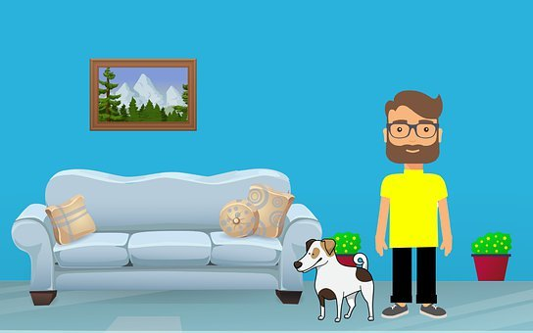
The living room

Recycled sun catchers from CDs with scratches
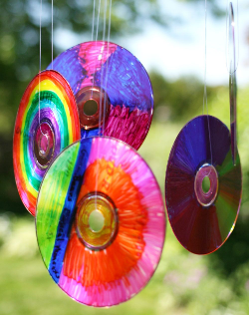
You will need:
Old CD or DVDs ( make sure they are no longer needed)
Permanent markers
Nylon thread or fishing line

Colour both sides of the CD / DVD with the permanent markers
Thread the fishing line or thread through the middle of the CD or DVD and then tie the ends together securely
Hang from a branch
Watch them spin in the breeze.

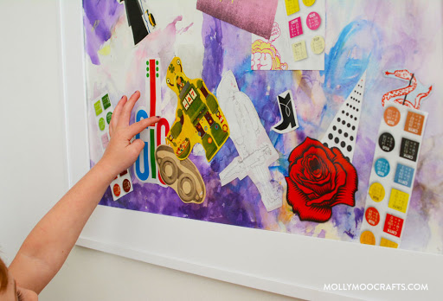
New pictures from Newspapers
You will need:
Old newspapers and magazines
Card
Glue Tear or cut shapes from your papers and magazines and arrange in a collage

Junk mail jewellery
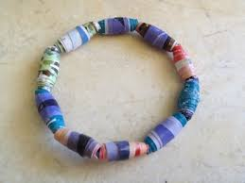
You will need:
Junk mail or old takeaway menus
Scissors
String
Glue

Cut the menus or junk mail into long triangle shapes
Wind around a pencil or straw starting with the widest part
Glue the end to secure it
Make lots of beads
Thread the beads onto a length of string and tie the ends.

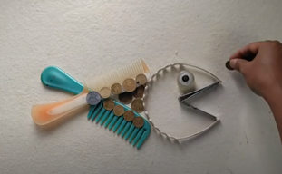
Found object art
Be bold with bits and bobs
You will need:
Any bits and bobs you find lying around. Don’t forget to have a look down the back of the sofa!
Arrange then to make a picture
Take a photo or create a series of photos by rearranging the objects or changing the background.

Make some music
Download these Apps for free
Dramatic Music- Free app with a few sound effects to go with any acting you may want to do, alongside some instruments sounds. Simple touch screen to play.


Sensory Speak up- Simple app that creates sound waves in different shapes/patterns as you speak. Could try and see what hitting different
objects does to the shape. E.g. using pots and pans or instruments you have made/have in class/at home.


Mini Piano- A simple keyboard on screen- 1 octave.


Triple A- touch visualizer -Plays music continuously, as you move your finger on screen it will create interesting patterns.


What at performance!
On the Spot drama game for the whole family
Each child or family member will take turns performing in front of the family. Start off with a simple scenario, for example, the child performing imagines they are in the kitchen. A picture could be shown. Family members will take turns suggesting something to integrate into the performance. Suggestions can be as general as someone saying, “Cooking”, or as specific as someone saying, “mum/dad has cooked your favourite meal”. The child performing will find a way to incorporate the suggestions into their performance. Take between three to five suggestions before moving onto the next family member.

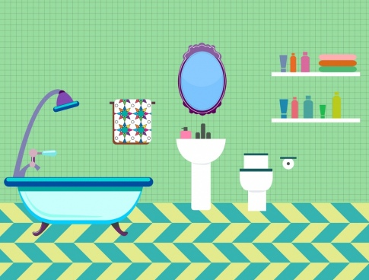
The
bathroom

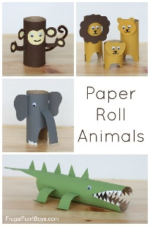
Let loose with a loo roll
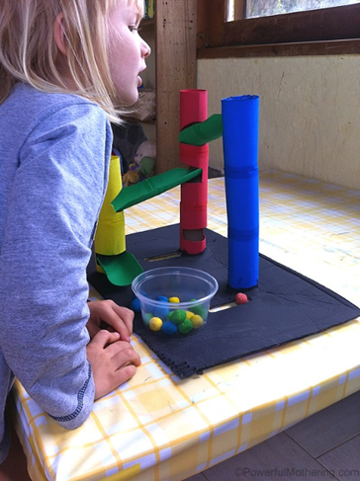
You will need:
Cardboard tubes from Loo rolls
Paint
Glue
Marbles
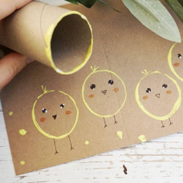
A solid piece of cardboard for the base of the marble run

Use your loo rolls to make models or dip in paint to print

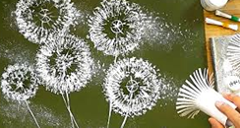

Create Cotton bud blossom and winter trees
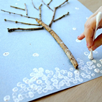
You will need:
Cotton buds
Paint
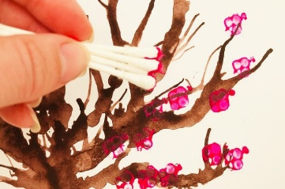
Twigs
Glue
Arrange the twigs and stick to the card
Add details using the cotton buds

Have fun with Fluffy Foam painting
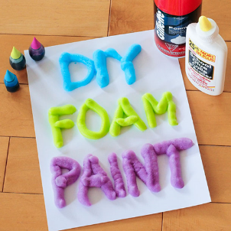
You will need:
Shaving foam
Liquid glue
Food colouring
Mix equal parts shaving cream and glue into a ziplock bag,
Add your desired food colouring
With the bag sealed, squish the ingredients until they are nicely mixed together.
Snip the corner of the bag and squeeze out the paint
Or Use your fingers to create a picture

Splatter painting with a toothbrush
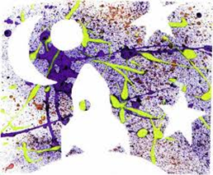
You will need:
A pieces of paper or card
Cut out shapes to act as a resist
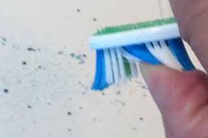
A tray of paint
An old paintbrush
Place the cut out shapes on the card

Dip the toothbrush in the tray of paint
Hold the brush over the card and flick the paint off with your thumb nail
Lift off the cut out shapes to reveal your picture

Stippling with sponges and shower puffs
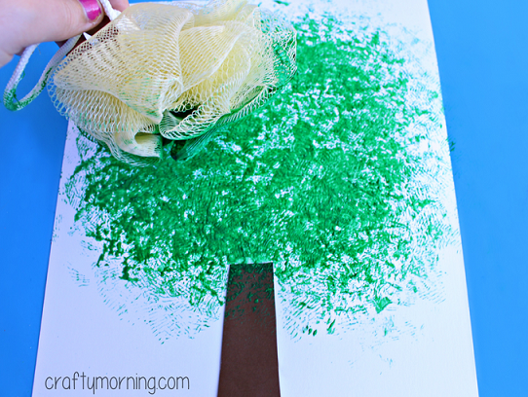
You will need:
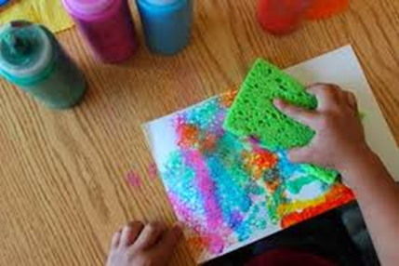
A bathroom sponge
A shower puff
A shallow tray of paint

Dip the sponges or the shower puffs in the paint and create!

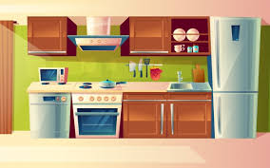
The
Kitchen
Salad spinner spirals
You will need:
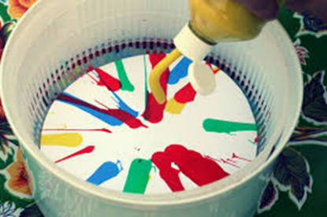
A salad spinner
Paper
Paint

Place a circle of paper inside the salad spinner
Drip different coloured paint into the spinner
And spin!

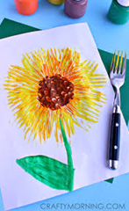
Paint mash up with kitchen utensils
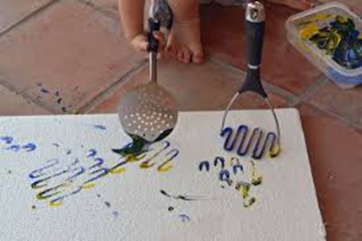
You will need:
Potato masher
Spatulas
Forks
Whisks etc
Find some kitchen utensils, dip them in paint or food colouring and see what interesting patterns you can make
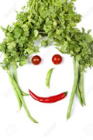
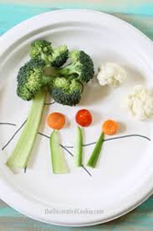
Fruit and vegetable portraits and landscapes
You will need:
a paper plate or a plate with no pattern
A range of fruit and vegetables
Arrange your fruit and veg to make a portrait or a landscape

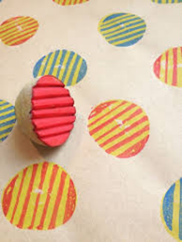
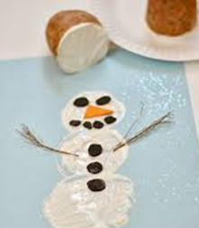
Potato printing
You will need:
Potatoes
Food colouring or paint
Paper

Cut shapes and patterns into a potato
Dip the potato in the paint and print away

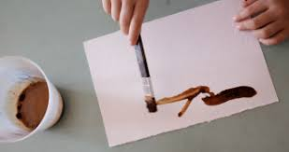
Create an instant classic with instant coffee

You will need:
Instant coffee
Just enough hot water* to dissolve the coffee
A paint brush and paper
(*be very careful with hot water )

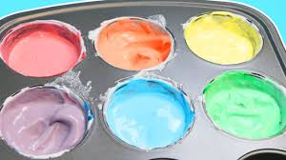
Feed your creativity with edible paint
Mashed potato paint: add food colouring, berries or beetroot juice to instant mashed potato
Coloured cream: Add food colouring to whipped cream
Edible finger paint Ingredients: 1/2 cup flour, 1 cup water, 1/4 tsp salt, food colouring and cold water for thinning
Instructions: Mix flour, salt, and 1 cup water in sauce pan. Heat flour/water while whisking. The mixture will be clumpy, then smooth, then thicken into a paste. Once it has thickened, remove from heat. Whisk in cold water a few tablespoons at a time until you have the desired consistency. Add food colouring. Allow to cool completely before using.

If you don’t like getting your hands dirty try the following Apps

Finger Paint with Sounds – by Inclusive Technology. A great, simple painting app.

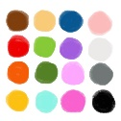
Scribbaloo paint. A simple colouring/painting app. Nice and simple, able to choose from a range of colours and brush sizes and take photos of the work.

Make a Musical Instrument
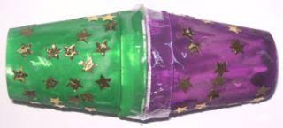
You will need:
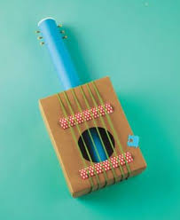
Empty boxes, packet, tins, paper plates and cups and kitchen rolls!
Rice beans or pasta for shakers

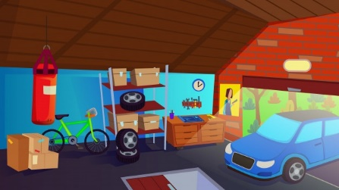
The garage
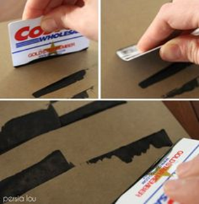
Brushless Painting
You will need:
tool handle ends, sponges, screwdriver, sticks, tyres (use toy ones!) thick paper/card, sandpaper, different coloured paints, trays
Use various items found in garage or shed to create different patterns.
Use different coloured paints if wish to.

Wallpaper People
Listen to https://www.youtube.com/watch?v=QkHQ0CYwjaI (This is me – Elf Learning) Suitable of younger pupils
https://www.youtube.com/watch?v=BwHMMZQGFoM (Parts of my body song – Have Fun teaching) Suitable for older pupils
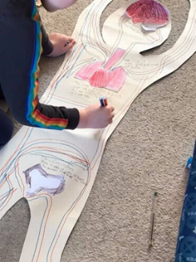
you will need:
Roll of old wallpaper or large pieces of paper old cardboard,
pencils, coloured pens, puppet (if using instead of person)
old materials

Paint roller Art

Use old/new paint rollers to create large pieces of art. A great activity foreveryone. Try customising the roller by wrapping string or bubble wrap around it or sticking foam shapes to it.
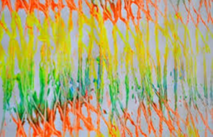
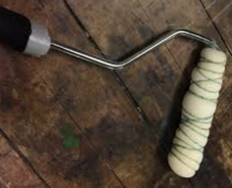
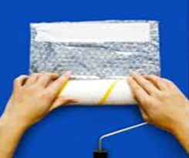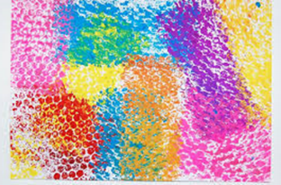

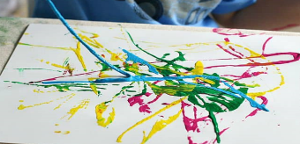
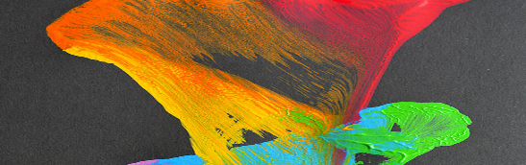
String Art

Use pieces of string dipped in paint and dragged across the paper, you may choose to leave the string on the paper to add texture or place on and pull off.

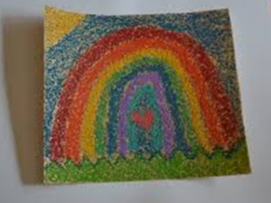
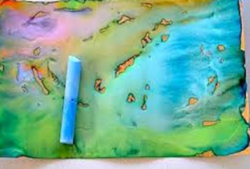
Sandpaper Art

Sandpaper is a good textured base for crayons, chalk or paint. It can add to the sensory experience and depending on the grade of the paper give varying effects with different mediums.

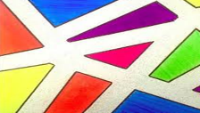
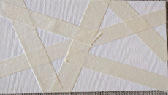
Masking tape

It’s easy to tear the masking tape and fun just sticking it, but the finished results can be effective.

Form a garage band
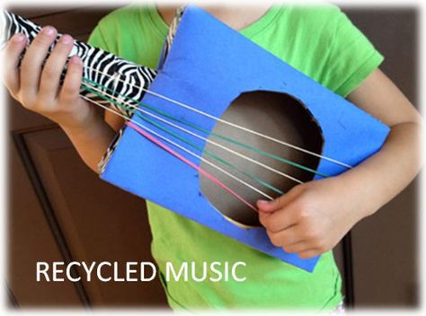
Use household instruments to make your own band!

Here are some different examples. This first two are by the STOMP! Company and is obviously super clever, but children may like to try and join in with 1 of the objects. Nigel from CBeebies is in one of the videos as he used to be in STOMP! So the children may recognise him if they watch CBeebies still.
https://www.youtube.com/watch?v=oCriI1E_4JA
https://www.youtube.com/watch?v=E_8NcJi17SQ
https://www.youtube.com/watch?v=Svg_fIoHij8
https://www.youtube.com/watch?v=mMpK4L2xkZw
https://www.youtube.com/watch?v=oQfLiTWtqxY
https://www.youtube.com/watch?v=HUyaSpLO3wU

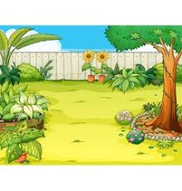
The
garden

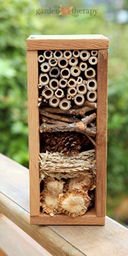
Bug Hotel
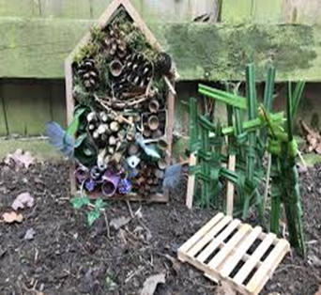
You will need:
plastic bottles
plant pots
straw, pieces of wood, sticks and dry leaves
cardboard tubes
old bird box
Create a bug hotel. Stick either into old plastic bottle (cut in half) or in wooden box/frame/bird box. Pad it out with dry leaves and/or straw.
Listen to https://www.youtube.com/watch?v=7xyXB8_BetQ (Bug ‘n’ roll/Dance along) suitable for primary pupils

And if it’s too cold outside try these free Apps
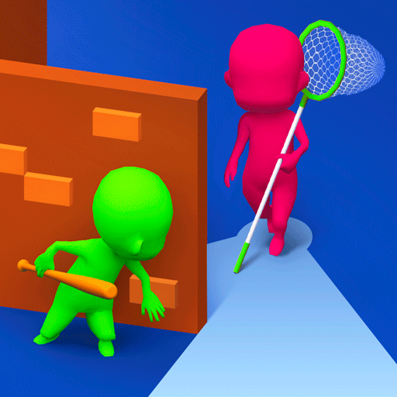
Hide ‘N Seek! This one is set in the garden/shed. Characters hiding and you need to tap on the objects to find them.
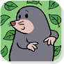
House Hunt Match the animal to their home.

Have fun stay, safe and don’t forget to take lots of pictures, videos or recordings of everything you create.

