6th Form 2
Wk Beginning 1st Feb. (Wed,Thursday,Friday )
Area | Activity | Links
PE/ Outdoor Education Healthy Living | 1. Go for a walk/cycle.  - While on the walk complete the ‘wildlife watch’,  - or identify some of the different OS map symbols you have been learning. Use the symbols work sheets to help and if can take some photos of the features to stick to the symbols worksheets.  - Revise the different compass points and complete the compass point worksheet.  - Complete the quick symbols worksheets to test your knowledge of the different OS map symbols.  2. Take part in on online fitness session. Joe wicks  3. Complete and evaluate weekly healthy living plan. Evaluate how well you have done at the end of each week. (use sheets on distance learning web site)  4. Some home PE ideas from Panathlon  5. Take part in the Big Garden birdwatch.  Map Coordinates activity  Work through the coordinate’s power point. | Lesson materials/worksheets  Wild life watch worksheets 1 and 2  OS map symbols worksheets  Healthy eating plan and evaluation sheet(from last week)  https://panathlon.com/panathlon-launches-at-home-sporting-challenges/  Big Garden Birdwatch | Join the fun - The RSPB  Big Garden birdwatch Recording sheet  Coordinates PowerPoint/treasure map  Ext work sheet
Cookery/Daily living skills | 1.Make cupcakes  The class have been enjoying making different cupcakes each Thursday morning. They have been making them using cupcake kits purchased from the local supermarket.  Here are some of the different cup cake mixes they have used.  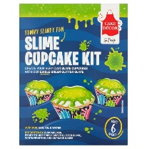  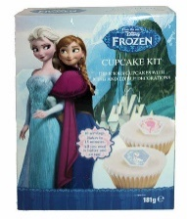  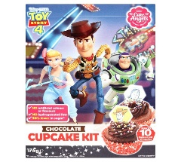  2. Make a simple Chinese stir-fry (link with China. Countries and Cultures)  3. Help around the house. Helping to wash and dry up, dusting, hoovering, making your own bed etc. | Lesson materials /worksheets  Quick chicken chow mein recipe - BBC Good Food  Zingy chicken stir-fry recipe - BBC Good Food
Vocational Studies | Vocational – Recycling  Sort your families recycling into different sections (e.g. plastic, tins, food, and cardboard). Then place them in the correct bins.  Link with the Big Garden birdwatch  Make a birdfeeder from a recycled plastic bottle  Make a speedy bird cake  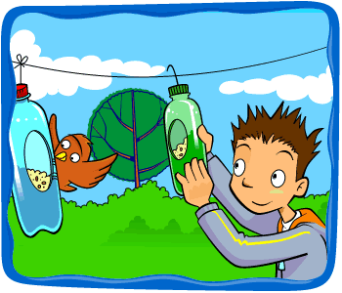  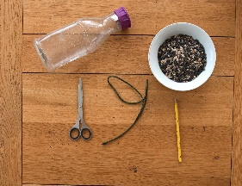  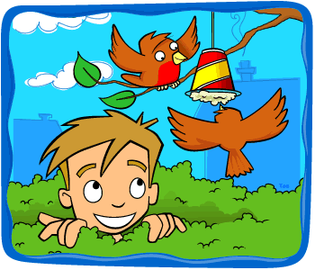 | Make a Recycled Bird Feeder | Fun Activities for Kids - The RSPB  Homemade Bird Food Recipe | Make Bird Seed Cakes - The RSPB  Bottle bird feeder instructions  Speedy bird cake instructions
Countries and Cultures | This term the Countries and Cultures group will also be learning about China. Here are some things you could do. (see separate sheets) 2weeks work  - Look at other traditional Chinese things. (See Power point)  - Chinese Food tasting  - Colour a template of the Chinese flag  - Complete China worksheet using pictures provided.  - Watch video clip of Chinese New year festival.  - Locate China on the map of world and label with labels provided.  - Complete China word search  - Chop stick challenge  - Dragon mask colouring template  - Look at the PowerPoint of animals of the Chinese calendar.  - Look up your name written in Chinese\Cantonese on a translation programme. Write your name in Chinese. | Lesson materials/worksheets  China Power Point  Chinese Food tasting sheets  China word search  Map of world  China label /symbol for map  China worksheet  China pictures  Chopstick challenge recording sheet  Chinese flag colouring page  Dragon mask colouring template  Animals of the Chinese calendar PowerPoint  Chinese calendar showing which year/animal you are.  Youtube clips  Chinese new year  CBeebies: Celebrating Chinese New Year - Let's Celebrate - YouTube  Chinese New Year 2019 Lion Dance, Hong Kong - YouTube  Chinese New Year for Kids - YouTube
English | Weekly Log.  Complete a simple weekly log using sheets provided. Using 2 photos (optional) and write a short sentence describing 2 things you have done this.  Include key information what ,where, who and what | Weekly Log recording sheet.
Art and  Extra | 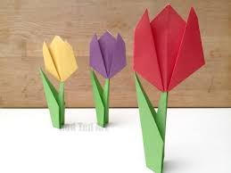  Spring Art ideas  Making paper tulips  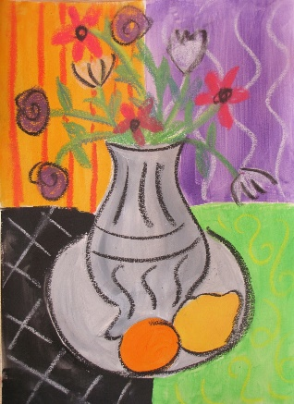  Matisse Spring flowers  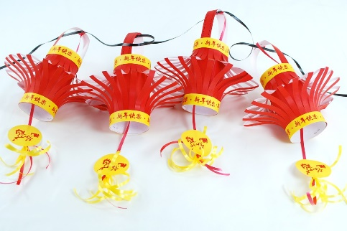  Make a Chinese lantern  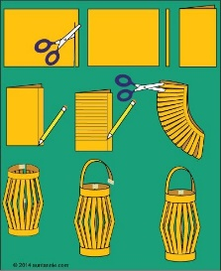 | https://www.youtube.com/watch?v=LFHGsHdY8w4  Matisse spring flowers instruction sheet  (283) Pinterest
- Please refer to annual reviews for your child’s personalised targets.

I would love to see and hear about what you have been doing, feel free to email myself anytime – eshaw@parklane,cheshire.sch.uk

