Stuff You Need
- Good quality bird seed
- Raisins
- Peanuts
- Grated cheese
- Suet or lard
- Yoghurt pots
- String
- Mixing bowl
- Scissors

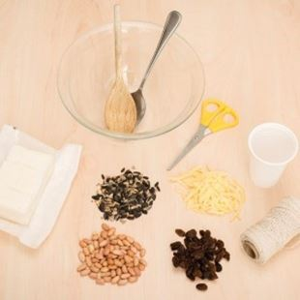

Step-by-step guide
- Carefully make a small hole in the bottom of a yoghurt pot. Thread string through the hole and tie a knot on the inside. Leave enough string so that you can tie the pot to a tree or your bird table.
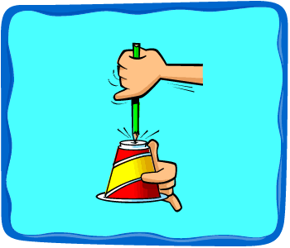
- Allow the lard to warm up to room temperature, but don’t melt it. Then cut it up into small pieces and put it in the mixing bowl.
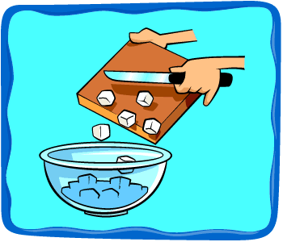
- Add the other ingredients to the bowl and mix them together with your finger tips. Keep adding the seed/raisin/cheese mixture and squidging it until the fat holds it all together.
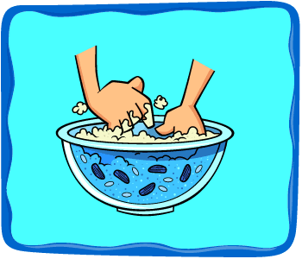
- Fill your yoghurt pots with bird cake mixture and put them in the fridge to set for an hour or so.
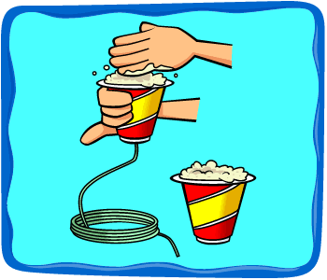
- Hang your speedy bird cakes from trees or your bird table. Watch for greenfinches, tits and possibly even great spotted woodpeckers.
