Arghi Class
WK:1st Feb and 8th Feb
Area | Activity | Links
English | Listen to the story of the Lighthouse Keeper’s Lunch by David Armitage and Ronda Armitage  Communication: Sign along: Practise signs for days of the week or find them on Proloquo2Go on your IPad  Draw a picture of something that might go in Mr. Grinlings lunch. Label your picture.  Write a set of instructions for making a mustard sandwich  Reading & Phonics: –  Write out the word lighthouse keeper cut up all the letters and see how many new words you can make.  OR Find any new words in the text that you do not know. With some help, use a dictionary to find out what they mean.  Can you find a synonym (a word that means the same) and an antonym (a word that means the opposite) for each new word? | https://www.youtube.com/watch?v=46wCRq50Wwg  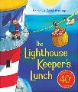  for PDF version  https://www.alexandraprimaryschool.co.uk/wp-content/uploads/2020/06/The-Lighthouse-Keepers-Lunch-story-original-pdf.pdf
Maths | Find the ingredient you need to make a sandwich  Find the heaviest item  Find the lightest item  Can you find anything in your fridge or food cupboard that is the shape of:  a sphere  a cube  a cylinder | 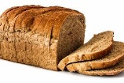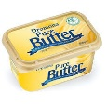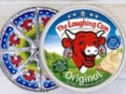
Creativity | Make a lighthouse  you will need:  white tape  large red plastic cup with a circular bottom  smaller clear plastic cup  black card  glue  battery-operated tea light  listen to the a sea shanty  The Wellerman - TikTok Sea Shanty mashup 2021  see if you can sing or tap along | 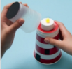  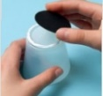  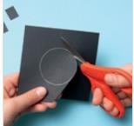  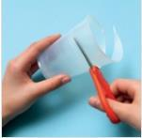  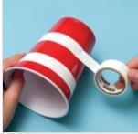  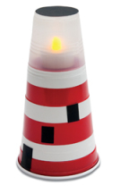  https://www.youtube.com/watch?v=auI9Cx8SGX4
Individuality | Have a go at the  Deep Sea Core Strength work out  (Jaime's Brain Breaks) | Cosmic Kids  Try something new, something healthy like a piece of fruit or vegetable  Keep a food diary  Make a list of all the food you eat each day for a week  At the end of the week make list of all the healthy and all the unhealthy foods you have eaten  Can you think of ways to make your diet healthier? | https://www.youtube.com/watch?v=pi6Sg4dKgZ0
Community | Watch the BBC Bite size clip Robert Stevenson and the Lighthouse Stevensons  Find out about a lighthouse near you. See if you can find it on a map. | https://www.bbc.co.uk/bitesize/topics/zxwxvcw/articles/z62h7nb
Challenge | Watch the clip on Electricity in remote locations on BBC Bitesize  The lighthouse in the clip does not have access to mains electricity so it uses batteries. These are equivalent to 100,000 torch batteries. The batteries are recharged by diesel generators, which produce electricity.  The lighthouse works just like a large torch.  If you have a torch see if you can find the switch, the batteries, the reflector and the bulb. | https://www.bbc.co.uk/bitesize/clips/z862tfr  Label the diagram  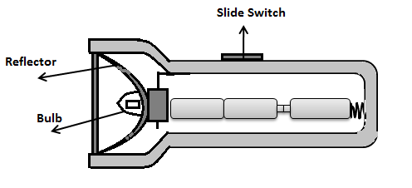  reflector switch bulb batteries
- Please refer to annual reviews for your child’s personalised targets.

I would love to see and hear about what you have been doing, feel free to email myself anytime – swright@parklane,cheshire.sch.uk

