Mulberry Spring Project 2021- The North Pole
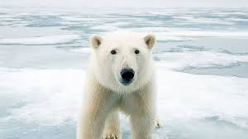

Let’s discover the North Pole and its amazing landscape!
English
- Read Polar Bear Polar Bear What do You Hear by Bill Martin Jr or watch it on
https://www.youtube.com/watch?app=desktop&v=ehoGdGokXfc&ab_channel=VidsWithRy

- Read The Polar Bear and the Snow Cloud by Jane Cabrera or watch it on
https://www.youtube.com/watch?v=9dJHSEGRBJY&ab_channel=StoryTellingwithKim

- Use the internet and books to do a polar bear fact file. You might want to find out:
- How big are adult polar bears?
- What do polar bears eat?
- How do they find their food?
- Can you describe what a polar bear looks like?
- Why is a polar bear’s fur white?
- What is their habitat (the place where they live)?

Maths- Volume and capacity
- Use cups and crushed ice/ice cubes/snow to identify empty, half-full and full.
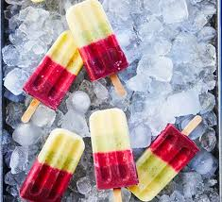
- Make rainbow ice lollies
- 100g mango , peeled, stoned and chopped
- 2 bananas
- 400g yogurt
- 2 kiwi fruit , peeled and roughly chopped
- 100g frozen raspberries
- 100g frozen blackberries
STEP 1
Blitz the mango with ½ banana and 100g yogurt in a blender until smooth. Divide between six ice lolly moulds and insert a stick into each. Hold each stick upright in the mould, and secure on both sides with tape. Freeze for 1 hr until set.
STEP 2
Repeat with another ½ banana, 100g more yogurt and the kiwi fruit, and pour that over the banana layer. Freeze for another 1 hr until set. Repeat with the raspberries, then the blackberries, freezing each layer before topping with the next. Cover and freeze the lollies overnight. Run under warm water to remove from the moulds. Will keep in the freezer for up to two months.
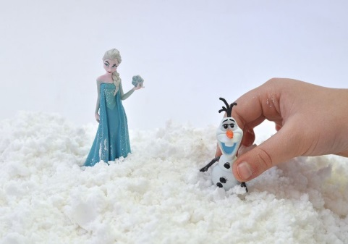
- Make snow
Ingredients:
2 lb. box of baking soda
1 can shaving cream
Dish or container (to mix it all up in)
DIY Snow Directions:
Pour all of the 2 lb. box of baking soda into a plastic container with a lid.

Add some shaving cream, and knead it into the baking soda. Add more shaving cream, mix, and repeat, until the mixture is the consistency of snow. The DIY fake snow become light and powdery, and will leave very little residue on your hands when fully mixed.

Maths -Time
Tell the polar bears how humans spend their days by filling in this timetable.
What do I do during the day?

Morning:  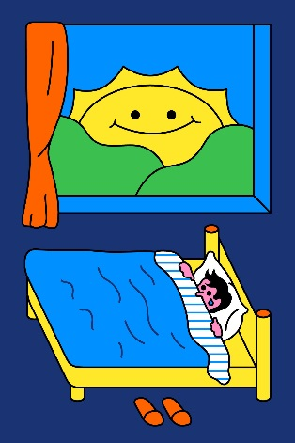 | For example: I brush my teeth.
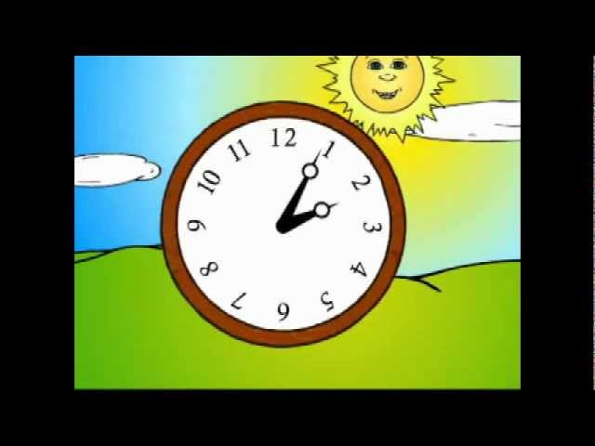  Afternoon: | For example: I do my school work.
Evening: | For example: I play with my pets.
Night:  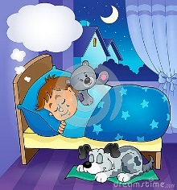 | For example: I put on my pyjamas.

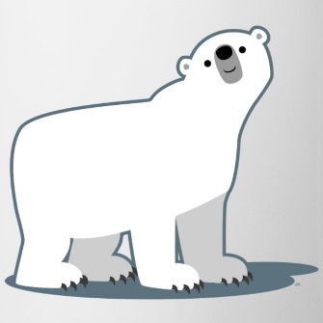
Polar bear’s day

What does a polar bear do during the day?

Morning:

Afternoon:

Evening:

Night:

Community
Polar Bears are an endangered animal. Find out what the word endangered means.
Can you find any charities that try to help animals?
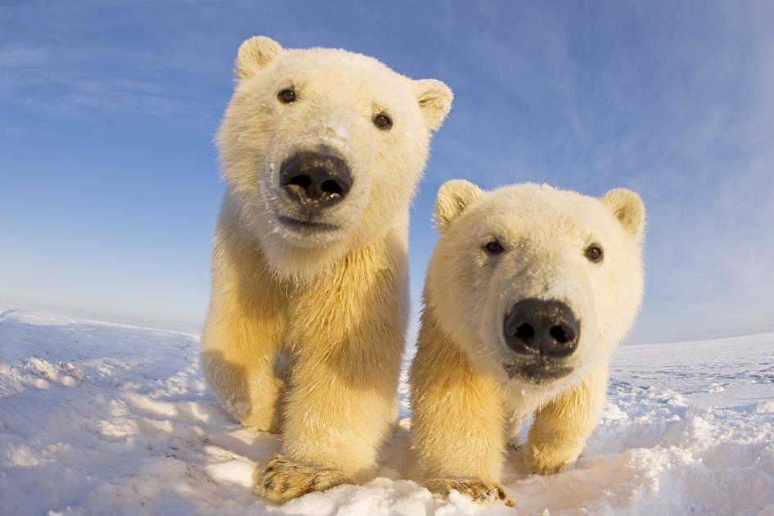
Can you find a charity that helps polar bears?

Creativity
Make a polar bear collage using old newspapers and magazines.
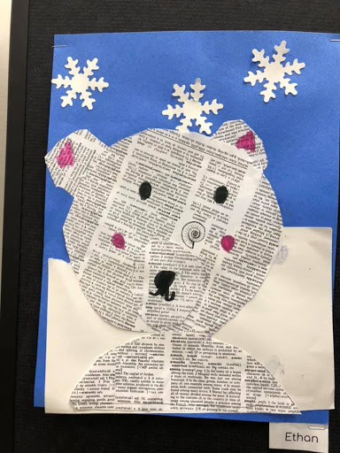
Make a polar bear by using a paper plate.
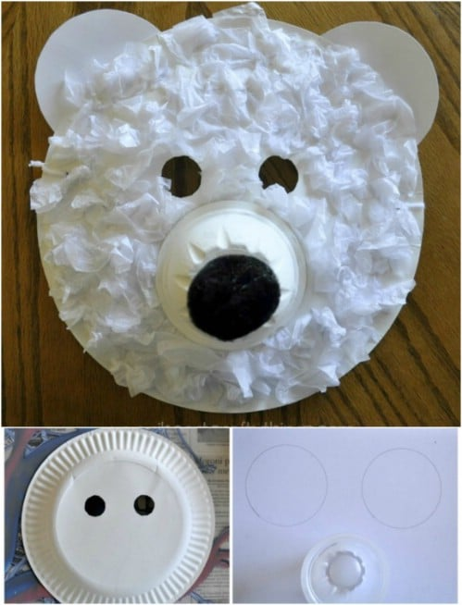

Winter painting
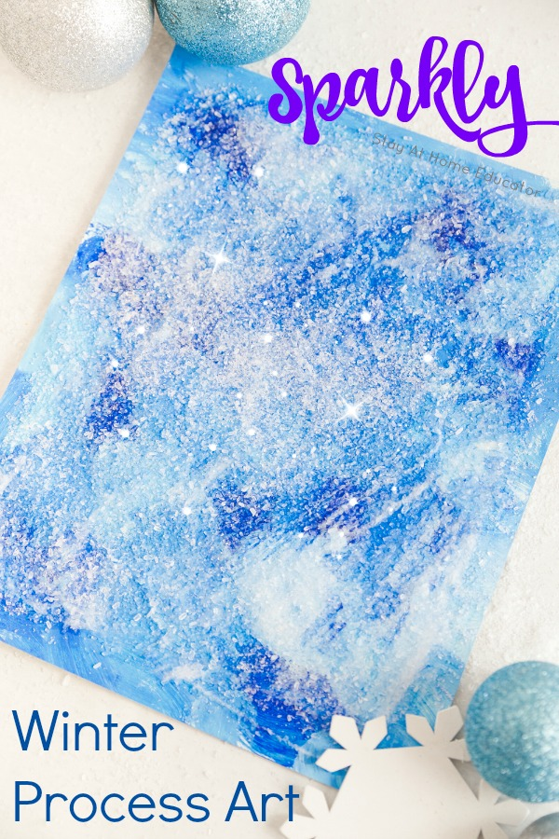

- paint, paint brushes, and paint palettes
- thick paper
- Epsom salt
- white liquid glue
Begin by dolling out a few dollops of white and blue paint. Mix the white and blue paint as you want. Before the paint has a chance to dry completely, squirt on some white liquid glue. Squeezing on the glue while the paint is still wet will cause it to react a bit with the paint as it dries, changing the blue paint under the glue to a purple hue. Finally, sprinkle some Epsom salt over the glue.

