Animals of the Chinese calendar

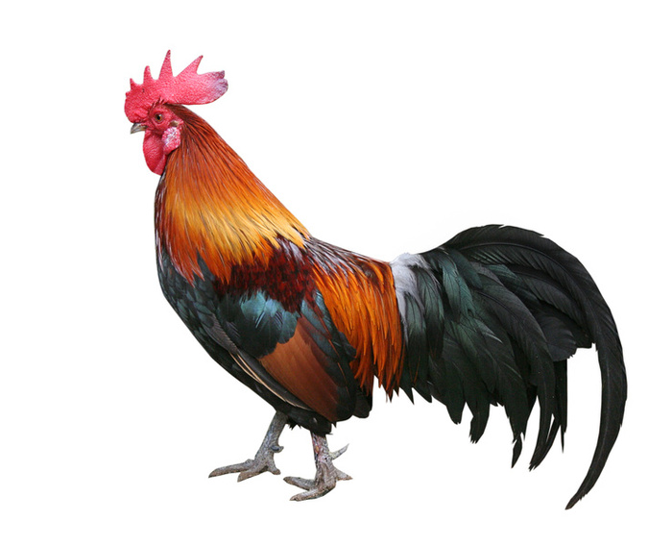

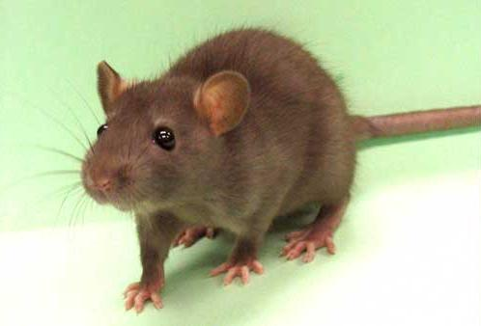

[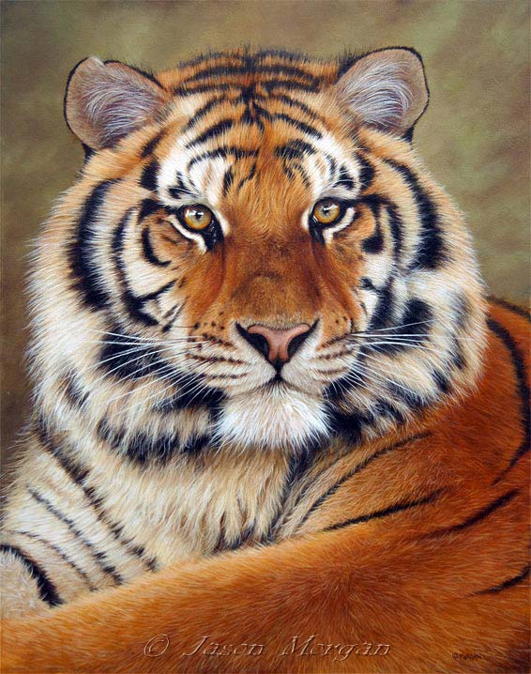](http://www.onlineartdemos.co.uk/pages/print_pages/siberian_tiger_2006.htm)

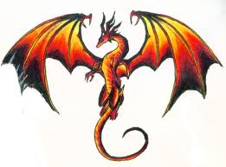

[](http://www.google.co.uk/imgres?q=dog&hl=en&gbv=2&biw=1441&bih=686&tbm=isch&tbnid=pntaOysLWeGPqM:&imgrefurl=http://myhappytails.co.uk/index.htm&docid=cIhidsX7-E8uSM&imgurl=http://myhappytails.co.uk/images/happy-dog.jpg&w=522&h=522&ei=1bTCTo6AM8m28QO9ivnlCg&zoom=1&iact=rc&dur=1&sig=101881473907924083529&page=7&tbnh=140&tbnw=140&start=120&ndsp=21&ved=1t:429,r:3,s:120&tx=80&ty=89)

