Chinese Food Tasting

[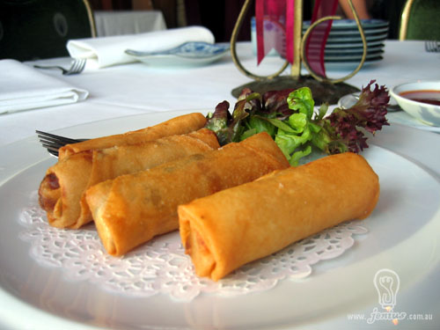](http://www.google.co.uk/url?sa=i&rct=j&q=&esrc=s&source=images&cd=&docid=w-og0pZUTsI6rM&tbnid=eMjvW35MhxBvzM:&ved=0CAUQjRw&url=http://www.ifood.tv/blog/how-to-make-soft-spring-roll-skins&ei=6JPuUtukB-bw0gWW3oHgDw&bvm=bv.60444564,d.ZGU&psig=AFQjCNFTXj-yQsK46IIdrj-zzvl94XV7TQ&ust=1391453522207621)

