6th Form 2
Wk Beginning 25th Jan. (Wed,Thursday,Friday )
Area | Activity | Links
PE/ Outdoor Education Healthy Living | 1. Go for a walk/cycle.  - While on the walk complete the ‘wildlife watch’,  - or identify some of the different OS map symbols you have been learning. Use the symbols work sheets to help and if can take some photos of the features to stick to the symbols worksheets.  - Revise the different compass points and complete the compass point worksheet.  - Complete the quick symbols worksheets to test your knowledge of the different OS map symbols.  2. Take part in on online fitness session. Joe wicks  3. Complete and evaluate weekly healthy living plan. Evaluate how well you have done at the end of each week. (use sheets on distance learning web site)  4. Some home PE ideas from Panathlon | Lesson materials/worksheets  Wild life watch worksheets 1 and 2  OS map symbols worksheets  Healthy eating plan and evaluation sheet(from last week)  https://panathlon.com/panathlon-launches-at-home-sporting-challenges/
Cookery/Daily living skills | 1.Make cupcakes  The class have been enjoying making different cupcakes each Thursday morning. They have been making them using cupcake kits purchased from the local supermarket.  Here are some of the different cup cake mixes they have used.  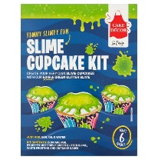  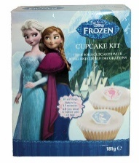  2. Make a simple Chinese stir-fry (link with China. Countries and Cultures)  3. Help around the house. Helping to wash and dry up, dusting, hoovering, making your own bed etc. | Lesson materials /worksheets  Quick chicken chow mein recipe - BBC Good Food  Zingy chicken stir-fry recipe - BBC Good Food
Vocational Studies | Vocational – Recycling  Sort your families recycling into different sections (e.g. plastic, tins, food, and cardboard). Then place them in the correct bins.
Countries and Cultures | This term the Countries and Cultures group will also be learning about China. Here are some things you could do. (see separate sheets) 2weeks work  - Look at other traditional Chinese things. (See Power point)  - Chinese Food tasting  - Colour a template of the Chinese flag  - Complete China worksheet using pictures provided.  - Watch video clip of Chinese New year festival.  - Look up what zodiac sign you are  - Look at Powerpoint of animals of the Chinese calender  - Locate China on the map of world and label with labels provided.  - Complete China word search  - Chop stick challenge  - Dragon mask colouring template | Lesson materials/worksheets  China Power Point  Chinese Food tasting sheets  China word search  Map of world  China label /symbol for map  China worksheet  China pictures  Chopstick challenge recording sheet  Chinese flag colouring page  Dragon mask colouring template  Animals of the Chinese calender powerpoint  Calendar showing the animals and their years.  Youtube clips  Chinese new year  CBeebies: Celebrating Chinese New Year - Let's Celebrate - YouTube  Chinese New Year 2019 Lion Dance, Hong Kong - YouTube  Chinese New Year for Kids - YouTube
English | Weekly Log.  Complete a simple weekly log using sheets provided. Using 2 photos (optional) and write a short sentence describing 2 things you have done this.  Include key information what ,where, who and what | Weekly Log recording sheet.
Art and  Extra | 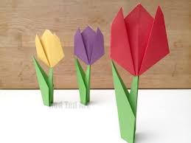  Spring Art ideas  Making paper tulips  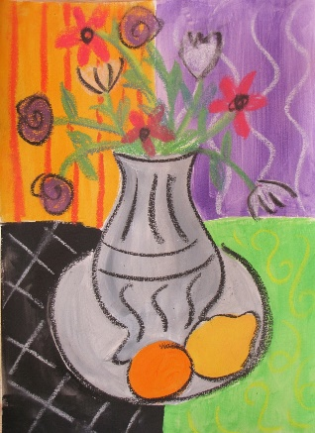  Matisse Spring flowers  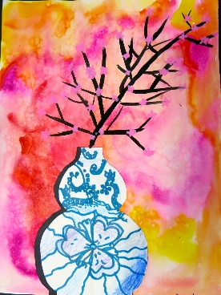  Chinese art ideas  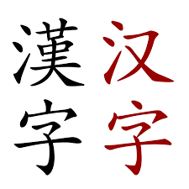  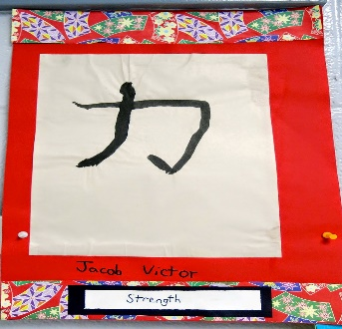  Chinese calligraphy  Translated your name into Chinese | https://www.youtube.com/watch?v=LFHGsHdY8w4  Matisse spring flowers instruction sheet  24 China: Art Lessons for kids ideas | art lessons, art projects, elementary art (pinterest.com)  Cassie Stephens: In the Art Room: Ming Vase Still Life with Third Grade  Google ‘Translate English to Chinese’
- Please refer to annual reviews for your child’s personalised targets.

I would love to see and hear about what you have been doing, feel free to email myself anytime – eshaw@parklane,cheshire.sch.uk

