Mandala prints
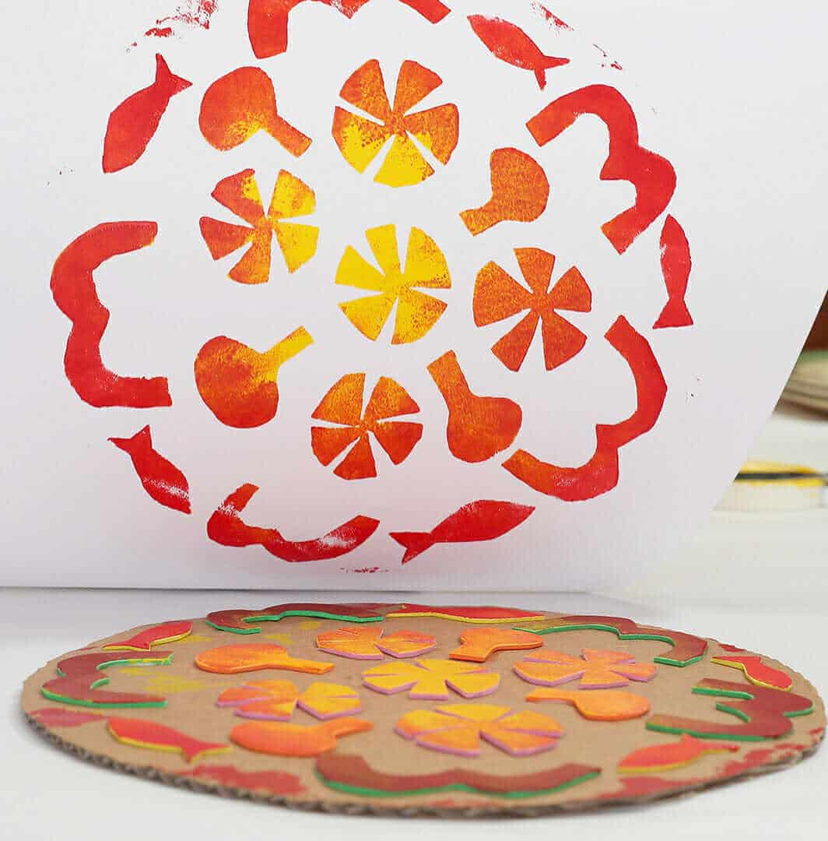

A sensory take on creating Mandala prints. Use cardboard to create the base and then use anything you can find around the house to stick on and make a relief pattern. You can either paint it as it is or use it to print onto paper.

The Buddhists make mandala’s as part of their meditation and use is as a relaxing, therapeutic experience.

