6th form 2 Class - Monday and Tuesday
Weeks beginning: 25th January & 1st February 2021
Subject | Activity | Links
Monday am (week 1)  Monday am  (week 2 ) | Shop, Cook and Eat  Choose a simple meal to make for lunch (pizza with a choice of toppings). Find all the food items needed and the utensils and make the snack with appropriate support. Tidy up, clean and wash up at the end of your lunch.  Shop, Cook and Eat  Research the ingredients on the Tesco direct website .What is needed to make ‘Healthy flapjacks’? Find the ingredients needed, write down the prices of each ingredient and add up the cost at the end.  Then:  Make yourself a healthy snack. Follow the link to make ‘healthy flapjacks’ (or find your own preferred recipe for flapjacks). Find all the food items needed and the utensils and make the snack with appropriate support. Tidy up, clean and wash up at the end of your snack. | When setting the table:  - Wash your hands  - Clean the table  - Decide which cutlery you will need and find the cutlery from the drawer  - Count out the people in your family - count out individually how many knifes/spoons/forks you will need  - Count out the mats and place them on the table with the cutlery  - Count how many drinks you will need for each family member and make the drinks. Maybe you could take an order for drinks? Like in a café.  - What else do you need for the table? Sauces/ spoons to serve food out etc  Making your meal  - Wash your hands  - Look at your recipe or chosen lunch  - Decide what items you will need to make it  - Find all the ingredients in your kitchen  - Find all the utensils you will need – knifes/chopping board/graters etc  - Make your chosen lunch with support from a family member  Once everyone has finished, don’t forget to wash up and clean the table!!  Healthy flapjack  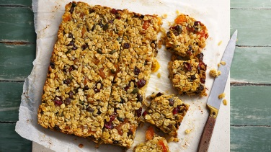  Suggestion:  https://www.bbc.co.uk/food/recipes/healthier_flapjack_10498
Monday pm  (week 1 )  Monday pm  (week 2) | Enterprise  PP: Take part in planning an identified mini- enterprise project  From your planning and research last week, you made two different cards. You had a vote to see which one was more popular.  Now make a few more of the same card and see if you can sell them to your family.  Use a computer or iPad to research Valentines gifts. Go on Pinterest and search for gift ideas linked to Valentines day. Look at simple gifts that you think you can make and sell to family and friends. Make a list of the different types of gifts you like.  Sensory  Make a Valentines themed sensory bottle. Use lots of valentine’s colours.  Follow the link to make the bottle.  https://www.youtube.com/watch?v=BLGl-U7pnPM | Ideas:  https://www.pinterest.co.uk/  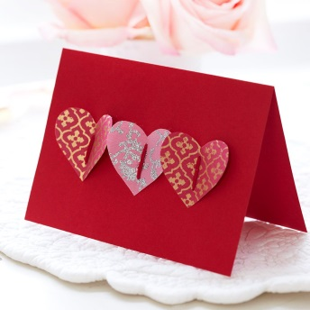  Valentine’s Sensory Bottle  https://www.youtube.com/watch?v=hmxDpNbaV_I
Tuesday am  (week 1)  Tuesday am  (week 2) | Vocational – Recycling  Continue to sort your families recycling into different sections (e.g plastic, tins, food, and cardboard). Have a look at the ‘Recycling symbols and their meaning 2’ sheet. Can you find any things in your house that have these symbols? Make a list/or photograph the things you find that have the symbols on.  Continue to sort your families recycling into different sections (e.g plastic, tins, food, and cardboard).  Remember to check the symbol on the items against your meaning list from last week, so you know what can and can’t be recycled. | Resources  ‘Recycling symbol and their meaning 2’ sheet
Tuesday pm  (week 1)  Tuesday pm  (week 2) | Vocational Studies - Gardening  Use the internet to research different types of gardens. What sort of gardens can you see? Modern gardens? Nature gardens? Yards? Patio’s? Pots? Themes gardens? Make a list of all the different types of gardens you research.  Choose a type of garden you would like to have. Start to design your garden on the ‘Design a garden’ grid. Take your time as this activity should take a few weeks. You can draw it or cut pictures out and stick them down or use a combination of both.  Think about the layout, planting and what purpose your garden will have? Is it somewhere to relax? Somewhere to play sports? Somewhere to grow vegetables? Do you have a pet?  Think about colour and smells. | Resources  Web ideas:  https://www.rhs.org.uk/advice/design  https://www.diy.com/ideas-advice/how-to-design-a-garden/PROD_npcart_100347.art  ‘Design a garden’ grid
- Please refer to annual reviews for your child’s personalised targets.

I would love to see and hear about what you have been doing, send emails and photos to Beth - batherton@parklane.cheshire.sch.uk

