6th Form One – Weekly Planner
Week Beginning 25th January & 1st February 2021
Subject | Activity | Links and resources
Monday am | 25.1.21 Community Visit  PP: participate in an activity that contributes to a healthy lifestyle: Walk round the garden or local area and listen to see what you can hear – use the scavenger hunt sheet if you want to, or just write down the things you can hear outside. There is also a sheet for things you can hear inside that you might want to do  When you get back home, click on the link and play the sound lotto games – see if you can get all the sounds correct.  1.2.21 Community Participation  PP: recognise aspects of their relationship to the communities to which they belong: be aware that they can contribute to their community  Look at the recording sheet they did a couple of weeks ago and remember the different places they use in their local community. Watch the PowerPoint about what makes a good citizen (neighbour). Think about where they live and talk about what responsibilities they have as part of their community, e.g. don’t drop litter, be kind to other people, pick up dog poo when walking your dogs, cross the road in safe places, don’t play music too loudly to annoy the neighbours. Use the recording sheet and pictures to show what you should, and shouldn’t do if you are a good neighbour. If you have any more ideas, you can record them on the back of the sheet. | Link to a listening lotto game on YouTube  https://www.youtube.com/watch?v=PiDcUIYncCA  Link to a listening in the living room Power Point game on Twinkl  https://www.twinkl.co.uk/go/resource/level-1-phonics-the-living-room-phonics-environmental-sounds-game-tg-ga-161  Link to a video clip about what makes a good citizen on YouTube  https://www.youtube.com/watch?v=LKCtzuvBZPc
Monday pm | Enterprise  PP: take part in selecting a mini-enterprise project to be involved in:  PP: Take part in planning an identified mini-enterprise project:  25.1.21: recap on what you did last week – make sure you have everything you need and continue making your Valentine/Mother’s Day/Easter cards/gifts/decorations  1.2.21: See what you have made so far & complete your Valentine cards/gifts – add inserts in the cards and wrapping to the gifts. Make flyers with pictures of your items and their prices plus an order form. Post these to family and friends and wait for the orders to roll in. In the meantime, continue making the rest of your items for sales later in the spring. | Link to the Pinterest site  https://www.pinterest.co.uk/
Tuesday am | Key Skills  English  PSD: Using technology in the home: demonstrate that you can use technology in the home safely:  26.1.21: Look at your recording work from last week to recall the technology you found in your home. Go into the kitchen and demonstrate how you can use a kettle and a toaster safely, by making yourself a hot drink (tea, coffee, hot chocolate) and some toast. Ask someone to take photos of you doing these tasks and enjoying what you have made. Demonstrate you can use other technology in the home safely e.g. speak to a family member on the phone or through FaceTime, use your games console, Wii, DVD or TV remote control safely. Ask someone to take photos of you enjoying these activities  2.2.21: Look at the photos of the things you did last week to show you can use technology in the home safely. Use them to record what you did and try to write how you used technology safely on the recording sheet.  Maths  PP: demonstrate an awareness of common measures – recognise coins up to £2 and notes up to £10  26.1.21: Recap on last week – can you remember the names of the coins and then order them by value? If you have forgotten the names of the coins, try completing some of the coin recognition sheets from last week.  Look at the value of coins. Go through the different coins, name them and see if you can talk about what the ‘p’ means when you write the name of a coin, e.g. 10p. It means ‘pence’ and says how many pennies each coin is worth. Select coins between 2p and 20p (depending on how many pennies you have), draw round them on the recording sheet (or make a rubbing of them with a pencil). Label the coin and then count out the right number of pennies for the coin. Draw round or take rubbings of the pennies next to the coin so you can see what each coin equals. For example, 10p is the same as 10 single pennies. If you feel you understand this, try doing the same activity, but use 2p coins as well as pennies to show a different way of making the different coins. For example, 5p is the same as 2x2p and 1x1p. Record the different ways of making coins using the same recording sheet (just print yourself another sheet out).  2.2.21: Recap on the work you did last week on understanding the value of the different coins. Look at the worksheets and choose some to complete – working out how much money is shown by adding amounts together.  Use the coin values number line to help you remember how many pennies each coin is worth. Only go up to the amount you can count to. One hundred pennies for a £1 or 200 hundred pennies for £2 is a lot of pennies to count, but you might be able to remember this amount and not need to count out that many pennies every time you come to £1 and £2 coins. If you have been able to complete some of the worksheets, see if you can make your own sheet, showing different ways of making the same amount. For example, how many different combinations of coins can you use to make 10p? 10 pennies, 2x5p, 1x5p & 5x1p and so on. Draw round the coins and label them to record, or take rubbings of the coins.
Tuesday  pm | Vocational Studies – Café Skills or Cleaning  Café Skills  PP: develop skills for the workplace: take part in activities that require simple decisions to be made & straightforward activities that require you to interact with other people  Recognise key features of health and safety in the workplace  26.1.21: Recap on last week’s café session. What role didi you have? Plan to run your café again. Check the menus from last week – do you need to change them? Have you got the same snacks and drinks on offer? If appropriate, don’t forget to add prices to the things on the menu. Once the menu is sorted, set up your café. Maybe use a table cloth to make the table look nice and put your menu on the table for your family to see what is on offer. Choose what role you want to take on and ask one member of your family to help you by being either cook to your waiter/waitress, or waiter/waitress to your cook. Make sure you tie long hair back, wear an apron and wash your hands with lots of soap and water before starting work. Take each person’s orders for drinks and snacks or go into the kitchen to make them. See if you can remember what to do and try to be as independent as you can. Remember and follow the safety rules when making hot drinks and toast. If you are being the waiter/waitress make a note of the prices of what each customer has orders and add the amounts up (use a calculator if you want to) and present your customers with their bills.  2.2.21: Run your café again – take on a different role – try to remember what to do and work as independently as you can in your role. Ask family member to help you by taking on the other role.  Cleaning  PP: develop skills for the workplace: follow instructions & Recognise key features of health and safety in the workplace  26.1.21: Explore a collection of cleaning equipment e.g. dust pan & brush, window cleaner and cloth, duster, mop & bucket, surface wipes etc. Do you know what each piece of equipment is used for? Look at the photos of different cleaning jobs and decide which equipment you would use for each one. If apporpriate, watch the short video clip of a cleaner, cleaning an office, or watch a family member doing a cleaning job. Select a piece of equipment and ask a family member to support you to carry out that cleaning job e.g. dusting furniture/surfaces, sweeping the floor, vacuuming, cleaning windows, mopping the floor, cleaning the sink etc.Make sure you use the equipment carefully and safely and wear gloves of you are using strong cleaning solutions. Once you have completed you job, ask a family member to give you marks out of ten for your work.  2.2.21: Recap on last week and what job you did. Either practise doing the same cleaning job again to see if you can remember what to do, or choose another job to work on. If possible, select the correct equipment for the job you have chosen and ask a family member to help you to complete the job. Ask someone else to look at your work and give you marks out of ten. | Use this Café Role play pack if you want to  https://www.twinkl.co.uk/resource/t-t-1192-cafe-role-play-pack  Link to a short video about cleaning an office  https://www.youtube.com/watch?v=GkTrrDJ9wZE
Wednesday am | SENSORY GROUP  (please see distance learning 2021 – 6th form 2 planner for ‘Outdoor Education’ group)  27th January Sensory Story and Sensory Art  Theme – January 30th – February 6th is National Storytelling week.  Follow the link to the brilliant and funny story ‘The Day the Crayons Quit’ by Drew Daywalt.  Listen to the story. As you listen find all the matching symbols on the sheet to the key words in the story. Sign the words if you know the signs or cut them out and stick them down in the order of the story.  Once you have listened to the story and completed all the symbols you will then need to start your art activity. To celebrate all the different colours you are going to make some marbled paper art. Follow the link to make the marbled paper. You don’t have to use watercolour paint or food colouring; you can just use ordinary paint.  Once you have made all your marbled paper leave it to dry.  Once it is dry you can cut different shapes out of the paper (e.g a tree, a sun) and make a picture of your choice just like Duncan did at the end of the story. Be as creative as you want!  Please take pictures of you completing the work and send them to Beth.  3rd February Sensory Story and Sensory Art  Theme – 4th February is ‘Time to Talk Day 2021’ Mental Health  Follow the link to the story ‘The Color Monster’ by Anna Llenas  Listen to the story. As you listen find all the matching symbols on the sheet to the key words in the story. Sign the words if you know the signs or cut them out and stick them down in the order of the story.  Once you have listened to the story and completed all the symbols, you will then need to start your art activity. You are going to make some Color Monster emotions jars.  Choose two colours from the story that you like e.g – Red for Anger and Green for Calm.  Find two empty jam jars. Follow the link to make and fill each jar, one colour each. You can use water, glitter, food colouring or small items such as sequins or lego bricks.  Once you have completed the jars you can explore them – shake them, turn them upside down. How do they make you feel?  Please take pictures of you completing the work and send them to Beth. | You tube link to ‘The Day the Crayons Quit’  https://www.youtube.com/watch?v=489micE6eHU  Crayons that Quit Symbols sheet  Shaving foam marble paper technique link:  https://www.youtube.com/watch?v=65e5hKRPEnA  You tube link to ‘ The Color Monster’  https://www.youtube.com/watch?v=W6wIEp-M4tg  Color Monster Symbols sheet  Sensory Bottles ideas link:  https://www.youtube.com/watch?v=QU1gXEKb90o
Wednesday pm | Physical Education 27th January  Using some of the exercises you learnt last week from your Joe Wicks session and things you have learnt in P.E, you are going to develop your own workout routine. Choose 3 different stretches that you can start to put together. Practise them. Don’t forget to warm up and warm down after your session.  Physical Education 3rd February  Choose another 3 different exercises to add to your routine from last week. Keep practising them not forgetting to warm up and warm down after your work out. | You tube for fitness/ exercise ideas
Thursday am | Shop Cook and Eat 28th January  Shop, Cook and Eat  Choose a simple meal to make for lunch (pizza with a choice of toppings). Find all the food items needed and the utensils and make the snack with appropriate support. Tidy up, clean and wash up at the end of your lunch.  Shop Cook and Eat 4th February  Research the ingredients on the Tesco direct website .What is needed to make ‘Healthy flapjacks’? Find the ingredients needed, write down the prices of each ingredient and add up the cost at the end.  Then:  Make yourself a healthy snack. Follow the link to make ‘healthy flapjacks’ (or find your own preferred recipe for flapjacks). Find all the food items needed and the utensils and make the snack with appropriate support. Tidy up, clean and wash up at the end of your snack. | When setting the table:  - Wash your hands  - Clean the table  - Decide which cutlery you will need and find the cutlery from the drawer  - Count out the people in your family - count out individually how many knifes/spoons/forks you will need  - Count out the mats and place them on the table with the cutlery  - Count how many drinks you will need for each family member and make the drinks. Maybe you could take an order for drinks? Like in a café.  - What else do you need for the table? Sauces/ spoons to serve food out etc  Making your meal  - Wash your hands  - Look at your recipe or chosen lunch  - Decide what items you will need to make it  - Find all the ingredients in your kitchen  - Find all the utensils you will need – knifes/chopping board/graters etc  - Make your chosen lunch with support from a family member  Once everyone has finished, don’t forget to wash up and clean the table!!  Healthy flapjack  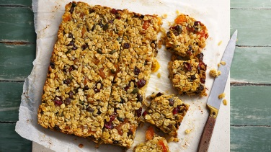  Suggestion:  https://www.bbc.co.uk/food/recipes/healthier_flapjack_10498
Thursday pm | PSHCE 28th January  PP: Express their individuality  Before you begin, access the ‘Rainbow breath ‘activity again on you tube. This helps to focus your mind and breathing ready to work.  Look at your hopes and aspirations tree from last week. Do you want to add to it? Change it in any way? If you are happy with it, you are going to create a ‘2021 aspirations and hopes ‘jar.  Find an empty jam jar or box with a lid. Decorate your jar/box with whatever materials you choose. It could be stickers, paint, glass paints or tissue paper. Be as creative as you wish!  Then write out all your ‘aspirations and hopes’ from your tree onto smaller pieces of paper and put them in your jar/box. You can place them in or roll them into little scrolls; it’s entirely up to you. The jar/ box can be placed somewhere in your home where you can see it and take them out and read them to remind you of your aspirations!  Please take pictures of you completing the work and send them to Beth.  PSHCE 4th February  PP: Express their individuality  Before you begin, access the ‘Rainbow breath ‘activity again on you tube. This helps to focus your mind and breathing ready to work.  You have completed your aspirations tree and jar/box.  Now have a go at answering the questions on the sheet.  Remember to write neatly on the lines and check your spellings.  Please take pictures of you completing the work and send them to Beth | Rainbow breath Go Noodle  https://www.youtube.com/watch?v=O29e4rRMrV4  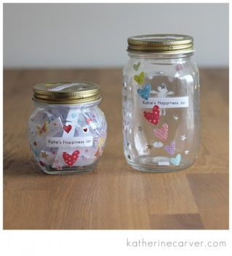  Aspirations Questions and Answer sheet
Friday am | Art (you will need a laminating pouch if you have a laminator, or some sticky backed plastic, brown and blue paper or card, white paint, glue and cotton buds)  PP: take part in different, new creative activities  29.1.21: Look at your picture of the winter tree from last week. Today you are going to make another winter tree picture, but this time to hang in your window. If you are using a laminator pouch, Blue Tac it to the table you will be working on and open it up so the top sheet is folded upwards. If you are using sticky backed plastic, cut a rectangle shape, slightly smaller than a standard A4 piece of paper. Carefully peel the sheets apart and put the top sheet to one side. Stick the bottom sheet onto the table with Blue tac, sticky side up. Tear up the brown card/paper into small strips and use them to create a tree shape on your laminating pouch/sticky backed plastic. Use the cotton bud to dip into white paint and add snowflakes all around the tree. Let the snowflakes dry. Cut the blue card/paper into strips and put them round the outside of the pictures to make a frame. Close the laminating pouch and carefully put it through the laminator to seal it, or carefully put the top sheet of sticky backed plastic onto the bottom sheet and smooth it down to seal the picture. You can hole punch the top of the picture and add string to hang it in your window.  5.2.21: (you will need A4 white card/stiff paper, old newspapers, a heart shaped template, a pencil, scissors, glue, a variety of paint including pink, red and purple, paintbrushes, sticky tape and some string)  Think about what you have been making in enterprise and what special day is coming up later in February. You are going to make some valentine bunting to hang in your bedroom. Water down a variety of colours of paints and paint patterns onto a few sheets of old newspaper. Leave these to dry. Cut the white card in half – have at least 6 pieces to make a good string of bunting. Draw round the heart shaped template on each piece of white card and then use the pink, red and purple paints to paint round the outside of the heart shape. Don’t worry if you go over the edges a bit, these will be covered up. Leave them to dry. Draw round the heart template on the painted newspaper – make sure you have enough hearts so there is one for each piece of bunting. Cut the hearts shapes out of the newspaper and stick them onto the white pieces of card. Stick the pieces of card onto a length of string and hang them up as Valentine decorations. | 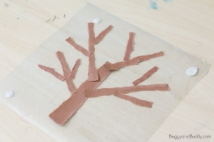  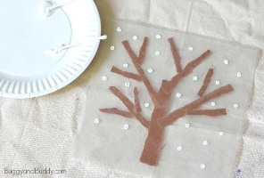  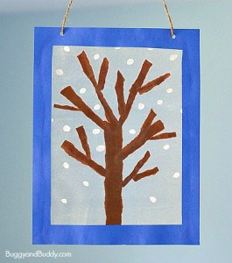  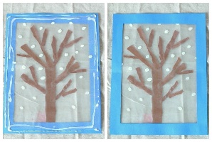  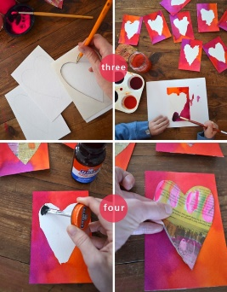
Friday pm | ICT  PP: Developing ICT skill: communicate with ICT  29.1.21 & 5.2.21: Compose an email with support to send Andrée photos/information on some of the activities you have been doing this week. Even if it something completely different from the planner, it doesn’t matter, she would love to see what you have been up to.
- Please refer to annual reviews for your child’s personalised targets.

We would love to see and hear about what you have been doing, feel free to email Andrée – abarnard@parklane.cheshire.sch.uk
For Wednesday and Thursday work please email Beth – batherton@parklane.cheshire.sch.uk

