Arghi Class
WK:18th– 25th^{th} January 2021
Area | Activity | Links
English | Story When Charlie McButton Lost Power  by Suzanne Collins (Author), Mike Lester (Illustrator)  listen / watch and read along with the story  on YouTube  Charlie s forced to find other things to do when his computer stops working due to a power cut caused by a thunderstorm.  Think of something you could do if you had a power cut. Draw a picture to illustrate your idea.  If you can, write a caption or sentence about your picture.  Communication: Sign along: Practice your signs for different types of weather.  Proloquo 2 Go: use your ipad to describe the weather everyday  Reading & Phonics: –  In the story there are lots of words that rhyme  find pairs of words in the text that rhyme | https://www.youtube.com/watch?v=jB-FTNTqStE 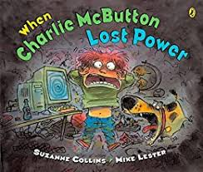  for PDF version  http://www.crazy4computers.net/uploads/8/0/8/1/8081888/when_charlie_mcbuttons_lost_power_pdf_book.pdf
Maths | Use some of your air dry clay to make any of these 3D shapes
Creativity | Charlie did not want to play with clay.  You could see if you like making things with clay.  Have a go at a clay snail  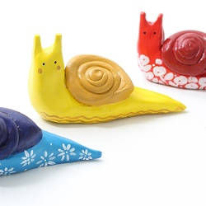  https://www.youtub e.com/watch?v=gq5XNbWPcEk  ( they use different coloured clay but you can paint yours when it is dry | Homemade Air Dry Clay Recipe  Ingredients  2 cups baking soda  1 cup cornflour (plus more for kneading)  1 ½ cups water  Instructions  In a small pan, mix the baking soda and cornflour. Stir in the water until completely blended.  Place pan over medium heat and cook, stirring constantly for 10 to 15 minutes until the clay begins to form. Remove from heat and continue stirring until the mixture becomes a sticky but soft dough.  Allow the dough to cool to the touch.  Place dough on a surface coated with additional cornflour. Begin kneading the clay adding more cornflour as needed until the clay becomes smooth and the tacky feeling is gone.  To store, wrap tightly in plastic wrap and place in an airtight container.  To dry, place shapes on a drying rack. If needed, flip shapes over after one side has dried. Depending on the thickness of the object, the clay may take up to 3 days to dry completely.
Individuality | In the story  Charlie knows what he likes and what he likes not.  Make a list of all the things you like to do and the things you do not like to do.  See if you can give reasons why.  Charlie was in trouble for being unkind to his little sister  How did his little sister feel?  How did this make Charlie feel?  Try a guided meditation from Cosmic Kids  Friendly Wishes (Peace Out: Guided Meditation for Kids) | Cosmic Kids | Things I like to do in my spare time Thinks I do not like to do in my spare time  Use feelings page on Ipad or in communication aids  or Download feelings and emotions cards to support  https://www.twinkl.co.uk/resource/t-t-2157-emotions-word-cards  https://www.youtube.com/watch?v=HtYIQiXyrsE
Community | Use the internet to find out what games and toys children played with in Victorian times, before everyone had electricity in their homes and long before computer games were invented.  Try making a ball and cup game.  Ask older family members what games and toys they played with when they were little.  Find out what early computer games were like  have a go at pong one of the first video games ever  https://www.ponggame.org/  (I remember playing this!) | Cup and Ball  Try to get the ball in the cup: harder than it looks!  Making the toy  1) Make a small cup, cut from a plastic bottle  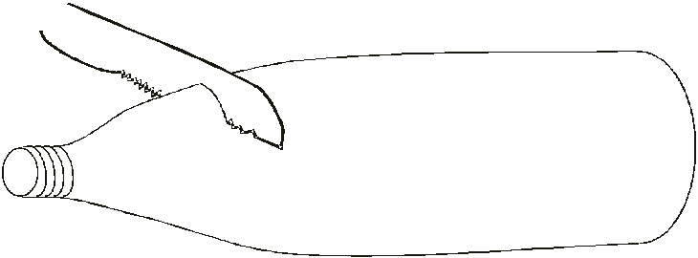  2) Cut a piece of thread or string no longer than half your height.  Tie it to the cup.  3) Find a small ‘ball’. Anything will do, screwed up newspaper is good. Make a hole if necessary.  Tie it to the end of the string.  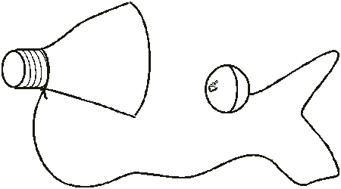  Connect the ball to the cup with string  Swing the ‘ball’ and try to catch it in the cup
Challenge | Some electrical items have to be plugged into a power source some use batteries.  Charlie was looking for an AAA battery  can you find something that uses batteries  What type of batteries can you find  What shape are they?  Why do some things need bigger batteries?  Find out about electricity safety in the home | http://www.switchedonkids.org.uk/electrical-safety-in-your-home
- Please refer to annual reviews for your child’s personalised targets.

I would love to see and hear about what you have been doing, feel free to email myself anytime – swright@parklane,cheshire.sch.uk

