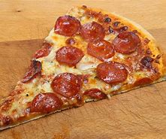

What am I going to have on my Pizza.

On my pizza I am going to put
_____________________
_____________________
_____________________
_____________________
_____________________
_____________________
_____________________

I would like with my pizza
____________________
_____________________
_____________________

