Cookery lesson
Cupcakes
The class have been enjoying making different cupcakes each Thursday morning. They have been making them using cupcake kits purchased from the local supermarket.

Here are some of the different cup cake mixes they have used.
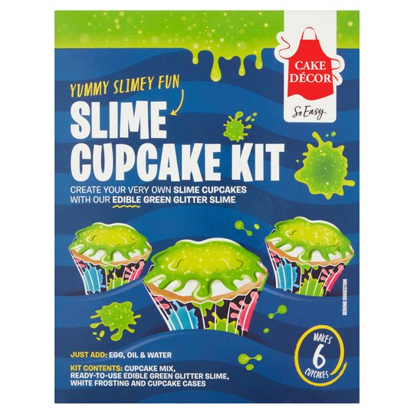
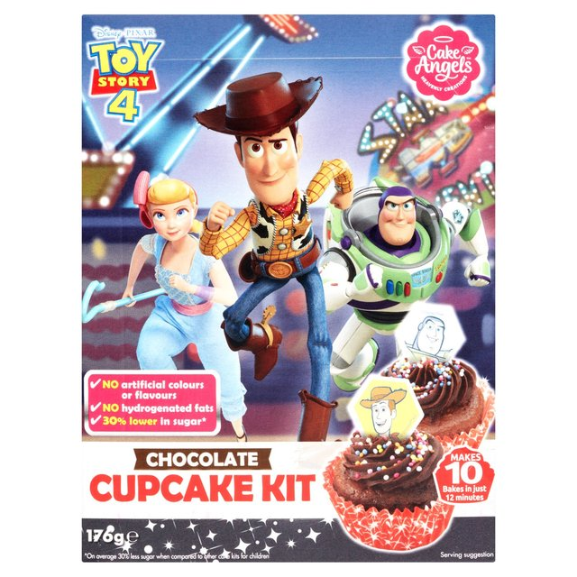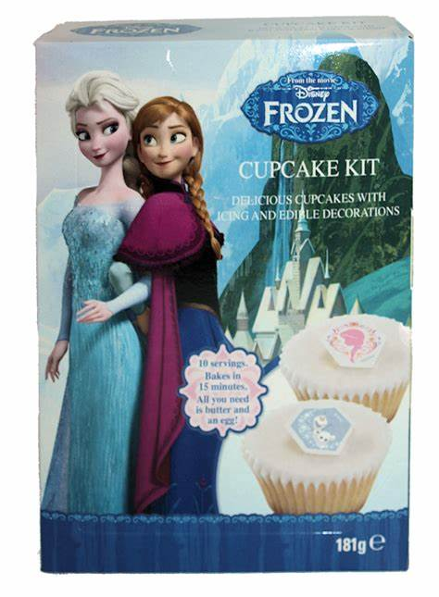
Making their own pizza
Using a pre bought base from the local supermarket chop and prepare various toppings you want to include on your pizza. The toppings can include salami, onion, pepper, pineapple, ham, mushroom and of course cheese.
Complete the work sheet below .’What I am going to have on my pizza’.
You could also draw your own pizza with all the toppings you have chosen. I have attached photos of different pizza topping also. ‘Pizza toppings’
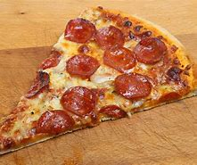

What am I going to have on my Pizza.

On my pizza I am going to put ….
_____________________
_____________________
_____________________
_____________________
_____________________
_____________________
_____________________

I would like with my pizza….
____________________
_____________________
_________________
_______________________

