6th Form 2
WK Beginning: 11th Jan 2021
Area | Activity | Links
PE/ Outdoor Education Healthy Living | 1. Go for a walk/cycle.  - While on the walk complete the ‘wildlife watch’,  - or identify some of the different OS map symbols you have been learning. Use the symbols work sheets to help and if can take some photos of the features to stick to the symbols worksheets.  - Revise the different compass points and complete the compass point worksheet.  - Complete the quick symbols worksheets to test your knowledge of the different OS map symbols.  2. Take part in on online fitness session. Joe wicks | Lesson materials/worksheets  Wild life watch worksheets 1 and 2  OS map symbols worksheets
Cookery/Daily living skills | - Make cupcakes  The class have been enjoying making different cupcakes each Thursday morning. They have been making them using cupcake kits purchased from the local supermarket.  Here are some of the different cup cake mixes they have used.  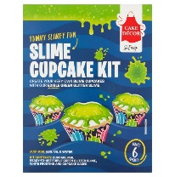  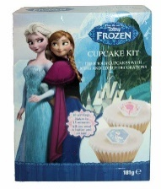  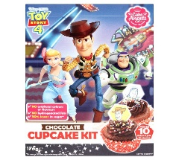  - Making a pizza  Using a pre bought base from the local supermarket chop and prepare various toppings you want to include on your pizza. The toppings can include salami, onion, pepper, pineapple, and ham, mushroom and of cause cheese.  Complete the work sheet below. ‘What I am going to have on my pizza’.  You could also draw your own pizza with all the toppings you have chosen. I have attached photos of different pizza topping also. ‘Pizza toppings’  3. Help around the house. Helping to wash and dry up, dusting, hoovering, making your own bed etc. | Lesson materials /worksheets  ’What I am going to have on my pizza’. Worksheet  ‘Pizza toppings’ worksheet
Vocational Studies | Vocational – Recycling  Sort your families recycling into different sections (e.g. plastic, tins, food, and cardboard). Then place them in the correct bins.
Countries and Cultures | This term the Countries and Cultures group will also be learning about Italy. Here are some things you could do. (see separate sheets)  - Make Ice cream  - Listen to and watch video of the Italian national anthem  - Watch Cornetto advert  - Listen to the songs. Mambo Italian and That’s Amore  - Look at other traditional Italian things. (See Power point)  - Food tasting  - Colour a template of the Italian flag  - Take a copy of the Mona Lisa then use things cut from different magazines to create your own version. Add different hair, jewellery , facial features etc  - Complete Italy worksheet using pictures provided.  - Watch an episode of the Teenage Mutant Ninja Turtles. | Lesson materials/worksheets  Making Ice-cream  The Mona Lisa painting  Italian Power Point  Food tasting sheets  YouTube clips  https://www.youtube.com/watch?v=s3Nr-FoA9Ps  https://www.youtube.com/watch?v=NAZ7iFji2s4  https://www.youtube.com/watch?v=OnFlx2Lnr9Q  https://www.youtube.com/watch?v=c54DL0DxZVA  https://www.youtube.com/watch?v=N4ztYjFxwmI
Community

Community visit

Art and  Extra | 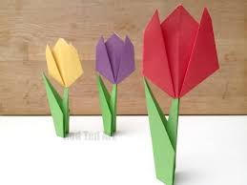  Spring Art ideas  Making paper tulips | https://www.youtube.com/watch?v=LFHGsHdY8w4
- Please refer to annual reviews for your child’s personalised targets.

I would love to see and hear about what you have been doing, feel free to email myself anytime – eshaw@parklane,cheshire.sch.uk

