6th form 2 Class - Monday and Tuesday
Weeks beginning: 4th January 2021
Subject | Activity | Links
Monday am | Shop, Cook and Eat  Make yourself a healthy snack. Follow the link to make ‘apple and sultana muffins’. Find all the food items needed and the utensils and make the snack with appropriate support. Tidy up, clean and wash up at the end of your snack. | 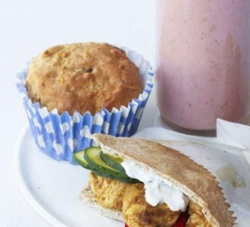  https://www.bbcgoodfood.com/recipes/apple-sultana-muffins  When setting the table:  - Wash your hands  - Clean the table  - Decide which cutlery you will need and find the cutlery from the drawer  - Count out the people in your family - count out individually how many knifes/spoons/forks you will need  - Count out the mats and place them on the table with the cutlery  - Count how many drinks you will need for each family member and make the drinks. Maybe you could take an order for drinks? Like in a café.  - What else do you need for the table? Sauces/ spoons to serve food out etc  Making your meal  - Wash your hands  - Look at your recipe or chosen lunch  - Decide what items you will need to make it  - Find all the ingredients in your kitchen  - Find all the utensils you will need – knifes/chopping board/graters etc  - Make your chosen lunch with support from a family member  Once everyone has finished, don’t forget to wash up and clean the table!!
Monday pm | Enterprise  PP: Take part in selecting a mini enterprise project to be involved in  Begin to research on the internet ideas for Valentine’s day. Things that you could make to sell/give to members of your family. Make a list of the things you have chosen. | Ideas:  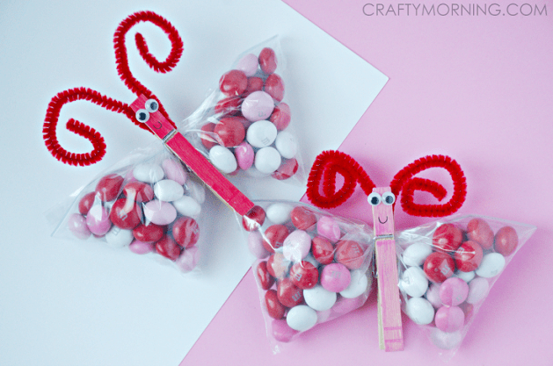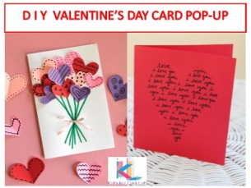
Tuesday am | Vocational Studies– Recycling  Sort your families recycling into different sections (e.g plastic, tins, food, cardboard). Then place them in the correct bins.
Tuesday pm | Vocational Studies - Gardening  Spend some time in the garden, planting, digging or tidying. Do a bird count and make a list of the birds that visit your garden. See if there are more or less than the last time you did a bird count.
- Please refer to annual reviews for your child’s personalised targets.

We would love to see and hear about what you have been doing, please send emails to Beth batherton@parklane.cheshire.sch.uk

