Arghi Class
WK: 4th – 11th January 2021
Area | Activity | Links
English | Story  The Magic Paint Brush is a traditional Story from China  listen / watch and read along with the story 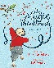  The Magic Paintbrush ( Julia Donaldson version) on YouTube  or take part in a sensory story  Imagine you have a magic paintbrush. What would you paint? Draw a picture. Add words, a short phrase or sentence, or a paragraph to describe your picture.  Communication: Sign along: Practice your signs for different colours  Proloquo 2 Go: Have someone point to objects / pens /pencils of different colours. Can you name all the colours using your Ipad  Reading & Phonics: –  In the story there are lots of words with ‘Sh’  Make a list of words from the story with Sh. Can you think of any more? | https://www.youtube.com/watch?v=z-0JZPzBDMc  Grandma Fran reads The Magic Paintbrush  or  Children's Bedtime Stories | The Magic Paintbrush By Julia Donaldson | Story Time  https://www.youtube.com/watch?v=qWM0kQmR_pI  simplified PDF  https://northridge.manchester.sch.uk/wp-content/uploads/2020/03/The-Magic-Paintbrush.pdf  Sensory story  https://www.ashlea.notts.sch.uk/wp-content/uploads/2020/05/The-Magic-Paintbrush-sensory-story-guide.pdf
Maths | Make some golden rice  INGREDIENTS  1 cup long grain white rice  1 medium onion diced  1 teaspoon turmeric  1 clove garlic minced  1 Tablespoon butter  2 Tablespoons olive oil  2 cups chicken or vegetable stock  1/2 cup toasted pine nuts or slivered almonds  1 teaspoon salt  1/2 teaspoon pepper more to taste  2-3 Tablespoons fresh chopped parsley for garnish.  INSTRUCTIONS  Heat oil and butter in a sauce pan over a medium heat. Add onions, and sauté 2-3 minutes, add rice, turmeric and garlic, and continue stirring, 2 to 3 minutes. Don't let garlic burn  Add stock and 1/2 teaspoon salt. Bring to a boil. Turn down heat to low, cover and cook rice until tender and liquid is absorbed, about 15-18 minutes.  Stir in toasted pine nuts or almonds and adjust seasoning to taste. Garnish with fresh chopped parsley.  Measure the ingredients carefully  discuss a half ½ compare half a cup to 1 cup or half a teaspoon to 1 teaspoon  This recipe is for 6  If you are feeling clever see if you can write the recipe out with ingredients for 12 people ( double everything)  or re- write the recipe for 3 people ( halve everything) | https://whatagirleats.com/golden-rice-pilaf/ 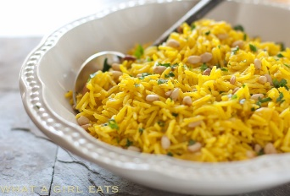
Creativity | 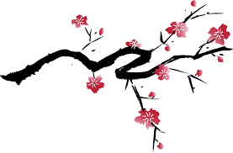  Make a Chinese cherry blossom painting , print or collage  you could use the base of a plastic bottle to print the blossom  you could use tissue paper or popcorn, finger painting or cotton buds and twigs.  Listen to some traditional Chinese music | 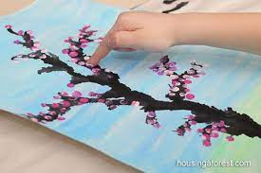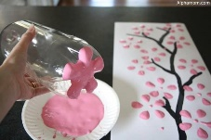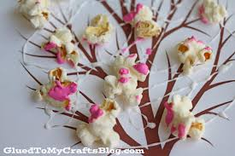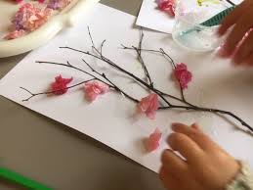
Individuality | What do you think is the moral of the story? Find the best answer.  a. Money is important.  b. Don’t be greedy and be kind to others.  c. The king is always right.  Discuss how you think Shen might be feeling when:  she was given the magic paintbrush  she was in Prison  she made food for the poor  try a dragon themed guided meditation with Cosmic Kids  or cracker the Dragon Yoga  Saturday Morning Yoga | Cracker the Dragon of Wonder | Sleeping Dragon | Guided Meditation for Kids | Peace Out  https://www.youtube.com/watch?v=AUjpWdbMrAg  https://www.youtube.com/watch?v=oh-yGiQA3g8
Community | Find China on a world map or globe  Find the UK and compare the size  Watch the BBC bitesize clip on how the Shang of ancient China invented writing  Write your name using the English Alphabet then make a symbol for your name. think about what is special about you and how you would like to be represented pictorially.  watch the BBC Bitesize clip Geography KS2: A child-led tour of Shanghai in China  and / or Geography KS2: A child-led tour of Yangshuo, in China  In what ways are these Children’s days similar to yours? How are they different? | https://www.bbc.co.uk/teach/class-clips-video/history-ks2-the-story-of-china-how-the-shang-invented-writing/zdcbmfr  https://www.bbc.co.uk/teach/class-clips-video/geography-a-child-led-introduction-to-the-chinese-city-of-shanghai/zdrtvk7  https://www.bbc.co.uk/teach/class-clips-video/geography-a-child-led-tour-of-yangshuo-in-china/zmn6f4j
Challenge | Magic Milk  Pour some milk into a shallow dish  add a few drops of different coloured gel food colouring  Add some liquid soap to a cotton bud  dip the cotton bud into the middle of the plate and watch as the colours mix.  If you are feeling really clever, use the internet to find out how this works. | 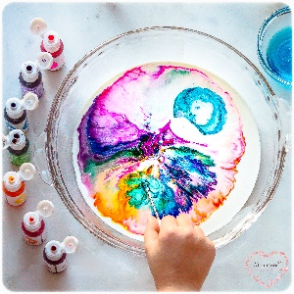
- Please refer to annual reviews for your child’s personalised targets.

I would love to see and hear about what you have been doing, feel free to email myself anytime – swright@parklane,cheshire.sch.uk

