Park Lane School

Mathematics Policy
Reviewed September 2022

Rationale:
At Park Lane School we believe that maths offers opportunities beyond conventional means of expressing thoughts and communication and it is an essential life skill that is used throughout our daily lives. We offer an enriched curriculum whereby maths is developed and enjoyed in all aspects of school life and with the whole school community. We provide our children with an exciting, relevant and challenging curriculum. Our curriculum is a work in progress; each term schemes of work are annotated, and improvements are made. We strive to ensure that all children develop a positive attitude towards maths and numeracy and become confident, life-long mathematicians.

COVID 19

During the school closures in response to the coronavirus (COVID-19) outbreak in the UK, Park Lane School quickly adapted to provide pupils with learning opportunities they could access from home. Over the course of the subsequent lockdown periods, we developed systems for delivering home learning to our pupils for a significant amount of time. Now that schools have reopened to all pupils and classroom learning is returning largely to ‘normal’, it is essential to have a plan in place to support any potential home learning for classes, should the need arise to isolate or close again.
To be fully prepared in the event of future closures, partial closures or isolation of bubbles, Park Lane School has carefully considered, consulted on and developed a policy for remote learning. The overarching goal is to enable pupils to access high-quality teaching and learning even when they are unable to attend school. We aim to provide remote learning, whether it is delivered as blended learning through the provision of both in-school and online lessons, or solely online home learning.
Maths resources were made available on both the school website: https://www.parklaneschool.co.uk/page/distance-learning-2021/89920 and sent home to parents/guardians, for those without access to the internet or a printer. Education City log-ins have been communicated to parents and guardians. Some teachers will either deliver online lessons, through pre-recorded content or live streaming. All lessons will be documented under the Remote Learning heading on the server. There will be changes made to the Scheme of Work, for example money was taught in the summer term when we were using coins and notes again.

Intent:
At Park Lane School, we believe that mathematical and numeracy skills are an essential part of learning, as they provide all students with powerful ways of exploring, investigating and understanding the world around them. We aim to deliver maths in an inspiring, practical and creative way, which is constantly evolving to suit the individual needs, learning styles and motivation of each student. Maths develops independence and decision-making skills, which are integrated through the whole curriculum. Maths lessons are taught following the National Curriculum and cross-curricular themes.
We teach maths through all learning situations that the pupils encounter during the day, such as playtime, snack time or lunchtime. Many opportunities are made to ensure that the students use their skills in practical situations such as cooking and gardening.
Since the Ofsted Report March 2020, steps have been taken to improve the delivery of maths at Park Lane School. Schemes of Work have been developed, which prioritise core and functional skills in maths to enable students to have full access to the world. The impact of these schemes of work are evaluated termly and will then be improved upon accordingly. We are now constantly planning to prepare our students to take the next steps and have interventions for those students, who may need additional support. Units of work are planned, sequenced and adapted to cognitive ability. The curriculum is not yet perfect, but it is an evolving project. We have invested in White Rose Maths to improve resources and provide training. There is now a calculation policy in place, which has been shared with all teachers to be discussed in team meetings.

Maths schemes of work progression
March 2020 | Term 1 number and place value | Term 2 geometry, shape and measure | Term 3 Position, direction and Movement, time and Money
EYFS
KS 1
KS 2
KS3
KS 4
KS 5
April 2021 | Term 1 number and place value | Term 2 geometry, shape and measure | Term 3 Position, direction and Movement, time and Money
EYFS
KS 1
KS 2
KS3
KS 4
KS 5
September 2021 | Term 1 number and place value | Term 2 geometry, shape and measure | Term 3 Position, direction and Movement, time and Money
EYFS
KS 1
KS 2
KS3
KS 4
KS 5
May 2022 | Term 1 number and place value | Term 2 geometry, shape and measure | Term 3 Position, direction and Movement, time and Money
EYFS
KS 1
KS 2
KS3
KS 4
KS 5

Planning priority for schemes of work
Revised but not yet evaluated
Fit for purpose
Requires major re-write
Evaluated and revision needed

We have researched cultures of exceptionally high aspirations and visited Hebden Green School to facilitate further improvement. Our aim is to match activities to students’ needs, in order to maximise achievement and deploy support staff effectively. We are striving to make effective use of assessment to plan and build on prior learning.

Aims:
- To follow the National Curriculum

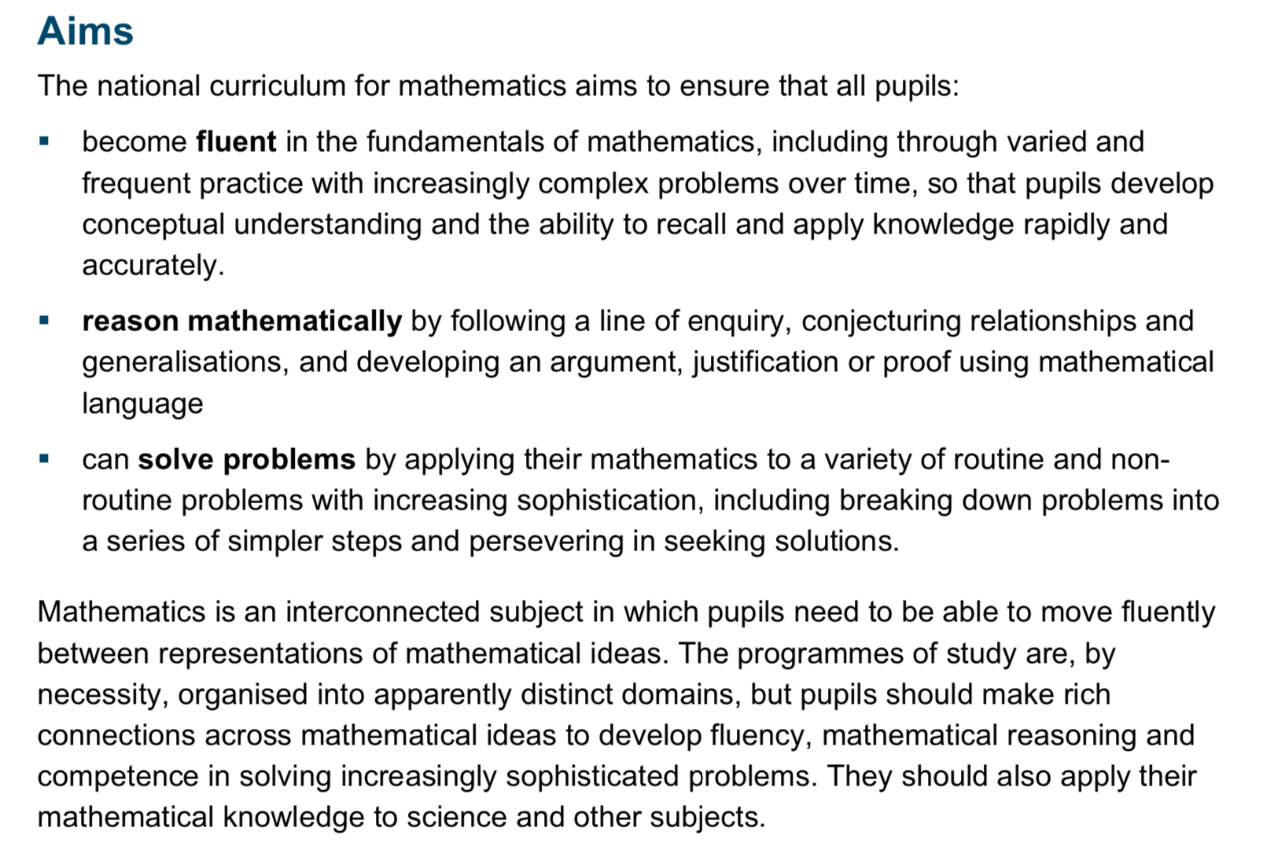

- To match activities and learning to the needs and understanding of individuals. This is critical at Park Lane School, as the rates of development of students are so variable.

- To develop their awareness of events in the immediate world through experience or exploration

- To develop awareness of pattern and quantities

- To respond to mathematical information including position, shape and quantities

- To reliably and solve simple number problems

- To use mathematical language to describe and compare position, shape, size and quantity

- To use and interpret a range of data through a variety of formats

To apply mathematical skills and concepts in everyday contexts and within daily living routines.

Assessment:

- Achievement on entry (foundation) assessment takes place based by teacher assessment using the sound Learning Baseline Assessment- this is reported to parents in the annual review.

- End of Key Stage assessment takes place based on teacher assessment using Early Learning Goals and Pre-Key Stage Standards or National Curriculum Levels as appropriate. Results are reported to parents at the end of the summer term.
- Formative assessment teachers currently use Evidence for Learning to assess and record pupil progress. This is a continuous process, but teachers will complete a formal update at the end of each term.
Where students are not making expected progress teachers will meet with a member of the Senior Leadership Team to draw up and appropriate action plan.
• Annual assessment takes place as follows:
Evidence for Learning.
Assessment of progress in the annual review of statement

Implementation of Mathematics in Park Lane School

Early Years
Pupils follow the curriculum based on different areas of learning. Pupils are taught to learn through play and through identified activities. Pupils are given the opportunity to experience number and counting, shape and measure. At the end of the foundation stage, some higher-attaining pupils may be able to count to 10, recognise 2D shapes and match primary colour.

Key Stage 1
Pupils in Key Stage 1 follow the National Curriculum Mathematics programmes of study at levels appropriate to their development. Pupils are taught through group numeracy sessions and individual activities. They are given opportunity to experience number and counting, shape and measure as well as topic-based maths as set out in the scheme of work. At the end of the key stage pupils may be able to count to 20, identify 2D shapes and measure capacity, weight and distance.

Key Stage 2
Pupils in KS2 follow the National Curriculum Mathematics programmes of study at levels appropriate to their development. Pupils are taught to, as far as is appropriate for each individual, solve numerical problems and are given the opportunity to experience numeracy through a first hand, experiential approach, through games, songs, based on a termly topic and key objective.
At the end of the Key Stage, pupils may be able to record their maths in written/symbol form or use ICT to do so. These pupils may be working within level 1 of the National Curriculum, completing simple addition, using money, identifying 3D shapes and measuring time.

Key Stage 3
Pupils in KS3 follow the National Curriculum Mathematics programmes of study at levels appropriate to their development. Pupils are taught numeracy skills related to the scheme of work and key objectives and these are practised in different situations
At the end of Key Stage 3 students may be able to count beyond 100, solve simple problems, show understanding of basic fractions, identify coins and tell the time.

Key Stage 4
As a school, we continue to offer formal mathematics lessons at Key Stage 4.
At Key Stage 4 students follow a maths curriculum appropriate to individual student’s need and this work covers all aspects of the mathematics curriculum. Pupils are taught to use numeracy skills in different contexts, which are both functional and meaningful, i.e., shopping, using vending machines, within a mini enterprise. Work in Key Stage 4 is accredited through elements of the ASDAN Transition Program.

Post 16
Pupils follow a more practical and relevant curriculum leading to independence as they move through the sixth form. The topics of position, measure, money and time are dealt with in more practical ways through shopping, cooking and use of the community. The aim is to build on knowledge acquired at Key Stage 4, develop functional skills and transfer those skills between contexts and settings.

Pupils working at Non-Subject Specific level
Pupils follow the same curriculum as their peers, differentiated according to need. Pupils experience the full breadth of mathematical experience, but their learning is even more embedded in practical experience and meaningful contexts. Activities are differentiated in terms of learning outcomes and materials are chosen to facilitate access. Pupils will have increased opportunity to revisit experiences and activities on a regular basis. Pupils working at the equivalent of P1-4 in Key Stages 1-3, use a differentiated curriculum that is based on sensory experiences and practical activities.

ASC
Pupils who have autistic spectrum disorders follow the same curriculum as their peers. Teachers plan, structure and differentiate the mathematical experience so that pupils have access to the visual structure and supporting language; this may be in the form of symbol or word schedules, physical structures such as workstations and for other pupils this may be in the form of TEACCH methodology.

The aims for numeracy for pupils with ASC, as for all other students are to:
- Maximise pupils' progress in the areas of number and place value, measurement, geometry, position
and direction, based on the scheme of work.
- Enable pupils to be able to work independently in certain areas of the curriculum.
- Enable pupils to begin to solve simple mathematical problems.
- Enable pupils to generalise skills and understanding

Procedures

- All pupils (foundation to Key Stage 4) have at least three mathematics (whole group) sessions each week planned from the termly key objectives, topic scheme of work and/or the Mathematics National Curriculum. Additional mathematics sessions are planned to ensure pupils 15-20% mathematics entitlement. This entitlement will also include sessions where there is additional focus on numeracy, for example within cookery sessions, PE, Independence, ICT etc. This enables students to have a range of contexts to develop and apply their numeracy skills.
- All pupils, who are taught subject-specific, have a personal learning goal in mathematics based on targets from their annual review and on their assessed developmental level.
- All pupils experience mathematics and numeracy daily across the curriculum, including where appropriate, within the work-based curriculum.

Long Term planning
Long term planning in based on a 2-year cycle for early years, Key Stage 1 and Key Stage 2. There is a 3-year cycle for Key Stage 3, a 2-year cycle for Key Stage 4 and a 3-year cycle for 6th form.

Medium-term planning
When planning the Park Lane mathematics scheme of work, account has been taken of the range of pupils' developmental age and ability. The majority of pupils typically work below level 1 of the National Curriculum and their attainment is measured using Early Learning Goals and Pre-Key Stage Standards. A small group of pupils achieve above level 1 of the National Curriculum in certain areas of the curriculum, for example, in number and the number system.
(All teachers plan and record whole group/small group numeracy sessions/lessons). Teachers use recording sheets and Evidence for Learning to record pupils' individual progress in numeracy. These records are to be found in files for the class or the individual pupil and on Evidence for Learning.
At the end of each term, the teacher completes a summary of pupils' attainment and progress. These records are to be found in individual pupil files using Evidence for Learning and new targets are set and recorded.

Short-term planning
Planning for whole group and small group activities is carried out weekly on the weekly forward planner or on separate lesson plans.
Medium-term objectives from the scheme of work are broken down into small steps and delivered by the teacher and the education support staff who record achievements, which form the basis of the teacher's class recording.
Gaps in knowledge and skills are identified which help to inform further short-term planning of pupils' individual targets.

Cross-curricular links
Numeracy is intrinsic to all areas of the curriculum and is embedded in all subjects. Cross-curricular links are suggested, and teaching and education support staff exploit opportunities for developing pupils' mathematical skills in all areas of the curriculum and the `complementary' curriculum.

Equal Opportunities
Park Lane values all individuals and promotes a broad and balanced curriculum, which reflects our diverse society. Staff have high expectations of students, regardless of sex or culture and our scheme of work aims to support this.
Please also refer to the Equal Opportunities policy.

Preparing for Adulthood
At Park Lane the PfA programme is embedded throughout the school curriculum and in everyday activities beyond the classroom. Through our teaching of maths, we aim to raise aspirations and expectations and encourage all professionals and families to think about what the future might look like for students with SEND. We provide opportunities to help students achieve paid employment, independent living, housing options, good health, friendships, relationships and community inclusion.

Jackie French
(Mathematics Coordinator)
September 2022

