6th form 2 Class - Monday and Tuesday
Week beginning: 14th December 2020
Subject | Activity | Links
Monday am | Shop, Cook and Eat  Make yourself some festive mince pies. Follow the link for the recipe. Find all the food items needed and the utensils and make them with appropriate support. Tidy up, clean and wash up at the end. | 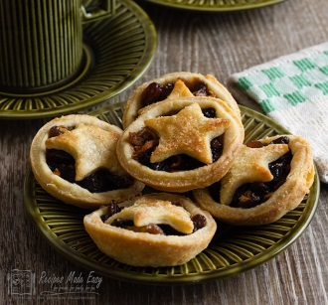  https://www.bbcgoodfood.com/recipes/mince-pies  When setting the table:  - Wash your hands  - Clean the table  - Decide which cutlery you will need and find the cutlery from the drawer  - Count out the people in your family - count out individually how many knifes/spoons/forks you will need  - Count out the mats and place them on the table with the cutlery  - Count how many drinks you will need for each family member and make the drinks. Maybe you could take an order for drinks? Like in a café.  - What else do you need for the table? Sauces/ spoons to serve food out etc  Making your meal  - Wash your hands  - Look at your recipe or chosen lunch  - Decide what items you will need to make it  - Find all the ingredients in your kitchen  - Find all the utensils you will need – knifes/chopping board/graters etc  - Make your chosen lunch with support from a family member  Once everyone has finished, don’t forget to wash up and clean the table!!
Monday pm | Enterprise  Use the internet to research Christmas decorations and make some decorations for your Christmas tree. You could use cupcake liners to make some trees and decorate them using stickers. Alternatively, you can make reindeers out of pine cones.  Have fun and use your imagination. | Ideas:  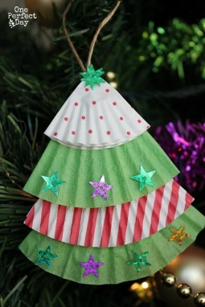  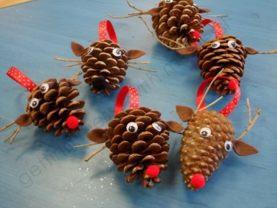
Tuesday am | Vocational – Recycling  Sort your families recycling into different sections (e.g plastic, tins, food, cardboard). Then place them in the correct bins.
Tuesday pm | Vocational Studies - Gardening  Spend some time in the garden, planting, digging or weeding. Fill up your bird seed feeders that you have made and the replenish the bird seed fat balls.
HAVE A LOVELY CHRISTMAS AND NEW YEAR

- Please refer to annual reviews for your child’s personalised targets.

We would love to see and hear about what you have been doing, feel free to email Beth and Emma in 6th form.

