6th form 2 Class - Monday and Tuesday
Weeks beginning: 16th & 23rd November 2020
Subject | Activity | Links
Monday am (week 1)  Monday am  (week 2 ) | Shop, Cook and Eat  Make yourself a healthy peach melba smoothie. Find all the food items needed and the utensils and make the snack with appropriate support. Tidy up, clean and wash up at the end of your snack.  Choose a simple meal to make for lunch (tuna and pasta bake). Find all the food items needed and the utensils and make the snack with appropriate support. Tidy up, clean and wash up at the end of your lunch. | https://www.bbcgoodfood.com/recipes/peach-melba-smoothie  When setting the table:  - Wash your hands  - Clean the table  - Decide which cutlery you will need and find the cutlery from the drawer  - Count out the people in your family - count out individually how many knifes/spoons/forks you will need  - Count out the mats and place them on the table with the cutlery  - Count how many drinks you will need for each family member and make the drinks. Maybe you could take an order for drinks? Like in a café.  - What else do you need for the table? Sauces/ spoons to serve food out etc  Making your meal  - Wash your hands  - Look at your recipe or chosen lunch  - Decide what items you will need to make it  - Find all the ingredients in your kitchen  - Find all the utensils you will need – knifes/chopping board/graters etc  - Make your chosen lunch with support from a family member  Once everyone has finished, don’t forget to wash up and clean the table!!
Monday pm  (week 1 )  Monday pm  (week 2) | Enterprise  Using an old jam jar, research festive images that you can draw/ paint on the glass.  Start to make your own Christmas lanterns for your family.  Place a tea light inside to create a beautiful Christmas glow. | Ideas:  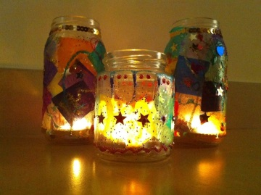  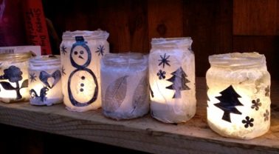
Tuesday am  (week 1)  Tuesday am  (week 2) | Vocational – Recycling  Sort your families recycling into different sections (e.g plastic, tins, food, cardboard). Then place them in the correct bins.  Continue to sort your families recycling into different sections (e.g plastic, tins, food, cardboard). Then place them in the correct bins.
Tuesday pm  (week 1)  Tuesday pm  (week 2) | Vocational Studies - Gardening  Spend some time in the garden, planting, digging or weeding or you could grow your own herbs in pots on your window sill and watch them grow.  Keep all the bugs in your garden warm and dry in the winter. Make them a bug hotel using old tin cans from your recycling. | Grow mint  https://www.youtube.com/watch?v=aqe1_2N4eRM  Bug hotel  https://www.youtube.com/watch?v=gwYObDIen1Q
- Please refer to annual reviews for your child’s personalised targets.

We would love to see and hear about what you have been doing, feel free to email Beth and Emma in 6th form.

