6th form 2 Class - Monday and Tuesday
Weeks beginning: 2nd & 9th November 2020
Subject | Activity | Links
Monday am (week 1)  Monday am  (week 2 ) | Shop, Cook and Eat  Choose a simple healthy snack – rainbow skewers. Find all the food items needed and the utensils and make the snack with appropriate support. Tidy up, clean and wash up at the end of your snack.  Choose another simple meal to make for lunch (spaghetti bolognese). Find all the food items needed and the utensils and make the snack with appropriate support. Tidy up, clean and wash up at the end of your lunch. | 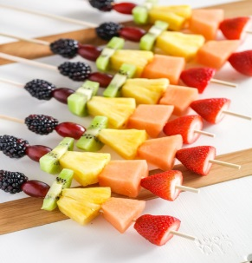  When setting the table:  - Wash your hands  - Clean the table  - Decide which cutlery you will need and find the cutlery from the drawer  - Count out the people in your family - count out individually how many knifes/spoons/forks you will need  - Count out the mats and place them on the table with the cutlery  - Count how many drinks you will need for each family member and make the drinks. Maybe you could take an order for drinks? Like in a café.  - What else do you need for the table? Sauces/ spoons to serve food out etc  Making your meal  - Wash your hands  - Look at your recipe or chosen lunch  - Decide what items you will need to make it  - Find all the ingredients in your kitchen  - Find all the utensils you will need – knifes/chopping board/graters etc  - Make your chosen lunch with support from a family member  Once everyone has finished, don’t forget to wash up and clean the table!!
Monday pm  (week 1 )  Monday pm  (week 2) | Enterprise  Research Christmas cards ideas on the internet. Choose 3 designs you might like to make for your family.  Start to make your own Christmas cards for your family. | Ideas:  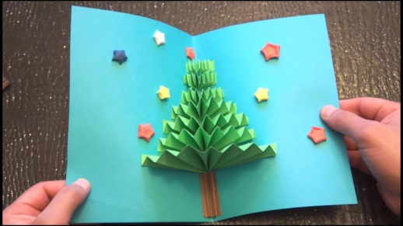  https://www.youtube.com/watch?v=OC8SoBSMvS4  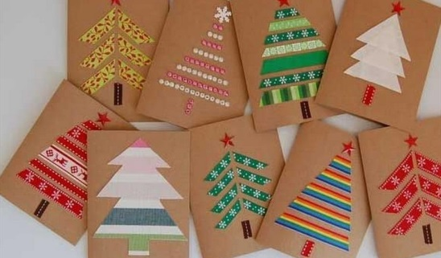
Tuesday am  (week 1)  Tuesday am  (week 2) | Vocational – Recycling  Sort your families recycling into different sections (e.g plastic, tins, food, cardboard). Then place them in the correct bins.  Continue to sort your families recycling into different sections (e.g plastic, tins, food, cardboard). Then place them in the correct bins.
Tuesday pm  (week 1)  Tuesday pm  (week 2) | Vocational Studies - Gardening  Spend some time in the garden, planting, digging or weeding or you could grow your own ‘Cress heads’ using recycled yogurt pots or egg shells. Decorate your yogurt pot/egg shell in any way you wish. Watch your cress grow!  Check on the cress you planted from last week. Using old recycled milk bottles, make a bird feeder (following the link). You can decorate it and hang it in your garden for our feathered friends. | Cress heads  https://www.youtube.com/watch?v=SZW5EIP8fVY  Bird feeders  https://www.youtube.com/watch?v=Patct5hdrDU
- Please refer to annual reviews for your child’s personalised targets.

We would love to see and hear about what you have been doing, feel free to email Beth and Emma in 6th form.

