6th Form One – Weekly Planner
Week Beginning 19th October 2020
Subject | Activity | Links
Monday am | Community Visit  Complete work sheet – what activities would you use Astbury Mere for. Make a spider diagram and record your ideas neatly all around the picture in the middle. Think of what we do when we go there and also of what we see other people doing there. Tyr and think of your own ideas before you look at the answer sheet!  Go outside in the garden.  Find natural items linked to autumn. Take photos of them, or make a list of what you have seen. Record your autumn hunt using photos or drawings, once you are back inside.
Monday pm | Enterprise  Look at the photos of different ideas for Halloween decorations. Decide on one or two you could make to decorate your house, or think of your own.  - Draw ghost shapes on white paper & cut them out. Draw spooky eyes and mouths on them. Use Sticky tape to attach them to string to make some spooky Halloween bunting to hang up.  - Save some tin cans. Make sure they are clean and dry. Paint them white and add spooky eyes and mouths on them. Cut white tissue paper into long strips. Stick these on the inside of the bottom of the tins. These can be made using cardboard tubes from toilet rolls of you don’t have any tins to use.  - Blow up some orange and white balloons. Use a black market pen to draw faces on them. Draw pumpkin lantern faces on the orange balloons and ghost faces on the white ones.  - Collect some smooth stones form the garden. Wash and dry them. Paint them white and let them dry. Use coloured market pens and draw one eye on each stone to make monster eyes.  - Collect empty milk cartons. Wash and dry them. Draw spooky faces on them. Cut a small hole in the back of the carton so you can out a battery tea light inside the carton.  You could search the internet for Halloween decorations you can buy, look at how much they cost and decide how much you could charge for your decorations. | 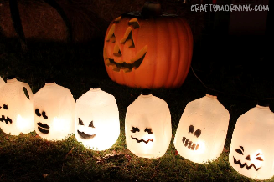  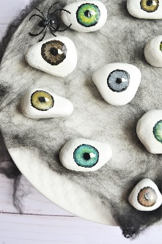  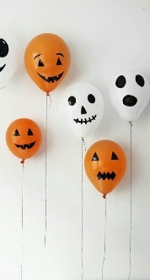  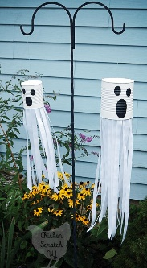  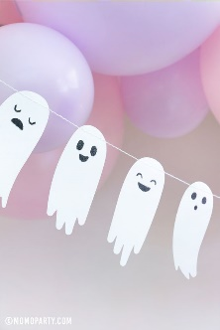
Tuesday am | Key Skills  English  Watch the video of the spooky story – ‘Too Much Candy’  Use the Narrative sheet to recall and write the story, remembering as much detail as you can. Think about your writing – finger spaces, capital letters and full stops.  Maths  Follow the recipe to make basic sponge cakes – make them as cupcakes – measure out the ingredients carefully and follow the sequence of the recipe in the right order. Once the cakes have cooked, using icing and decorations to make Halloween cupcakes. | Video story – Too Much candy  https://www.youtube.com/watch?v=400M0vtPcJ4
Tuesday  pm | Vocational Studies  Gardening  Get ready to work in the garden – put on warm clothing, boots and an old coat or overalls. Don’t forget to wear gardening gloves. Go outside and decide which jobs you are going to do – clear up leaves, dig over beds to clear weeds. Cut back any dead plants, ready for winter – check with Mum or Dad, before cutitng anything back. Make sure you follow the safety rules, handle tools carefully, move carefully around the garden, clear away any tools you have used when you have finished. Take photos of the jobs you have done or ask someone to take photos of you whilst you are working. Don’t forget to wash your hands with lots of soap when you have finished.
Wednesday am & pm | Recreation & Leisure  Physical activity – play ball games in the garden – kick/throw or push the ball to each other  Go on you trampoline & see how many jumps you can do  Put your favourite music on and dance around – rock it out!  Watch and follow Jo Wick’s fitness routine  Try some of the Cosmic Yoga for Kids sessions on YouTube  Use any of the Wii Fit/Dance games | This link will take you to a site where you can revisit all of Jo Wick’s PE sessions  https://www.t3.com/features/how-to-re-watch-joe-wicks-pe-lesson-on-youtube-april-7
Thursday am | Daily Living Skills  Plan and make your own meal for dinner. For example, fish fingers and oven chips, homemade pizza on a readymade pizza base, tuna pasta bake, bacon and eggs, pasta and bolognaise, sausages and mash, chicken nuggets, wedges and peas/corn  Plan your meal – List or select what ingredients you will need and collect or choose what equipment you will need e.g. chopping board, grater, knife, can opener  Can you remember what you need to do to make your meal? Try to be as independent as you can.  Remember to wash your hands with soap and put an apron on before starting to make your meal. Remember the safety rules when using any sharp/hot equipment.  Don’t forget to tidy up, wash up, dry and put away everything you have used when you have finished. Take a photo of what you have made or ask someone to take photos of you making your meal.
Thursday pm | PSHCE  Watch the video clip all about personal hygiene. Have a think about your personal care routines in the morning and in the evening. Can you remember what you need to do regularly to take care of your body? E.g. have a shower, wash your hair, clean your teeth, wash your hands, wash your face, shave etc  Use the symbols or write a list to record the activities you should do regularly and collect all the items you need to use for each task. E.g. wash your face – flannel and soap. Make sure you have the correct items for each activity. Ask someone to take a photograph of the items you use and if possible, print them out for you.  Use the symbols or your writing and record on one of the recording sheets. E.g. clean your teeth – toothbrush & toothpaste. There are three different recording sheets available to do this, an easier one, a slightly harder one and an even harder one. You can use the symbols and photos as they are, you can add your own writing to the pictures, or you can draw lines and write the answers down. | Video clip about personal hygiene:  https://www.youtube.com/watch?v=jQ2e0KH5WrI
Friday am | Art – you will need a pumpkin for this activity  Watch this video on how to carve a pumpkin lantern: https://www.youtube.com/watch?v=2AH--A8wcTc  Design the face you would like on your pumpkin and then cut the top off remove all the seeds and some of the pumpkin out of the inside. Once it is clean, you can start to cut the face out on your pumpkin. Be careful if using a sharp knife – you may want your Mum or Dad to cut the top off your pumpkin to begin with – it’s quite tricky to do. Once you have finished your pumpkin lantern, put a battery tea light, battery fairy lights or a small torch inside the lantern to make the face shine.
Friday pm | ICT  Compose an email with support to send Andrée photos/information on some of the activities you have been doing this week. Even if it something completely different from the planner, it doesn’t matter, she would love to see what you have been up to.
- Please refer to annual reviews for your child’s personalised targets.

We would love to see and hear about what you have been doing, feel free to email Andrée – abarnard@parklane.cheshire.sch.uk

