Activity Ideas for the weeks beginning 13 and 20 July
Hi everyone! What a strange time this continues to be. I hope you are all well and coping, despite the weather. I would like to wish you all the very best over the summer and look forward to seeing you in September. As usual, if you have any questions about the suggested activities, please feel free to email.
Phonics
It is very beneficial to reinforce the phonics sounds. You could make letters out of play dough or scatter some rice or sand into a tray and write the letter hand over hand.
https://www.youtube.com/watch?v=el-T1ygwZHE
If you would like some phonics sheets printed from Twinkl, please let me know.

Literacy
Over in the Meadow
Another lovely story with some counting.
https://www.youtube.com/watch?v=C6ljGXMMB-g
Songs: 5 little speckled frogs
https://www.youtube.com/watch?v=WSC-gHBU_d0
Here is the beehive
https://www.youtube.com/watch?v=V5Bs9xydba0
The bees go buzzing
https://www.youtube.com/watch?v=bWUgZm_AE64
You could make frogs, bees and a mouse. Please see separate attachments.

Numeracy
On/Under and Behind/ In front
Place a snack on an up-turned bowl/ cup, then say “on”. Repeat with under.
Ask student to put a snack on and under the bowl, then in their mouth
Put a favourite toy behind something and say “behind”
Ask student to take the toy. You could have a treasure hunt around the house/garden looking for favourite things.
By developing an understanding of prepositions our students are gaining an understanding of spatial concepts.

Songs: On, in, under, by
https://www.youtube.com/watch?v=DHb4-CCif7U
On, in, under song
This is good with signing
https://www.youtube.com/watch?v=3VwQrnA6dkY
Where is it?
https://www.youtube.com/watch?v=8F0NYBBKczM

Sensory
Fill balloons with different textured materials. You could draw happy and sad faces and talk about emotions.

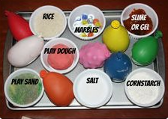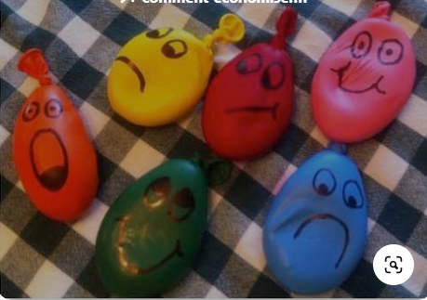
Have a great summer and take care!

