Lower 6th Form – Weekly Planner
Weeks Beginning 29th June & 6th July 2020
Subject | Activity | Links
Monday am | Community Visit  Go for a walk round your neighbourhood, to the park, or somewhere else nearby and/or go into your garden.  Use the scavenger hunt sheets and a phone/camera to take pictures of the different things on the lists.  To extend the activity, you could print your photos/selfies out and make a collage of your scavenger hunts.
Monday pm | Enterprise  Follow the symbol recipe to make ginger biscuits. Do this as independently as you can. Don’t forget to wash your hands before you start and to wear an apron. Also, remember to wash up and tidy up after yourself when you have finished.  See if your family would like to buy some biscuits.  This could be extended to include using the supermarket website to price up ingredients and work out how much you have spent using a calculator.  You could also work out how much you could make if you charged 50p for each biscuit, using calculator and compare this with how much you spent on the ingredients
Tuesday am | Key Skills  Maths  Following on from last week’s worksheets on weight, recap by completing the ordering by weight sheet, cutting out the pictures and deciding what order they would go in from lightest to heaviest. Explore using kitchen scales to weigh different items – use the sheet to record the weights. Complete the other sheets on reading scales if you can. If you go shopping, look for the weights of the things you buy. They may be in grams or kilograms – decide which is heavier. You could take photos of some of the regular packets & tins you buy, such as pasta, sugar, cereal, rice, flour, beans, soup etc and order them by weight, reading the weight on each item and deciding which is the lightest/heaviest etc – ask someone in your family to help you do this. Stick the pictures down in order and write the weight of each item underneath its photo.  English  - Practise filling in the personal information sheets from last week again and then try writing the new sheets on activities you like and ‘all about me’. See if you can answer some simple questions about what you like and what you don’t like. You could write lists of foods you like and foods you don’t, activities you enjoy and ones you don’t like, films you enjoy and places you like visiting etc. You could try asking different people in your family the same questions and ask them to help oyu record the answers.  - FaceTime/Zoom meet/House Party/Messenger call a family member or close friend. Listen carefully and respond appropriately to questions they ask you. Where appropriate, talk clearly/use signs or symbols to have a conversation with them.
Tuesday  pm | Vocational Studies  Café Skills  Take on the role of waiter/waitress or cook and invite you family to come to your café. Try doing a differetn role from the last time you did this. Ask one member of your family to help you by being either cook to your waiter/waitress, or waiter/waitress to your cook. Make a simple menu using pictures from the internet or your own drawings & labels. Take each person’s orders for drinks and snacks and go into the kitchen to make them. See if you can remember what to do and try to be as independent as you can. Remember to wash your hands and wear an apron before starting and remember and follow the safety rules when making hot drinks and toast.  Gardening  Watch the power point of gardeing jobs, to remind you of the different things you might do as a gardener. Make sure you are appropriateky dressed and wearing safe shoes/boots. Go out into the garden and decide which job you are going to do – digging, planting, weeding, watering, cutitng the grass, composting etc. make sure you wear gardening gloves before you start and hold and use gardening equipment safely. Make sure your hair is tied up if it is long and remember not to run in the garden. Either continue with jobs you have been doing, or try something new Take photos of the jobs you have done or ask someone to take photos of you whilst you are working. Don’t forget to wash your hands with lots of soap when you have finished. | Use this Café Role play pack if you want to  https://www.twinkl.co.uk/resource/t-t-1192-cafe-role-play-pack  Use this crop calendar to choose things to plant & grow  https://www.twinkl.co.uk/resource/sowing-schedule-crop-calendar-t2-t-10000479
Wednesday am & pm | Recreation & Leisure  Physical activity – play ball games in the garden – kick/throw or push the ball to each other  Go on you trampoline & see how many jumps you can do  Put your favourite music on and dance around – rock it out!  Go for a walk with your family  Go out in the garden on your scooter or take your scooter out when your family go out for their exercise – remember the road safety rules!  Use chalk to make a hop scotch on the path in the garden – see if your mum, dad or siblings will teach you how to play it – hop, step, jump or move into the number you have thrown/dropped the stone into.  Watch and follow Jo Wick’s fitness routine  Try some of the Cosmic Yoga for Kids sessions on YouTube  Use any of the Wii Fit/Dance games | This link will take you to a site where you can revisit all of Jo Wick’s PE sessions  https://www.t3.com/features/how-to-re-watch-joe-wicks-pe-lesson-on-youtube-april-7  This site has a video of how to set up and play hopscotch  https://learnenglishkids.britishcouncil.org/how-videos/how-play-hopscotch
Thursday am | Daily Living Skills  Plan and make your own meal for dinner. For example, fish fingers and oven chips, homemade pizza on a readymade pizza base, tuna pasta bake, bacon and eggs, pasta and bolognaise, sausages and mash, chicken nuggets, wedges and peas/corn  Plan your meal – List or select what ingredients you will need and collect or choose what equipment you will need e.g. chopping board, grater, knife, can opener  Can you remember what you need to do to make your meal? Try to be as independent as you can.  Remember to wash your hands with soap and put an apron on before starting to make your meal. Remember the safety rules when using any sharp/hot equipment.  Don’t forget to tidy up, wash up, dry and put away everything you have used when you have finished. Take a photo of what you have made or ask someone to take photos of you making your meal.
Thursday pm | PSHCE  My Community  The learning objective is to show that you can use local facilities and services. This includes post offices, leisure centres, churches, youth clubs, drama clubs, D of E activities etc. If you have/can get someone to take any photos of yourself using some of these, you can use them to record how you use these facilities. You could stick the photos down and write a sentence about what you are doing in the picture.  Another objective is to show you can use local shops. The same applies. If you have/can get photos of you using the supermarket or any other local shops, you can stick the photo down on a sheet and write about it or type text next to the photo on the computer.  The third objective is to show you can use local eating places such as cafes, restaurant and pubs. If you have photos of you in these places, possibly from family celebrations or parties, use these to record what you did e.g. ordering food or drinks, waiting for the order, enjoying a drink/snack/meal etc.
Friday am | Art  Make some bird feeders from discarded items such as a juice or milk carton, twigs, canes or wooden spoons, the inside of a toilet roll, an empty, plastic drinks bottle, pipe cleaners or wire. Look at the photos below to work out how to decorate and make the bird feeders and fill them with bird seed, cereal or fruit. Ask someone in your family to take photos of you making the item as well as the finished product hung up outside. See which birds visit you feeders – try and get photos of them.  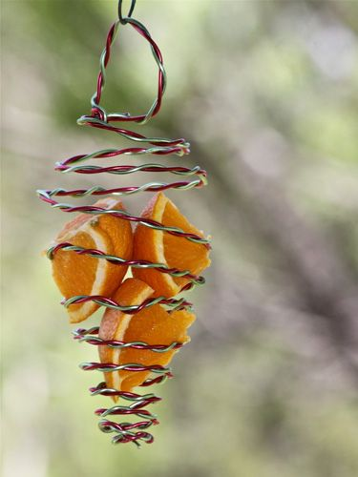  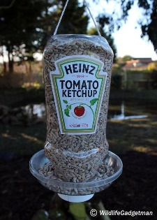  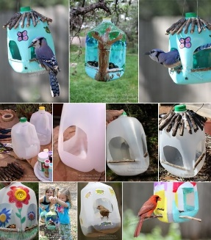  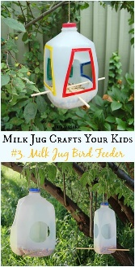  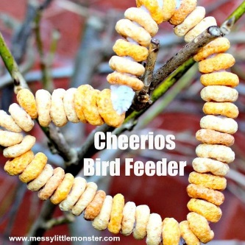  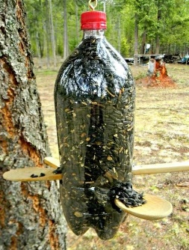  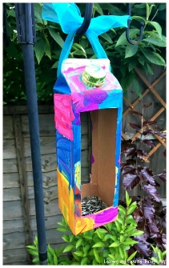
Friday pm | ICT  Record your personal information about likes and dislikes on the computer – insert photos and text into the recording sheet.  Compose an email with support to send Andrée photos/information on some of the activities you have been doing this week. Even if it something completely different from the planner, it doesn’t matter, she would love to see what you have been up to.  Use one of the free educational apps on the school Face Book page on your iPad. Let Andrée know how you’ve got on with it – ask someone to help you send an email about it.
- Please refer to annual reviews for your child’s personalised targets.

We would love to see and hear about what you have been doing, feel free to email Andrée – abarnard@parklane.cheshire.sch.uk

