Arighi Class
WK: & 29th June and 6th July 2020
Area | Activity | Links
English | Listen to the story of the Tiny seed on you tube  Sensory story version as PowerPoint as separate page on website  Try to recall some of the things that happened the seed on its journey.  Fill in the missing letters of the words that rhyme with seed ( see attached – scroll down )  complete the word search ( attached )  Reading & Phonics: – Reading books / Education City login  https://www.booktrust.org.uk/books-and-reading/have-some-fun/storybooks-and-games/  https://www.oxfordowl.co.uk/for-home/find-a-book/library-page/ | https://www.youtube.com/watch?v=ls6wTeT2cKA  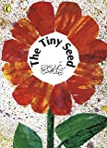
Maths | Find a dandelion clock seed head and blow the seeds off counting as you go one o clock two o’clock etc. How far did you get?  Dye some pumpkin seeds  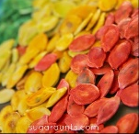  Sort into different colours  Make sets of 2 , 3, 4 and 5  Write out numbers to 10 , 20 or 30 on cards and match the number of seeds to each number  Guess or estimate how many pumpkin seeds you can fit on a teaspoon then count them. Did you make a good guess?  Try making pumpkin seed chocolate energy bars following the video on you tube  weigh and measure the ingredients and discuss what happens to the chocolate when it is heated in the microwave and what happens to the chocolate when you put it in the fridge | https://www.theottoolbox.com/how-to-dye-pumpkin-seeds-for-sensory  3 Ingredient Pumpkin Seed Chocolate Candy - Healthy and Easy  https://www.youtube.com/watch?v=rTOv3CwHQUg
Creativity | Make dandelion seed head pictures using cotton wool buds and toilet roll cardboard tubes  Add some seeds to homemade playdough to add different textures  sunflowers, poppy seeds etc ( see attached –i.e. scroll down for recipe) | https://www.youtube.com/watch?v=zz384I62s7U  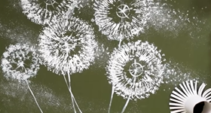  Toilet Paper Rolls Dandelion Q Tip Painting Technique | Easy Creative Art
Individuality | In the story the seed grows into a big flowering plant  An acorn grows into a mighty oak  Think about what you might want to be when you grow up  draw a picture of what you will look like when you are fully grown  Have a go at the Flower Power Peace Out  sing along to the Seed Song  make up some actions to go with the song | https://www.youtube.com/watch?v=wlsG4ZqHVDE  Flower Power | Guided Meditation for Kids | Peace Out  https://www.youtube.com/watch?v=7IcsyVVHHYc  The Seed Song ' from Out of the Ark Music @ Home (Words on Screen Lyric Video)
Community | visit a garden centre  look at the seeds and the plants  Can you identify any of the plants?  Go on a garden scavenger hunt.  Give yourself a reward if you find all the items on your list! | 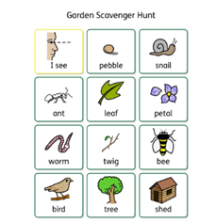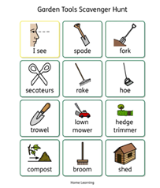
Challenge | watch the BBC Bitesize seed dispersal clip  Sprout your socks  You spread seeds with your feet when you go for a walk. To find out if you are  picking up seeds wear a large old sock over our shoe and try to get it  muddy. Go for a walk around hedges, woods and meadows and  get your socks muddy (if it is very dry, you might need to give the socks a spray with  water to help pick up the soil). When you finish the walk, take  the sock off your shoe (muddy side out!) and put it into a zip lock plastic bag.  Then give the sock a squirt of water to make it damp and seal the bag  up. When you get indoors again, tape the bag to a sunny window and check daily  to see the socks slowly sprout to life (this should take around a week).  Measure and count each  seedling as they appear. | https://www.bbc.co.uk/bitesize/topics/zxfrwmn/articles/z28dpbk
- Please refer to annual reviews for your child’s personalised targets.

I would love to see and hear about what you have been doing, feel free to email myself anytime – swright@parklane.cheshire.sch.uk
words with ee
n w j w f f f r h d  s y f f w e g m a i  o w h f u e x z l m  h y b f g t d d x m  g l h i t r e e g x  r s e e i n v a w c  e p e e l w a n e y  e m w s e e d e e p  n d i j v i p g d v  z m f n m j g n i f | weed  seed  feet  green  peel  tree  deep  see

Words with ee Add the missing letters

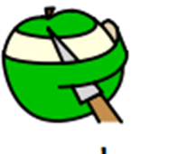
gr_ _ _ w_ _ _ s_ _ _ p_ _ _

b_ _ f_ _ _ tr_ _ d _ _ _

