Please do not print me!
Remember to print from page 2 to avoid wasting paper and ink.
If you do find me, then visit twinkl.co.uk to find out why milions of educators worldwide love twinkl.
A brief word about copyright...
By downloading this resource, you agree to the following:
You may use this resource for personal and /or classroom use only.
In order to support us, we ask that you always acknowledge www.twinkl.co.uk as the source of the resource. If you love these resources, why not let others know about Twinkl?
You must not reproduce or share this resource with others in any form. They are more than welcome to download the resource directly from us.
You must not host or in any other way share our resources directly with others, without our prior written permission.
We also ask that this product is not used for commercial purposes and also that you do not alter the digital versions of our products in any way.
Thank you for downloading!
Educational Publishing. Your first choice for easy to use, trusted and high quality teaching materials for educators and parents worldwide - professionally crafted materials with a personal touch. twinkl.co.uk
twinkl
Craft Instructions

Handprint Monkey
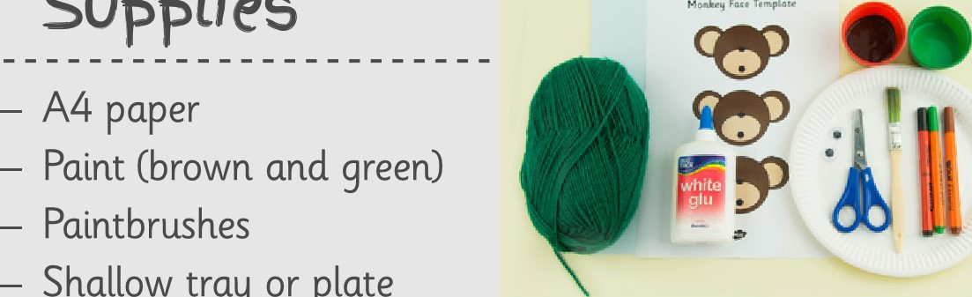
Supplies
Shallow
tray
or
plate

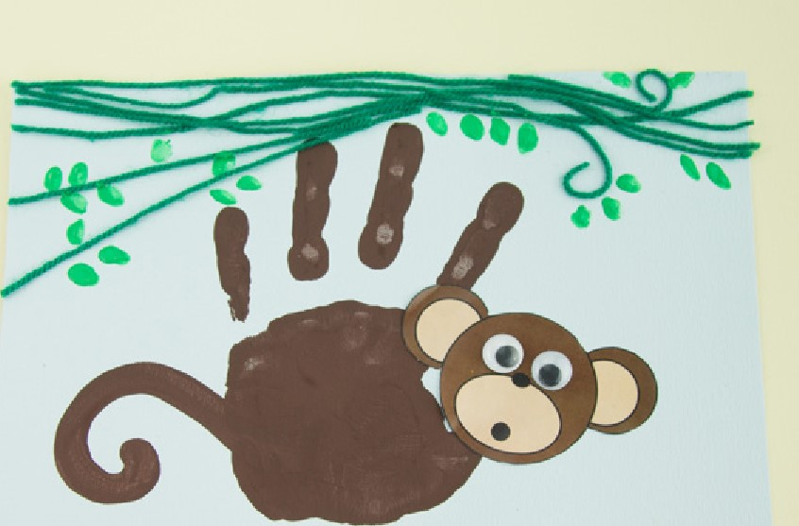
Scissors Googly eyes
Glue Felt-tip pens
Green wool Monkey face template
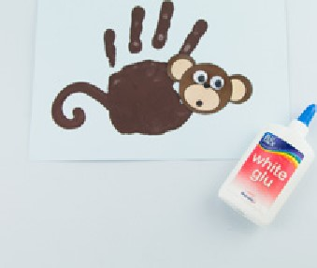
1 First, paint your hand using a5 Stick some googly eyes onto the brush and some paint or dtp yourmonkey's face. hand into a shallow tray/plate of paint. Next, gently press your hand onto the middle oj a piece oj paper. Remove your hand and allow the print to dry. Don't forget to wash your hands!
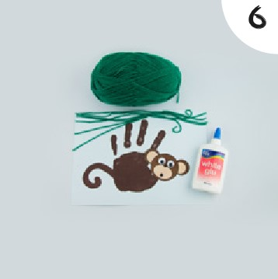
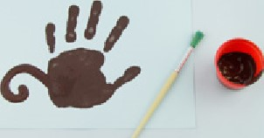
2 Carefully use a little more brown Next, put a little glue along the top paint to paint on a tail opposite to oj the page, near to your printed your thumbprint.fingers. Then lay some green wool onto the glue as vines for your monkey to climb!
3 If you have used the black and | 7 Once the glue is dry, dip a finger
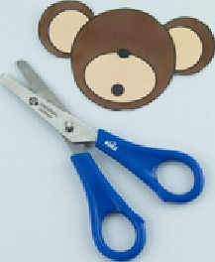
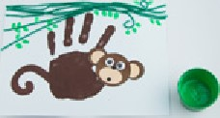
white version, you may wish to into some green paint and print colour or paint your monkey's facesome leaves along the woolly before carefully cutting out thevines. Leave to dry and wash your template.hands.
Once the handprint is dry, stick the monkey's head on top of your
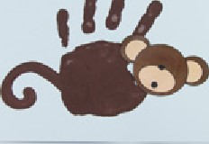
thumb. The monkey's legs (your printed fingers) should be at the top oj the page.
111
twinkl
Craft Instructions

Handprint Monkey
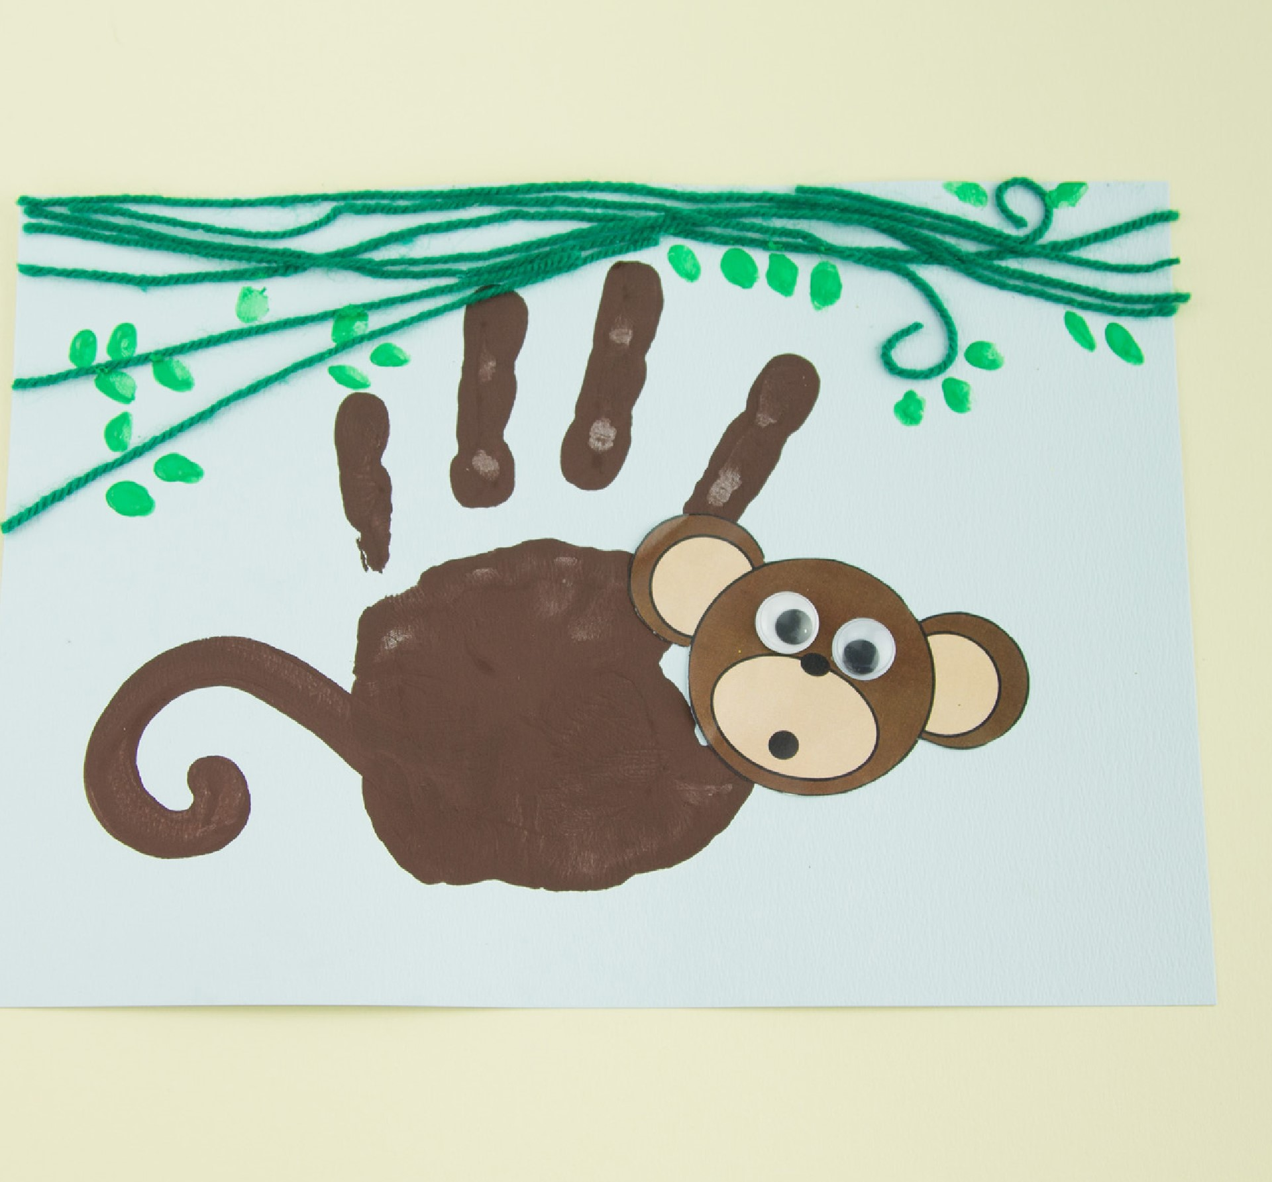

SUpp(ies
ALI paper | Googly eyes
Paint (brown and green) | Felt-tip pens
Paintbrushes | Monkey face template
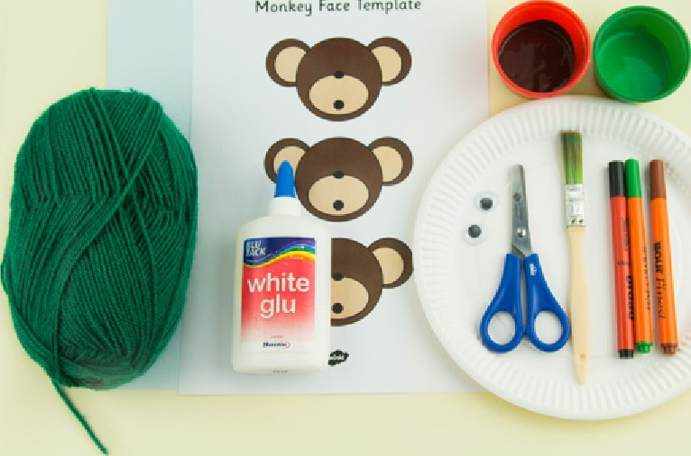
Shallow tray or plate
Template
Scissors
Glue
Green wool

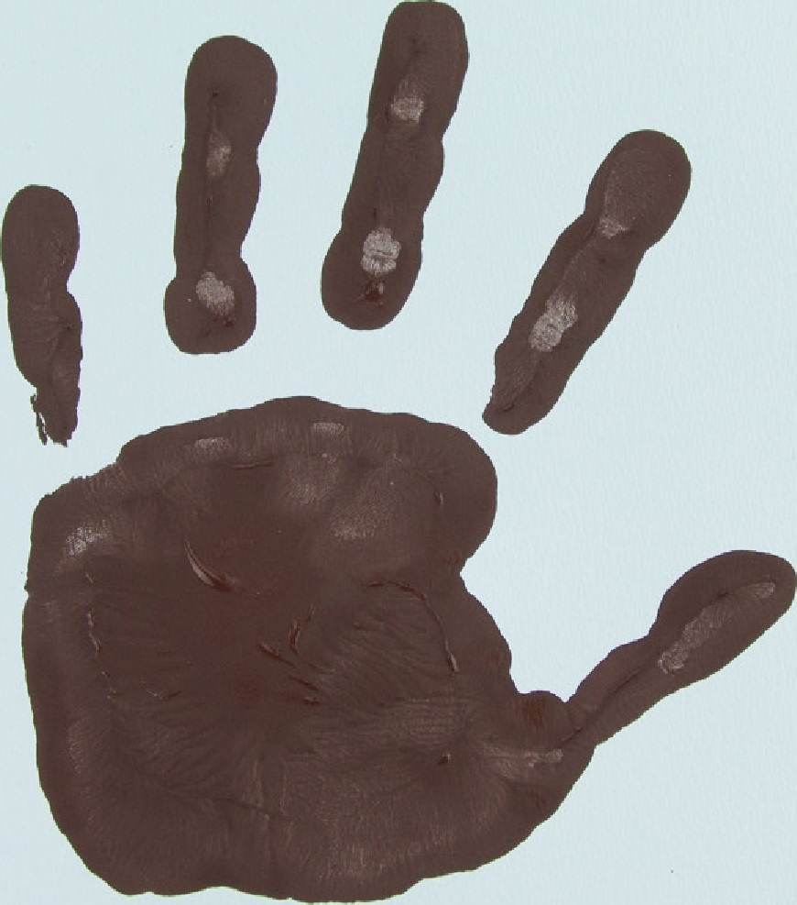
Step 1, First, paint your hand using a brush and some paint or dip your hand into a shallow tray/plate oj paint. Next, gently press your hand onto the middle of a piece of paper. Remove your hand and allow the print to dry. Don't forget to wash your hands!
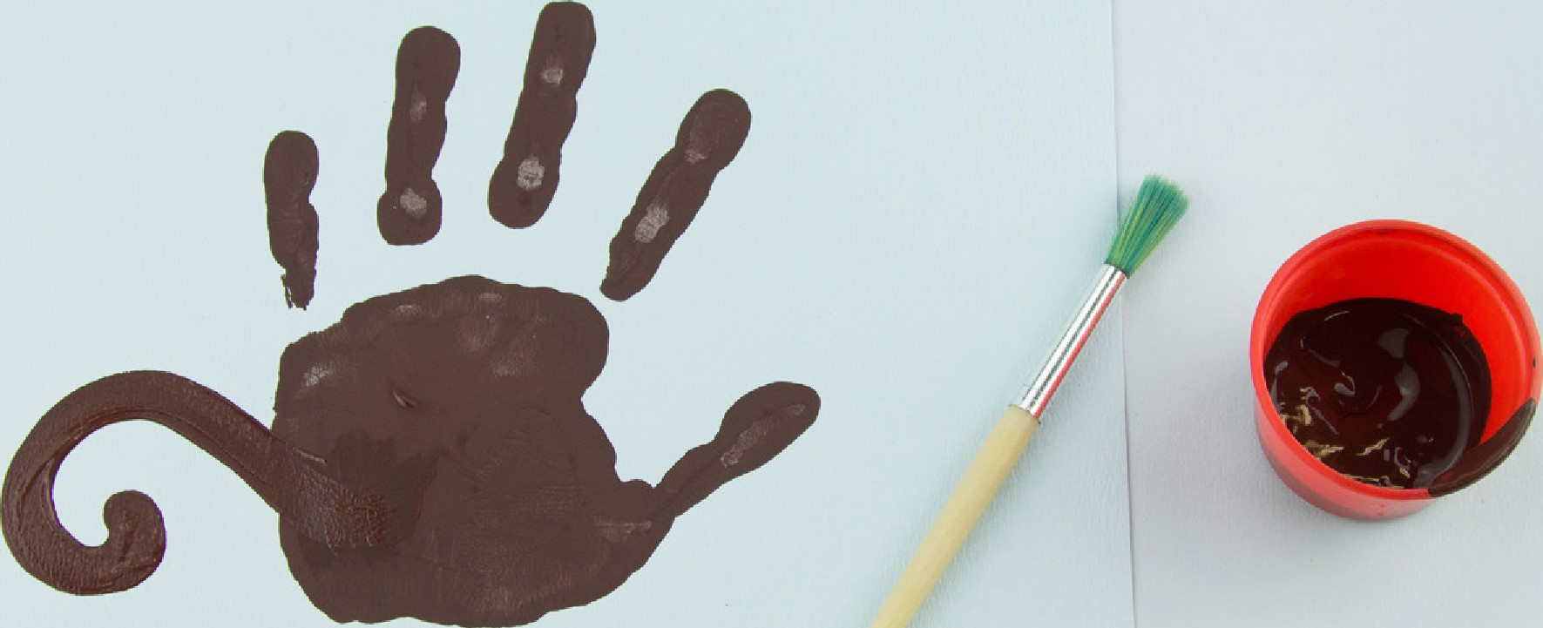
Step 2, Carefully use a little more brown paint to paint on a tail opposite to your thumbprint.
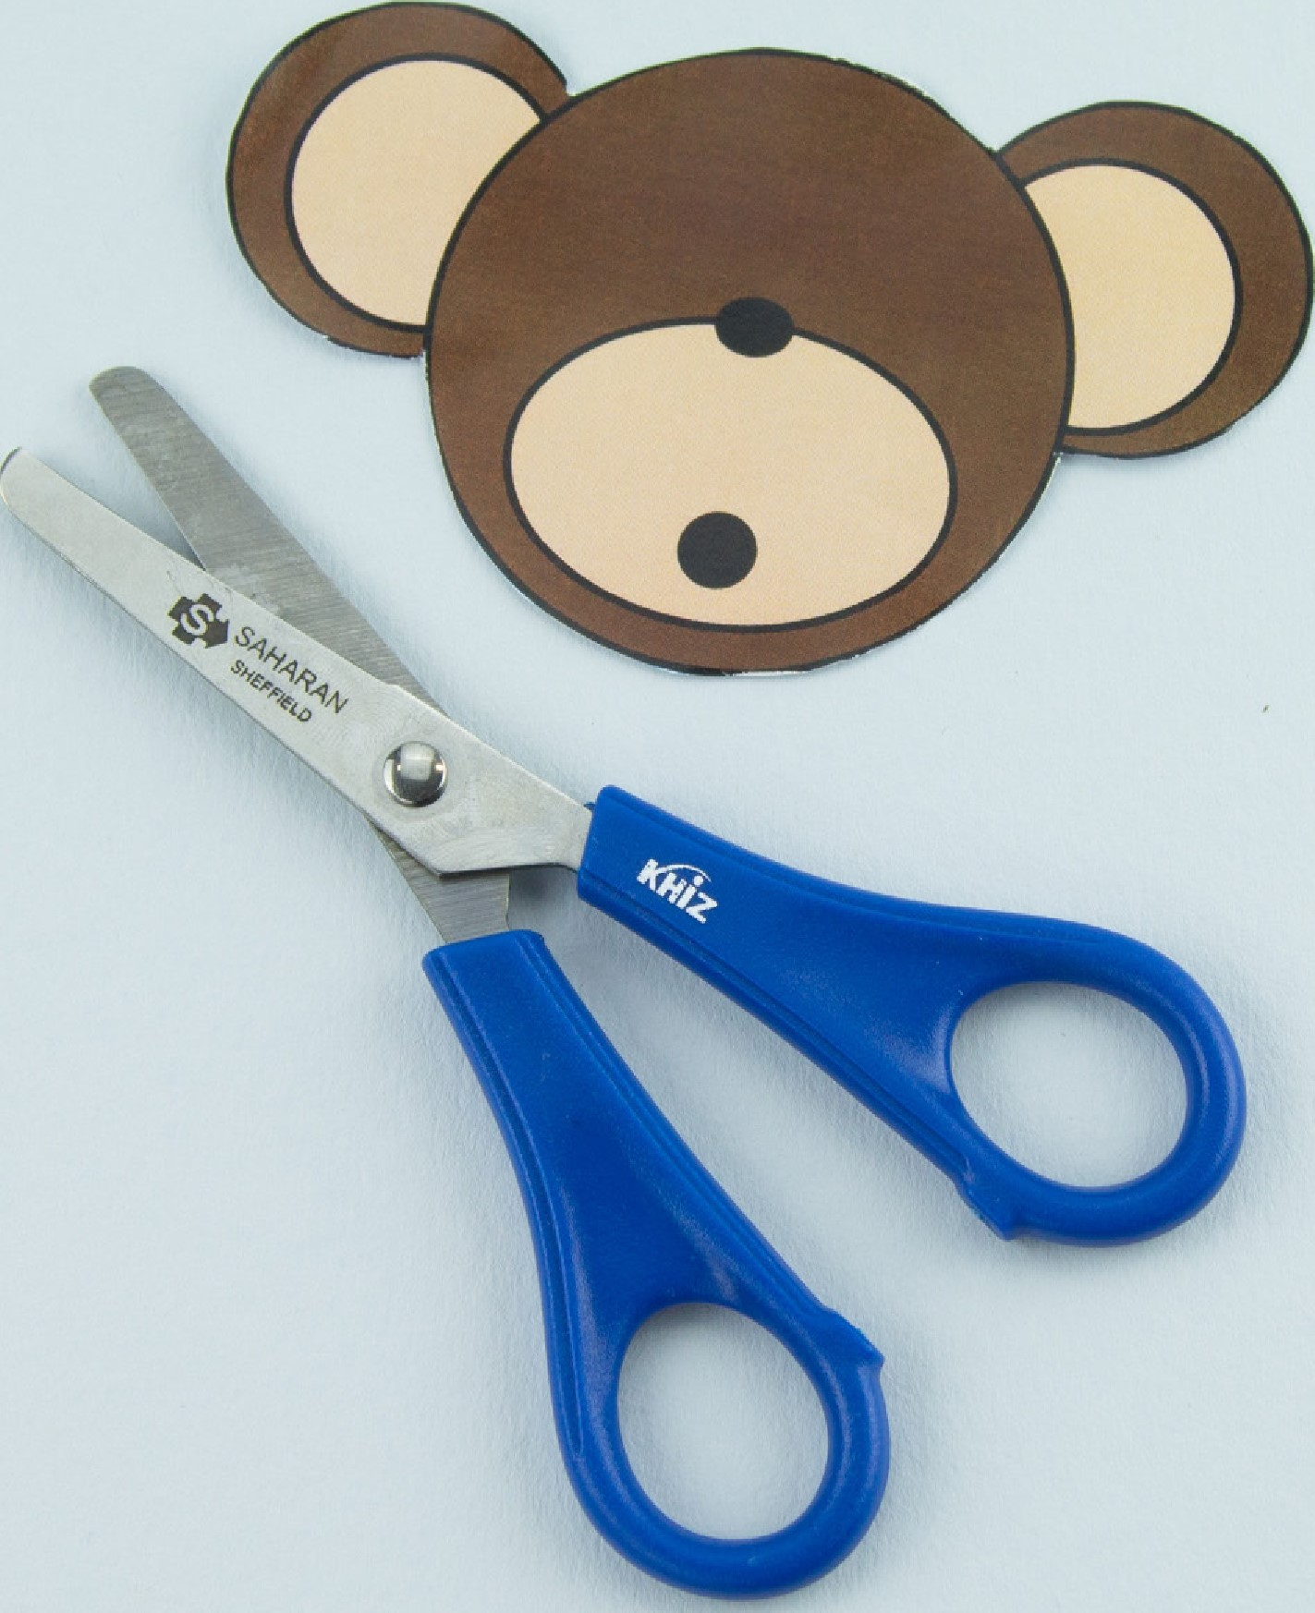
Step 3, If you have used the black and white version, you may wish to colour or paint your monkey's face before carefully cutting out the template.
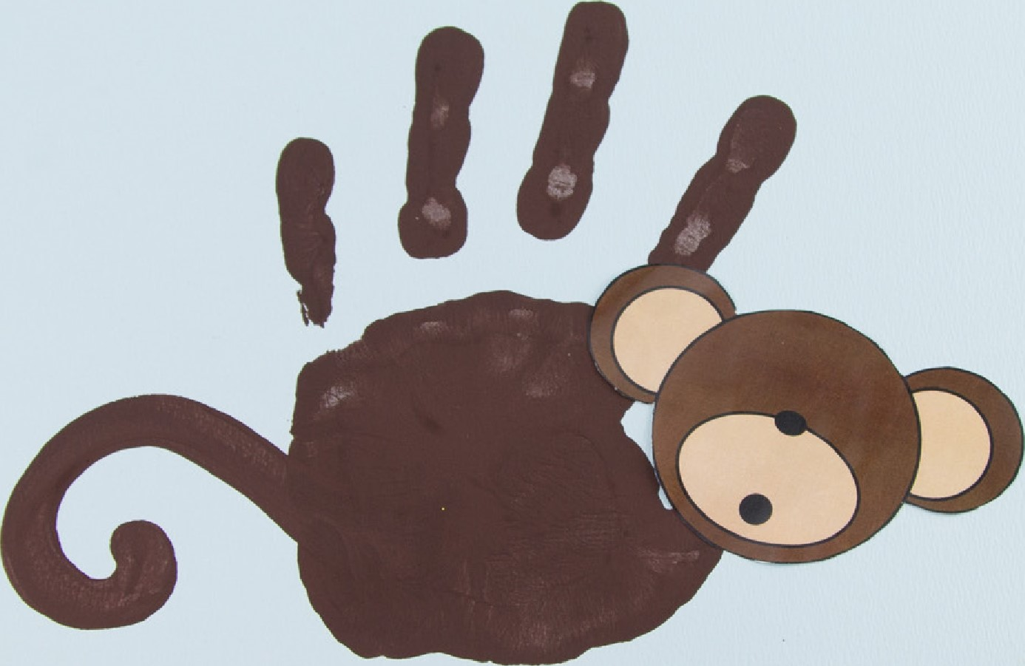

Step 9, Once the handprint is dry, stick the monkey's head on top oj your thumb. The monkey's legs (your printed fingers) should be at the top oj the page.
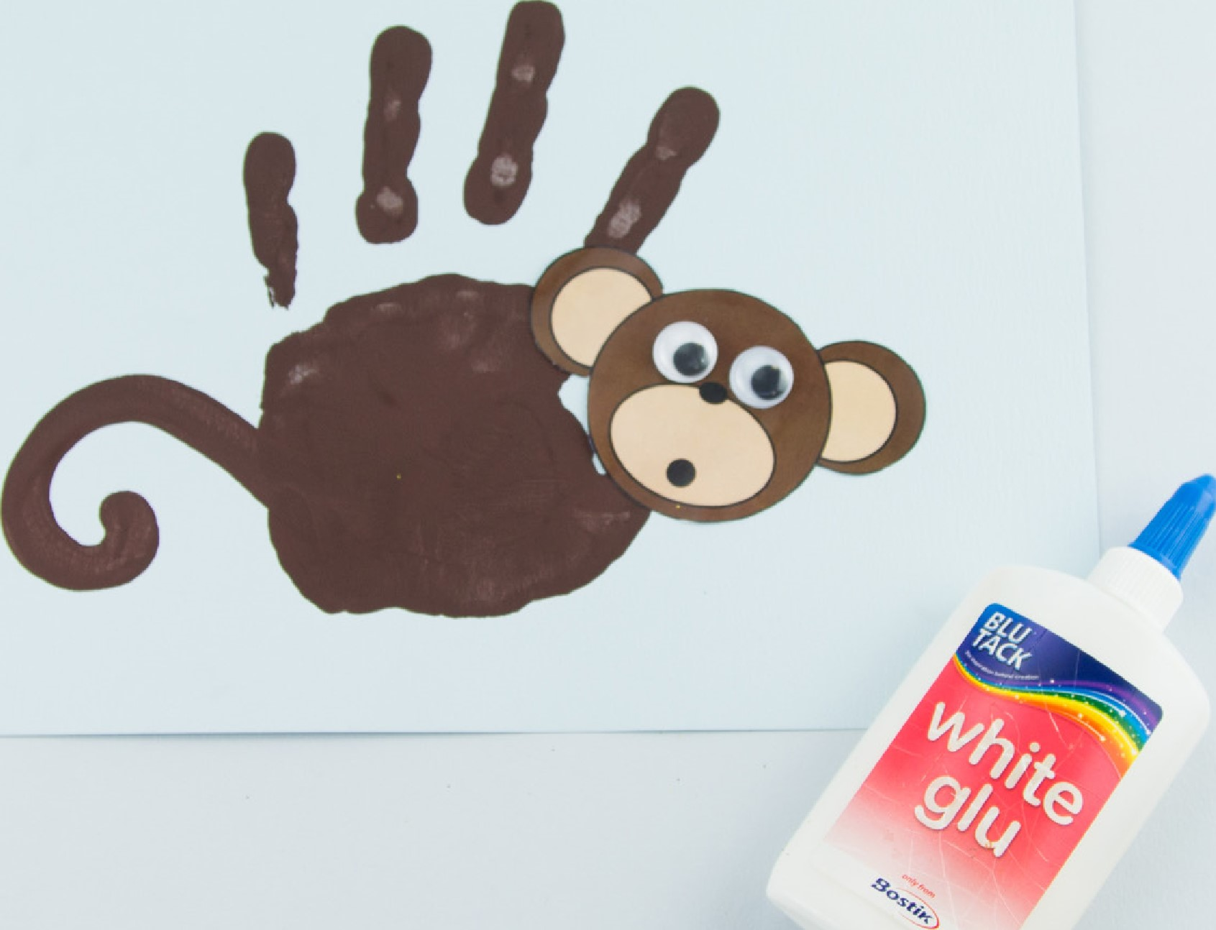
Step 5, Stick some googly eyes onto the monkey's face.
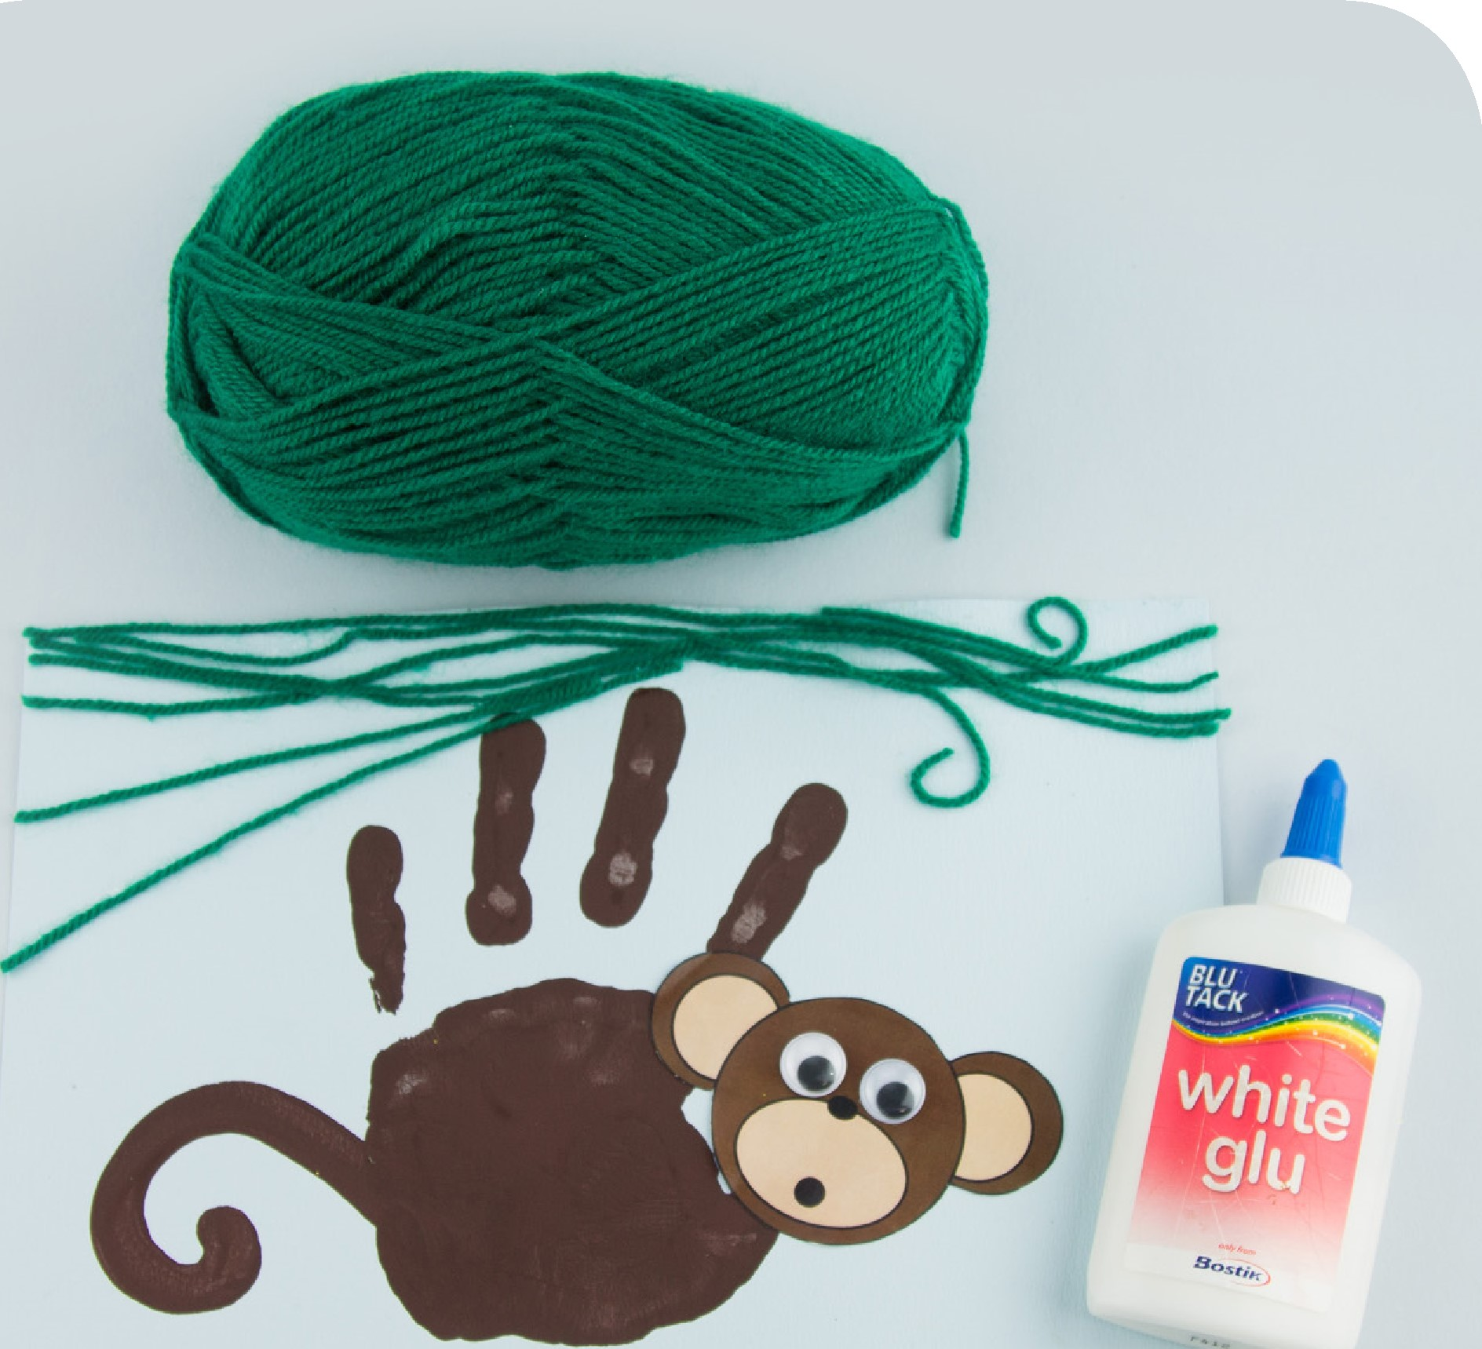
Step 6, Next, put a little glue along the top of the page, near to your printed fingers. Then lay some green wool onto the glue as vines for your monkey to climb!
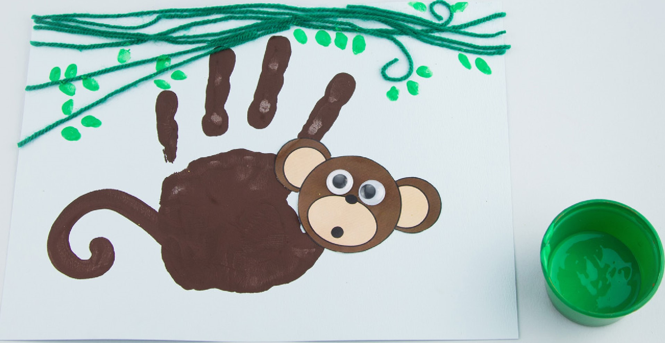
step Once the glue is dry, dip a finger into some green paint and print some leaves along the woolly vines. Leave to dry and wash your hands.

