Hovis Class
Week Beginning 22/06/2020 and 29/06/2020
Summer Term Topic – Living Things Focus- Plants
Area | Activity | Links
English | Story, song or rhyme: Choose a story to share either a physical book, or an interactive book available on Youtube or alternatively, if you are feeling energetic, you can choose a story from Cosmic Yoga- and complete the actions to each story you read. Ask students comprehension questions about each story- name/recognise characters, talk about events in the story, why events happened etc.  Reading & Phonics: – Reading books / Education City login for phonics songs and letter recognition activities.  Also use Letters and Sounds website to access online games for each phase.( Please contact me if you want specific games to play on or any resources making and I would be happy to do this.  Fine motor skills: Practice mark making, writing letters from your name or writing words of your choice. You could even make a diary of your what things you have been able to do at home, how you are feeling or any other thoughts or feelings. Work on fine motor skills activities such as threading, picking up items with tongs or tweezers, inset jigsaw puzzles, pegging out washing etc.  Communication: Learn the new Signalong signs. Practice signs on Signalong and Park Lane Facebook group/Website ( weekly stories) . Use any opportunity to make and confirm choices using personalised communication systems e.g making choices at playtimes, mealtimes, snacktimes etc. Work on Communication Targets outlined in Annual Reviews.  ( If you would like more specific targets or any resources for any section of the English work please let me know) | https://www.youtube.com/user/CosmicKidsYoga  https://www.vooks.com/  https://www.educationcity.com/  http://www.letters-and-sounds.com/  https://en-gb.facebook.com/signalongcharity/  https://en-gb.facebook.com/pages/category/Elementary-School/Park-Lane-Special-School-1641122062807137/
Maths | Number – Counting activities  Continue working on recognising numbers and counting numbers.  For recognising numbers you can use flashcards hidden around the room, place numbers under inset jigsaw pieces and every time you lift them up say the number you see, you can put numbers in a bag and say the number every time you pull one out.  Some lovely counting games and resources can be found on the link below  https://www.earlylearninghq.org.uk/numeracy/  You can also incorporate counting into cooking and everyday activities like making lunch- counting how many of each food item you have etc. Playing board games- counting the dots on the dice and counting how many spaces you are moving. Counting movements e.g how many star jumps can we do etc.  Measure- Role play playing ‘shops’ Set up a shop, it could be a toy shop or snack café- label each item with either a number, coin or price ( depending on the level of your child) – get the child to pay for what they want to buy  Repeat the following steps until the concept is grasped and then move on to the next one….  Start by asking them to hand over any amount of coins to get used the concept of transaction.  Then for the next step they should purchase by giving you the same coin as the one on the item, limit this to 2 or 3 coins at first then expand.  Then counting out the number of coins e.g six coins, 4 coins etc  Then extend by telling them which coin you need e.g find me a £1
Creativity | Go on a nature walk- collecting as many different leaves, twigs, pebbles and natural items as you can.  Leaf printing- Use some of the different leaves you have found to make some beautiful art work following the instructions on the link below  https://theimaginationtree.com/leaf-printing-art/  Use other leaves to make some leaf pictures – Sticking down the different shaped leaves and adding detail to create pictures. Have a look at the link below for some inspiration.  https://gr.pinterest.com/panothe/leaf-art/  Use some of the twigs you have collected to make your own artwork by gluing them on to card or into a shape- see pics below for inspiration  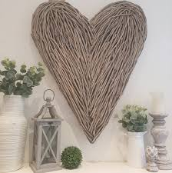  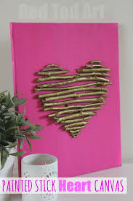  When you created your piece you could paint it in colour of your choice.  Can you try some pebble painting? Paint pebbles with bright colours and leave them around your garden or in the community.
Individuality | Independent living skills – developing independence in self dressing, helping out with jobs around the house e.g dusting, brushing etc  Work on independence in personal care routines ( See Annual reviews for up to date targets)  Take pictures and send them to me if you like, I have really enjoyed seeing the ones people have sent me so far.  I can produce certificates for all the hard work you are doing and send it via email or post
Community | In School we will be continuing to make cards and send them to our community.  This week we will be making cards for our NHS workers.  We will be looking at the role of doctors, nurses and all support staff in the hospital. Then will we make and design cards and send them out.  World Community Events  Look at The Dragon Boat Festival in China that was meant to take part on June 25th- information can be found on the link below  https://www.chinahighlights.com/festivals/dragon-boat-festival.htm  Have a go at making your own dragon boat- you can make it from whatever you like or follow the instructions below.  https://www.littlepassports.com/blog/craft-diy/diy-chinese-dragon-boat-activity-for-kids/  Throw your own festival and race your boat, you could do this in a paddling pool, the bath or a local stream or river if it is safe to do so. Have a picnic like they would at the boat festival, you may even want to try and make some Chinese food to eat at the picnic.
Challenge | Growing challenge  You can grow anything you like. You could grow cress seeds, carrot tops, herbs and design and make your own pot/tray for them to grow in. Take pictures of your items growing.  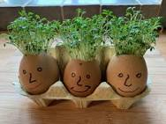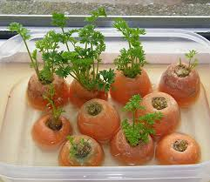  Play Dough Sculpture Challenge  Use Play Dough you already have or by making your own play dough using the link below.  https://www.bbcgoodfood.com/howto/guide/playdough-recipe  Try and make some plants or animal sculptures out of the playdough.  There are some ideas on the link below  https://www.pinterest.com/pin/479844535289474194/  Take pictures of your creations and add them to your scrapbook.  Science Challenge –  Can you find the best material for Incy Wincy Spiders Umberella. Use the link below  https://www.science-sparks.com/umbrellas-for-incy-wincy-spider/
- Please refer to annual reviews for your child’s personalised targets or ask me and I can provide more specific work

Please feel free to email me anytime if you have any questions, if you need any further support or if you want to send pictures or an email to update me on your progress. I would love to see what you are getting up to. My email address is lrashleigh@parklane.cheshire.sch.uk

