Lower 6th Form – Weekly Planner
Weeks Beginning 15th & 22nd June 2020
Subject | Activity | Links
Monday am | Community Visit  Go for a walk round your neighbourhood, to the park, or somewhere else nearby and/or go into your garden.  Use the scavenger hunt sheets and a phone/camera to take pictures of the different things on the list or selfies with different items.  To extend the activity, you could print your photos/selfies out and make a collage of your scavenger hunts.
Monday pm | Enterprise  Follow the symbol recipe to make flapjack. Do this as independently as you can. Don’t forget to wash your hands before you start and to wear an apron. Also, remember to wash up and tidy up after yourself when you have finished.  See if your family would like to buy some flapjacks.  This could be extended to include using the supermarket website to price up ingredients and work out how much you have spent using a calculator.  You could also work out how much you could make if you charged 20p for each scone, using calculator and compare this with how much you spent on the ingredients
Tuesday am | Key Skills  Maths  Following on from last week’s practical weighing activity, complete some of the worksheets on weight. Either; look at the pictures of objects and tick the one you think would be heavier; cut out and order pictures of everyday objects by weight (heaviest to lightest, in sets of three); cut out pictures and put them in the correct place on the recording sheet (balance scales) to show which would be heavier/lighter or the same and/or cut out pictures of objects and sort them into heavy or light sets on the recording sheets.  English  - Work on learning, remembering and recording personal information – use the writing sheets – there are easier and more complicated ones. Start by learning to communicate these details by talking to begin with e.g. role play an appointment or ordering a take away over the phone where you are asked details such as your name, address, age, date of birth, gender, telephone number etc. Work on remembering these details and start to practise writing them down – as if you were completing a form. If you are confident enough, see if you can use the phone to order a take away – make sure you know what food you are asking for e.g. what pizza topping you want, or Chinese dishes and use your recording sheets to prompt you when you have to give your name & address.  - FaceTime/Zoom meet/House Party/Messenger call a family member or close friend. Listen carefully and respond appropriately to questions they ask you. Where appropriate, talk clearly/use signs or symbols to have a conversation with them.
Tuesday  pm | Vocational Studies  Café Skills  Take on the role of waiter/waitress or cook and invite you family to come to your café. Try doing a differetn role from the last time you did this. Ask one member of your family to help you by being either cook to your waiter/waitress, or waiter/waitress to your cook. Make a simple menu using pictures from the internet or your own drawings & labels. Take each person’s orders for drinks and snacks and go into the kitchen to make them. See if you can remember what to do and try to be as independent as you can. Remember to wash your hands and wear an apron before starting and remember and follow the safety rules when making hot drinks and toast.  Gardening  Watch the power point of gardeing jobs, to remind you of the different things you might do as a gardener. Make sure you are appropriateky dressed and wearing safe shoes/boots. Go out into the garden and decide which job you are going to do – digging, planting, weeding, watering, cutitng the grass, composting etc. make sure you wear gardening gloves before you start and hold and use gardening equipment safely. Make sure your hair is tied up if it is long and remember not to run in the garden. Either continue with jobs you have been doing, or try something new Take photos of the jobs you have done or ask someone to take photos of you whilst you are working. Don’t forget to wash your hands with lots of soap when you have finished. | Use this Café Role play pack if you want to  https://www.twinkl.co.uk/resource/t-t-1192-cafe-role-play-pack  Use this crop calendar to choose things to plant & grow  https://www.twinkl.co.uk/resource/sowing-schedule-crop-calendar-t2-t-10000479
Wednesday am & pm | Recreation & Leisure  Physical activity – play ball games in the garden – kick/throw or push the ball to each other  Go on you trampoline & see how many jumps you can do  Put your favourite music on and dance around – rock it out!  Go for a walk with your family  Go out in the garden on your scooter or take your scooter out when your family go out for their exercise – remember the road safety rules!  Use chalk to make a hop scotch on the path in the garden – see if your mum, dad or siblings will teach you how to play it – hop, step, jump or move into the number you have thrown/dropped the stone into.  Watch and follow Jo Wick’s fitness routine  Try some of the Cosmic Yoga for Kids sessions on YouTube  Use any of the Wii Fit/Dance games | This link will take you to a site where you can revisit all of Jo Wick’s PE sessions  https://www.t3.com/features/how-to-re-watch-joe-wicks-pe-lesson-on-youtube-april-7  This site has a video of how to set up and play hopscotch  https://learnenglishkids.britishcouncil.org/how-videos/how-play-hopscotch
Thursday am | Daily Living Skills  Plan and make your own meal for dinner. For example, fish fingers and oven chips, homemade pizza on a readymade pizza base, tuna pasta bake, bacon and eggs, pasta and bolognaise, sausages and mash, chicken nuggets, wedges and peas/corn  Plan your meal – List or select what ingredients you will need and collect or choose what equipment you will need e.g. chopping board, grater, knife, can opener  Can you remember what you need to do to make your meal? Try to be as independent as you can.  Remember to wash your hands with soap and put an apron on before starting to make your meal. Remember the safety rules when using any sharp/hot equipment.  Don’t forget to tidy up, wash up, dry and put away everything you have used when you have finished. Take a photo of what you have made or ask someone to take photos of you making your meal.
Thursday pm | PSHCE  My Community  Use the spider diagram you made last week and on separate sheets, record what you do in each of the groups – you can use the Narrative Strategy writing sheets to record each group if you want to. You can use your own writing and/or use photographs of the activities to do – these can be actual photos of you doing the activities, or you can search for pictures on the internet of the activities you do e.g. go out for a meal with your family, attend services at church, go riding at the stables, play games/listen to music/play at youth club, sing/perform at drama club etc
Friday am | Art  Make a Father’s Day card for your Dad/Grandad/Uncle. Use a photo of yourself or your Dad/Grandad/Uncle and use pens, paint or collage materials to decorate round the outside of the photo. Don’t forget to write a greeting inside the card and write you name in it.  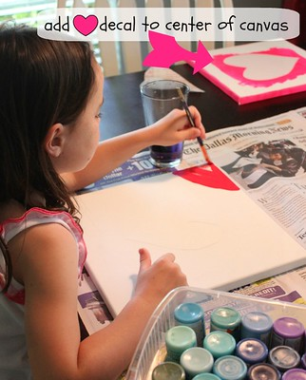  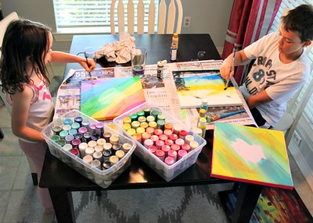  Make a new picture/set of pictures for you bedroom wall. Use stiff card or even small canvases (available in The Works). Decide the colour scheme – bright colours, pastel colours or themed to match the colours of your room. Decide the shapes for the centre of your pictures – something you like e.g. heart shapes, football/sports shapes, animal shapes, leaf/flower shapes etc. Ask your family to help you draw and cut out simple shapes from card and stick these into the middle of the stiff card/canvases using masking tape rolled back on itself underneath the shape – make sure the tape rolls are near the edges of the shape so paint doesn’t get underneath the shapes. Use the colours you have chosen to paint a design or pattern over the card/canvases and when completed & dry, remove the shapes, leaving a shape in the middle of your pictures. You can use a sponge to apply the paint to prevent paint leaking under the shapes.
Friday pm | ICT  Use the internet to search for, save and print photos of the different groups you belong to, including school. Save photos of the activities you have been involved in – you may even find pictures of yourself on the school Facebook page. Use the pictures in your PSHCE work on the different groups you belong to.  Compose an email with support to send Andrée photos/information on some of the activities you have been doing this week. Even if it something completely different from the planner, it doesn’t matter, she would love to see what you have been up to.  Use one of the free educational apps on the school Face Book page on your iPad. Let Andrée know how you’ve got on with it – ask someone to help you send an email about it.
- Please refer to annual reviews for your child’s personalised targets.

We would love to see and hear about what you have been doing, feel free to email Andrée – abarnard@parklane.cheshire.sch.uk

