[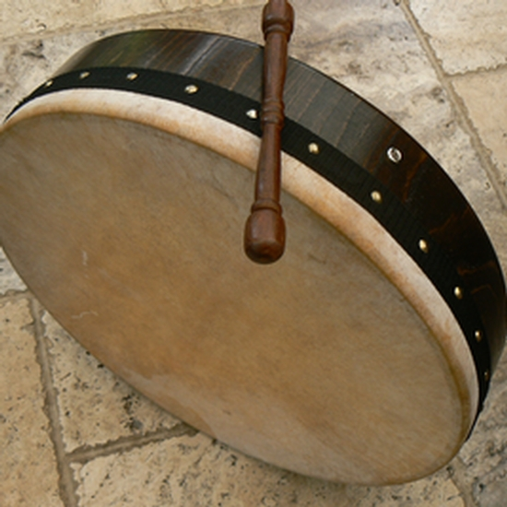](http://www.google.co.uk/url?sa=i&rct=j&q=&esrc=s&frm=1&source=images&cd=&cad=rja&docid=f_3c2uck11mSWM&tbnid=m98-cTXWhiIXWM:&ved=0CAUQjRw&url=http://fandalism.com/rpdrummer&ei=DwtLUpmHC4Ol0AWRgYH4BQ&psig=AFQjCNH-IamzwCJuXW-vofWm35w-rsFZ-Q&ust=1380736109348269)

[](http://www.google.co.uk/url?sa=i&source=images&cd=&cad=rja&docid=6SvTEE4OIRxUKM&tbnid=NcltvOmiHUatkM:&ved=0CAgQjRwwAA&url=http://runningonaraisin.blogspot.com/2013_01_01_archive.html&ei=sQpLUtHzOKmY0QXuvoGwBQ&psig=AFQjCNGAG7zoxYm2FVTwvKITVrPeBn4k9g&ust=1380736049976633)

[](http://www.google.co.uk/url?sa=i&rct=j&q=&esrc=s&frm=1&source=images&cd=&cad=rja&docid=hWnJcG_XXct_BM&tbnid=0rFlJ4qIb-xT8M:&ved=0CAUQjRw&url=http://www.theflagshop.co.uk/ireland-tri-colour-flag-8ft-x-5ft-369-p.asp&ei=MwtLUrP9FMyS1AWghoHoBA&psig=AFQjCNHQSZWAsjveu3Q2ocrHJrOdDpNB_w&ust=1380736174084158)

[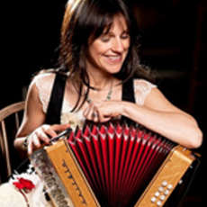](http://www.google.co.uk/url?sa=i&rct=j&q=&esrc=s&frm=1&source=images&cd=&cad=rja&docid=LAmsdwaX8aV2TM&tbnid=o2Lv9r1pUy6j0M:&ved=0CAUQjRw&url=http://livebrum.co.uk/2011/10/23/sharon-shannon-eleanor-mcevoy&ei=2QtLUtSEI4Kl0wXLtoHYCQ&psig=AFQjCNG2iGWqXlTi4TaaRXbkbyCQ3UPFhA&ust=1380736261585666)

[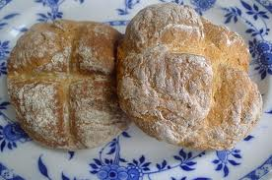](http://www.google.co.uk/url?sa=i&rct=j&q=&esrc=s&frm=1&source=images&cd=&cad=rja&docid=aK8Uox3YMk1SmM&tbnid=6rBN6cDUAkBkzM:&ved=0CAUQjRw&url=http://www.bakewithmaria.com/2011/11/06/soda-bread-by-amy/&ei=9gxLUpz0Eqr40gWa-oHQBA&psig=AFQjCNE98aimSOKG6f1GkMwT0WJCgpaJlg&ust=1380736609204234)

[](http://www.google.co.uk/url?sa=i&rct=j&q=&esrc=s&frm=1&source=images&cd=&cad=rja&docid=yARbFoBBKOY6tM&tbnid=VVxD40AANX1iwM:&ved=0CAUQjRw&url=http://depositphotos.com/6578078/stock-illustration-Illustration-of-St.-Patricks-Day-leprechaun.html&ei=CAxLUt79GeWW0QWIiIDwDQ&psig=AFQjCNH5s9XSKlPHhlIRJPqbAPt9AZY9QA&ust=1380736384127190)

[](http://www.google.co.uk/url?sa=i&rct=j&q=&esrc=s&frm=1&source=images&cd=&cad=rja&docid=JDOz1cBoNjdguM&tbnid=HdLXwnpogZ8w5M:&ved=0CAUQjRw&url=http%3A%2F%2Fwww.soundstagedirect.com%2Fvan-morrison-brown-eyed-girl-2lps-vinyl-records.shtml&ei=np9OUqTeIsyVswbM64HwAg&bvm=bv.53537100,d.Yms&psig=AFQjCNGeZkheY_e7B6AT2xK_O7-228Os0Q&ust=1380970778848566)

[](http://www.google.co.uk/url?sa=i&rct=j&q=&esrc=s&frm=1&source=images&cd=&cad=rja&docid=jFsFWkRs4p4u8M&tbnid=VoWdoLC_ofzbZM:&ved=0CAUQjRw&url=http://www.sparksunderland.com/magazine/2010/12/too-cool-for-christmas-the-festive-songs-we-need-to-hear/&ei=Ag5LUvG9Domn0wWDmIHoBw&psig=AFQjCNFpxtD_VLPJauh0RiejHIkexoifOw&ust=1380736879351055)

[](http://www.google.co.uk/url?sa=i&rct=j&q=&esrc=s&frm=1&source=images&cd=&cad=rja&docid=laS66FX68TKKhM&tbnid=ihuKDWEVsq3SrM:&ved=0CAUQjRw&url=http://cercledeseleves.e-monsite.com/pages/mes-pages/river-dance.html&ei=VA1LUprNF4KU0AXQu4HgBQ&psig=AFQjCNED8uOshWS0lpZ6fVkYxATb4WqhuQ&ust=1380736702420842)

Ireland

__________

Ireland

__________

Ireland

__________

[](http://www.google.co.uk/url?sa=i&rct=j&q=&esrc=s&frm=1&source=images&cd=&cad=rja&docid=36RFh_mSX7E9AM&tbnid=tsAQ7xGfjQI7sM:&ved=0CAUQjRw&url=http://jobspapa.com/countries-and-flags-page.html&ei=VFlqUrD8BOO80QXziIG4DQ&bvm=bv.55123115,d.d2k&psig=AFQjCNGj922ocfNIOZIv9JCGR_vmDl4w4A&ust=1382787792411616)

[](http://www.google.co.uk/url?sa=i&rct=j&q=&esrc=s&frm=1&source=images&cd=&cad=rja&docid=hWnJcG_XXct_BM&tbnid=0rFlJ4qIb-xT8M:&ved=0CAUQjRw&url=http%3A%2F%2Fwww.theflagshop.co.uk%2Fireland-tri-colour-flag-8ft-x-5ft-369-p.asp&ei=_hRLUvj8B8ml0QXH6IGgBQ&bvm=bv.53371865,d.d2k&psig=AFQjCNHVl5Ee2dnwj6q6_x1ieaN2fnaWlg&ust=1380738656033857)

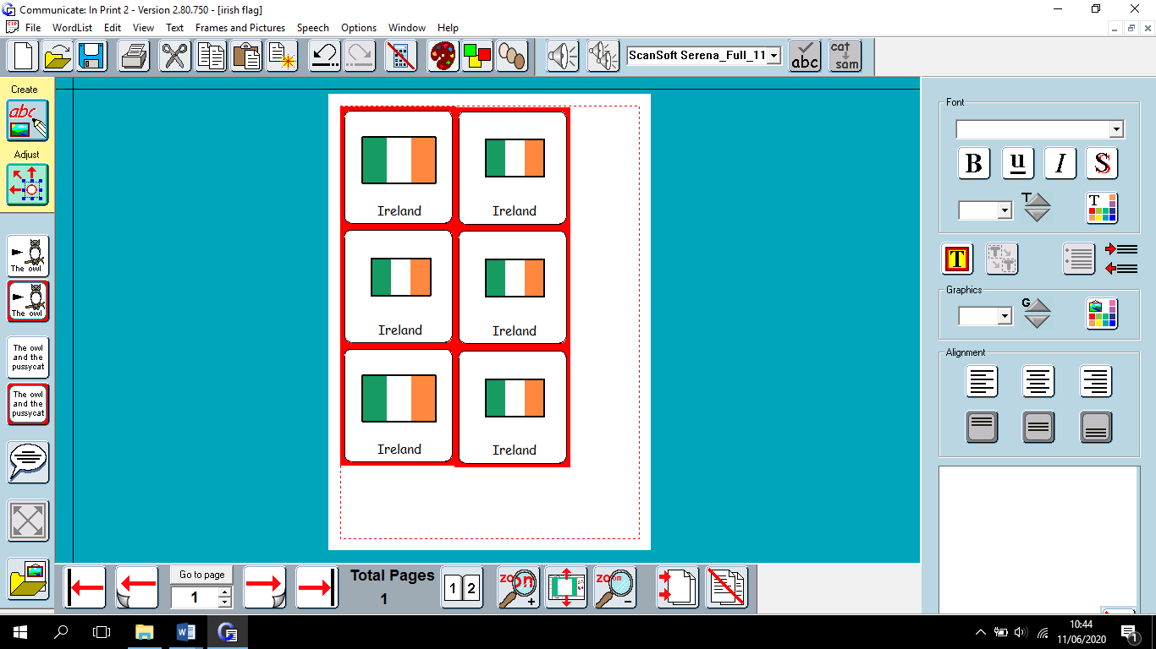



Leprechaun Coloring Pages

