Upper 6th Form
WK: 15th June & 22nd June 2020
Area | Activity | Links
PE/ Healthy Living  (Weekly) | 1. Go for a walk/cycle.  2. Take part in on online fitness session. Joe wicks  3.Fitness work out using household objects  4. Complete the yoga session. See link  5.I have also attached some virtual sports challenges sent to me from our local SSCO (schools sports coordinator)  6.Learn a tiktok dance/ or create your own  7. Go for a walk/picnic and complete the picnic spotting sheet  8. Garden mini beast hunt.  (Recording sheets on distance learning page) | Yoga link  https://www.youtube.com/watch?v=ho9uttOZdOQ  https://www.thrillist.com/home/10-ways-you-can-use-household-objects-to-work-out-diy-home-gym  https://www.kidsyogastories.com/kids-yoga-poses/  Compass point challenge  https://www.youtube.com/watch?v=90IuC7CAp8M&feature=youtu.be  See information sheet on class distance learning page  Tri golf challenge  See information on class distance learning page  Volley Ball challenge  See information on class distance learning page  Handball challenge  See information on class distance learning page  Orienteering challenge and resources  See information on class distance learning page  https://www.youtube.com/watch?v=uCLfS61R9pE
Cookery/Daily living skills | Take part in a cookery session. Pasta salad for your picnic.  Make your own wraps for a picnic lunch. Choose your own fillings. Use the symbols provided to help you.  Making ice-cream/ ice lollies for the hot sunny days  Make summer pudding  Fruit chocolate fondue  Help around the house. Helping to wash and dry up, dusting, hoovering, making your own bed etc. | Pasta salad for your picnic.  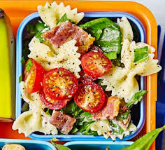  E.g. BLT pasta salad  https://www.bbcgoodfood.com/recipes/blt-pasta-salad  Other examples of lunchbox recipes  https://www.bbcgoodfood.com/recipes/collection/lunchbox  https://www.bbcgoodfood.com/recipes/collection/wrap  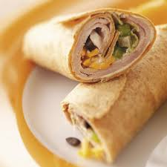  https://www.youtube.com/watch?v=N4ztYjFxwmI  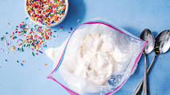  https://www.bbcgoodfood.com/recipes/collection/ice-lolly  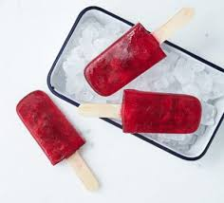  https://www.bbcgoodfood.com/recipes/classic-summer-pudding  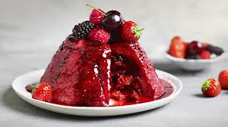  https://www.bbcgoodfood.com/recipes/fruity-fondue
Vocational Studies | Vocational – Recycling  Sort your families recycling into different sections (e.g. plastic, tins, food, and cardboard). Then place them in the correct bins.
Countries and Cultures | This term the class will also be learning about Ireland. Here are some things you could do. (See separate Ireland file for work sheets)  - Make soda bread  - Other Irish traditional food  - Listen to and watch video of the Irish national anthem  - Look at other traditional Irish things. (See Power point)  - Find and add Irish flag to the map of Great Britain  - Colour a template of the Irish flag (see Ireland File)  - Watch clips from River dance  - Leprechaun colouring page | https://www.bbcgoodfood.com/recipes/simple-soda-bread  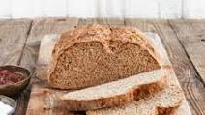  https://www.bbcgoodfood.com/recipes/collection/irish  https://www.youtube.com/watch?v=W2rRzvsZJfM  https://www.youtube.com/watch?v=w0v_pu6miJ8
Community  Community visit | Look at photographs, name friends & family members;  Go for a walk around your local area/ park. Return to your garden and enjoy the picnic lunch you made for yourself.  These are some of the places we hope to visit at some point this term.  Find photos and some information about these places.  - Buxton Town and pavilion gardens  - Bramhall Hall and park  - Fernillee Reservoir  - The Goyt Valley  - Rudyard lake  - Carsington Waters | Carsington Waters Buxton  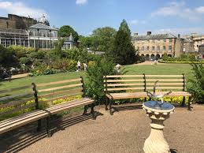  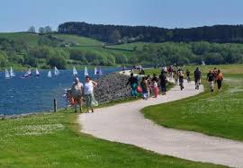
Art and  Extra | Watch and measure the sunflowers growth. Continue to Plot the growth of each sunflower on a homemade Sunflower design-measuring chart and a recording table.  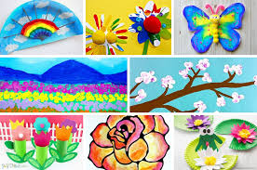  Spring Art ideas  Summer artwork | 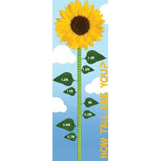  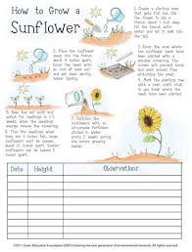  https://www.google.com/search?q=sunflower+measuring+chart  https://www.projectswithkids.com/spring-art-projects/  https://www.pinterest.co.uk/kidssteamlab/spring-art-projects-for-kids/  https://www.pinterest.co.uk/danettefos/summer-art-ideas/
- Please refer to annual reviews for your child’s personalised targets.

I would love to see and hear about what you have been doing, feel free to email myself anytime – eshaw@parklane,cheshire.sch.uk

