Ideas for Granelli class pupils for the weeks beginning 01.06.20 and 08.06.20

Hi there,
I hope you and your families are all continuing to stay healthy during these tricky times. At least the weather has been wonderful! Here are some more suggested activities/songs you could try at home with the pupils. It is entirely up to you, as usual there is no pressure to do them. These ideas are merely a suggestion. The topic for this summer term is Animals.
Songs

Literacy
Read Noah’s Ark
Cartoon story (10mins)
https://www.youtube.com/watch?v=_vjjhMWJ2wE

You could try to make hand print animals: animal handprints
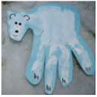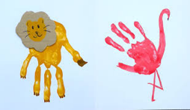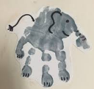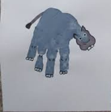
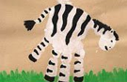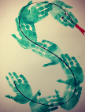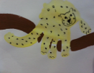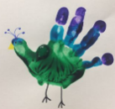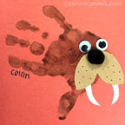

Songs:
The Ark song: https://www.youtube.com/watch?v=C5uVhsXqyc0
The animals went in two by two: https://www.youtube.com/watch?v=0mrbhsusOGM
Alphabet Animals: https://www.youtube.com/watch?v=_Wp0vZnR_FM
You could use the Play dough mat ideas
Phonics
As before the best thing to do is to continue to reinforce the following sounds: satpinmdgockeurhbfljvwx and the tricky words: I, to, go, into, the, no, he, she
Songs: Jolly Phonics action song
https://www.youtube.com/watch?v=1Qpn2839Kro
Tricky words song: https://www.youtube.com/watch?v=TvMyssfAUx0

Another suggestion is: https://www.youtube.com/watch?v=xg4_gWt8N_Q

Maths 2D shapes
Have fun finishing the pictures on the mats by making different shapes from
playdough. Encourage your child to look at the properties of the shapes
they are making. Do they have any vertices (corners)? Are their sides straight
or curved? How many sides do they have? You could also look for similarities and differences between the shapes together.

Try colouring the shapes different colours.

Have fun and stay safe! Any questions feel free to email and ask!

jfrench@parklane.cheshire.sch.uk

