Lower 6th Form – Weekly Planner
Weeks Beginning 1st & 8th June 2020
Subject | Activity | Links
Monday am | Community Visit  Go for a walk round your neighbourhood, to the park, or somewhere else nearby  Use the scavenger hunt sheet to find different things you might see on your walk.  Use the back garden scavenger hunt to find different things in your own garden
Monday pm | Enterprise  Follow the symbol recipe to make scones. Do this as independently as you can. Don’t forget to wash your hands before you start and to wear an apron. Also, remember to wash up and tidy up after yourself when you have finished.  See if your family would like to buy some scones.  This could be extended to include using the supermarket website to price up ingredients and work out how much you have spent using a calculator.  You could also work out how much you could make if you charged 25p for each scone, using calculator and compare this with how much you spent on the ingredients
Tuesday am | Key Skills  Maths  Use tins and packets from the cupboard, your own toys, books and games and see if you can compare two similar items, which are different in weight and say which is the heavier or lighter of the two. You could compare a thinner and a thicker book, which are of similar size, a full and half-empty packet of cereal, a full and half-full bottle of juice, a box of cards and a box of dominoes etc.  Write heavier and lighter labels or use the symbols to label each item and then use kitchen scales to find out if you were right – if you have balance scales you could compare the two items against each other on the scales.  You can extend this activity to include drawing each item and writing its weight in grams next to it, once you have weighed it on the scales.  English  - Watch a simple video clip or read/listen to a simple story. Can you retell the story using the Narrative Strategy/ Recall the facts, ‘When?’, ‘Where?’, ‘Who?’, ‘What happened?’ & ‘The end’ to help you retell the story. Once you have answered these questions and verbally retold the story, try to write the main facts of the story using the Narrative Strategy recording sheet. There are suggested video clips and picture symbols to go with them or you can watch something else and record with your own writing.  - FaceTime/Zoom meet/House Party/Messenger call a family member or close friend. Listen carefully and respond appropriately to questions they ask you. Where appropriate, talk clearly/use signs or symbols to have a conversation with them. | Video clip about a cat and a box:  https://www.youtube.com/watch?v=spvJJPqza6k  https://www.youtube.com/watch?v=TbiedguhyvM  Video clip about a dog with a stick:  https://www.youtube.com/watch?v=9azHYsMlaOM  https://www.youtube.com/watch?v=e-ADmee9u6U
Tuesday  pm | Vocational Studies  Café Skills  Take on the role of waiter/waitress or cook and invite you family to come to your café. Try doing a differetn role from the last time you did this. Ask one member of your family to help you by being either cook to your waiter/waitress, or waiter/waitress to your cook. Make a simple menu using pictures from the internet or your own drawings & labels. Take each person’s orders for drinks and snacks and go into the kitchen to make them. See if you can remember what to do and try to be as independent as you can. Remember to wash your hands and wear an apron before starting and remember and follow the safety rules when making hot drinks and toast.  Gardening  Watch the power point of gardeing jobs, to remind you of the different things you might do as a gardener. Make sure you are appropriateky dressed and wearing safe shoes/boots. Go out into the garden and decide which job you are going to do – digging, planting, weeding, watering, cutitng the grass, composting etc. make sure you wear gardening gloves before you start and hold and use gardening equipment safely. Make sure your hair is tied up if it is long and remember not to run in the garden. Either continue with jobs you have been doing, or try something new Take photos of the jobs you have done or ask someone to take photos of you whilst you are working. Don’t forget to wash your hands with lots of soap when you have finished. | Use this Café Role play pack if you want to  https://www.twinkl.co.uk/resource/t-t-1192-cafe-role-play-pack  Use this crop calendar to choose things to plant & grow  https://www.twinkl.co.uk/resource/sowing-schedule-crop-calendar-t2-t-10000479
Wednesday am & pm | Recreation & Leisure  Physical activity – play ball games in the garden – kick/throw or push the ball to each other  Go on you trampoline & see how many jumps you can do  Put your favourite music on and dance around – rock it out!  Go for a walk with your family  Go out in the garden on your scooter or take your scooter out when your family go out for their exercise – remember the road safety rules!  Use chalk to make a hop scotch on the path in the garden – see if your mum, dad or siblings will teach you how to play it – hop, step, jump or move into the number you have thrown/dropped the stone into.  Watch and follow Jo Wick’s fitness routine  Try some of the Cosmic Yoga for Kids sessions on YouTube  Use any of the Wii Fit/Dance games | This link will take you to a site where you can revisit all of Jo Wick’s PE sessions  https://www.t3.com/features/how-to-re-watch-joe-wicks-pe-lesson-on-youtube-april-7  This site has a video of how to set up and play hopscotch  https://learnenglishkids.britishcouncil.org/how-videos/how-play-hopscotch
Thursday am | Daily Living Skills  Plan and make your own meal for dinner. For example, fish fingers and oven chips, homemade pizza on a readymade pizza base, tuna pasta bake, bacon and eggs, pasta and bolognaise, sausages and mash, chicken nuggets, wedges and peas/corn  Plan your meal – List or select what ingredients you will need and collect or choose what equipment you will need e.g. chopping board, grater, knife, can opener  Can you remember what you need to do to make your meal? Try to be as independent as you can.  Remember to wash your hands with soap and put an apron on before starting to make your meal. Remember the safety rules when using any sharp/hot equipment.  Don’t forget to tidy up, wash up, dry and put away everything you have used when you have finished. Take a photo of what you have made or ask someone to take photos of you making your meal.
Thursday pm | PSHCE  My Community  Think about the different groups you belong to, e.g. your family, youth club, dance club, drama club, church, riding stables, school, the 6th Form etc. See if you can find photos or search for images of each of these.  Make a spider diagram showing all the different groups you belong to – use drawings, your own writing or photos to record you and all the groups you belong to
Friday am | Art  Make a Father’s Day card for your Dad/Grandad/Uncle. Use a photo of yourself or your Dad/Grandad/Uncle and use pens, paint or collage materials to decorate round the outside of the photo. Don’t forget to write a greeting inside the card and write you name in it.  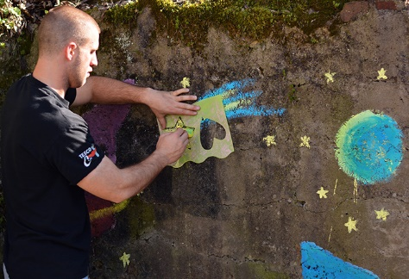  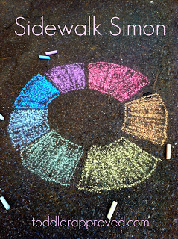  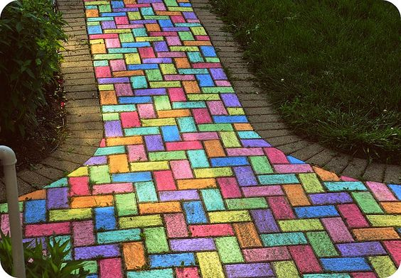  Use chalks and make some art work in your garden or driveway. You could do a rainbow, a picture of yourself or just create patterns and colours. Ideas for chalk art: use a stencil to make shapes on a wall, colour in blocks of colour (or bricks) and find natural things of the same colour to match to them, make blocks of colours in a circle and stand in the middle to play a ‘step on this colour’ game – you could do a dance like this if the colours were shouted out quite quickly or use the bricks on the drive or a wall to help you create a colourful pattern.  Take photos of your chalk art once it is finished and then use the garden hose or a watering can/water pistol to spray water on the chalk – see what happens to your art work.
Friday pm | ICT  Look at photos of yourself on the screen (phone, iPad, computer or TV) doing any of the activities during the week. Share these with your family – look at them, talk about them and choose symbols or say how you feel about them.  Compose an email with support to send Andrée photos/information on some of the activities you have been doing this week. Even if it something completely different from the planner, it doesn’t matter, she would love to see what you have been up to.  Use one of the free educational apps on the school Face Book page on your iPad. Let Andrée know how you’ve got on with it – ask someone to help you send an email about it.
- Please refer to annual reviews for your child’s personalised targets.

We would love to see and hear about what you have been doing, feel free to email Andrée – abarnard@parklane.cheshire.sch.uk

