Upper 6th Class - Monday and Tuesday
Weeks beginning: 1st & 8th June 2020
Subject | Activity | Links /Resources
Monday am (week 1)  Monday am  (week 2 ) | Shop, Cook and Eat  Choose a simple meal to make for lunch/dinner (pie/slice and beans). Find all the food items needed and the utensils and make the snack with appropriate support. Tidy up, clean and wash up at the end of your lunch. Work on independence skills from the previous week.  Choose a more challenging meal to make for lunch/dinner (spaghetti bolognese). Find all the food items needed and the utensils and make the snack with appropriate support. Tidy up, clean and wash up at the end of your lunch. Work on independence skills from the previous week. | When setting the table:  - Wash your hands  - Clean the table  - Decide which cutlery you will need and find the cutlery from the drawer  - Count out the people in your family - count out individually how many knifes/spoons/forks you will need  - Count out the mats and place them on the table with the cutlery  - Count how many drinks you will need for each family member and make the drinks. Maybe you could take an order for drinks? Like in a café.  - What else do you need for the table? Sauces/ spoons to serve food out etc  Making your meal  - Wash your hands  - Look at your recipe or chosen lunch  - Decide what items you will need to make it  - Find all the ingredients in your kitchen  - Find all the utensils you will need – knifes/chopping board/graters etc  - Make your chosen lunch with support from a family member  Once everyone has finished, don’t forget to wash up and clean the table!!
Monday pm  (week 1 )  Monday pm  (week 2) | Enterprise  Continue to help and work in your garden, planting, digging, weeding or watering your plants. We have had a very dry few weeks, so the plants will need plenty of water. Continue to fill up your bird feeders. You can also place a dish of water out for the birds and see if they visit for a drink and a wash.  From your household recycling, find the items needed to make a bug hotel for your garden. Follow the link to learn how to put all the items together. Once it’s complete, place it in your garden to encourage all the bugs to their new home. | https://www.youtube.com/watch?v=OexxoXo9uFk
Tuesday am  (week 1)  Tuesday am  (week 2) | Vocational – Recycling  Sort your families recycling into different sections (e.g plastic, tins, food, cardboard). Then place them in the correct bins.  Continue to sort your families recycling into different sections (e.g plastic, tins, food, cardboard). Then place them in the correct bins.
Tuesday pm  (week 1)  Tuesday pm  (week 2) | Gym /Sensory  Gym – Continue to practice your own fitness regime that you designed. Encourage your family to join in and see how your stamina is improving. Remember to warm down and stretch after your work out.  Sensory – Sensory boxes.  Find a plastic box. Collect lots of interesting items that you can place in the box. Fill the box with different solutions /textures each time, place your hands in the box and find the items.  e.g 1 . Sand 2.Shaving foam 3.Washing up liquid and water /bubble bath 4.Shredded paper 5. Gravel  Gym –Follow the Go Noodle link for lots of fun songs and exercises.  https://www.gonoodle.com/  Sensory –It’s the Queens birthday on June 16th . With support, explore different textures and smells and make a cake to celebrate. You could make a sponge cake, cupcakes or even simpler, some flapjacks or rice krispie cakes. Which ever you prefer. Enjoy afternoon tea in the garden to celebrate. | 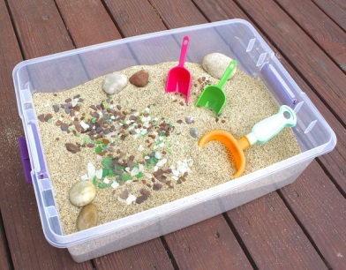  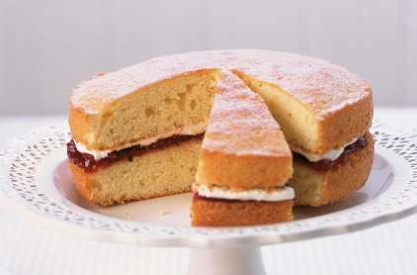
- Please refer to annual reviews for your child’s personalised targets.

We would love to see and hear about what you have been doing, feel free to email Beth and Emma – upper6th@parklane.cheshire.sch.uk

