Ideas for Granelli class pupils for the week beginning 18.05.20

Hi there,
I hope you and your families are all continuing to stay healthy during these tricky times. Here are some more suggested activities/songs you could try at home with the pupils. It is entirely up to you, as usual there is no pressure to do them. These ideas are merely a suggestion. The topic for this summer term is Animals.
Songs
- Alice the Camel
- How much is that doggy in the window?
- The hungry caterpillar song: https://www.youtube.com/watch?v=_tUBBh4QzTU

Literacy
Read The Very Hungry Caterpillar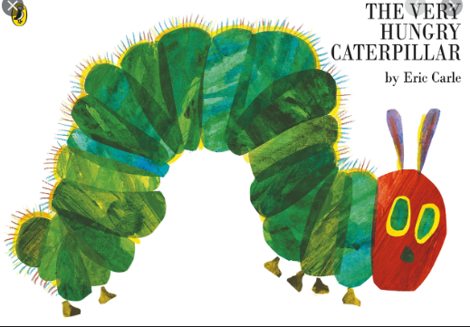

Phonics
The best thing to do is to continue to reinforce the following sounds: satpinmdgockeurhbfljvwx and the tricky words: I, to, go, into, the, no, he, she
Songs: Jolly Phonics action song
https://www.youtube.com/watch?v=1Qpn2839Kro
Tricky words song: https://www.youtube.com/watch?v=TvMyssfAUx0

Another suggestion is: https://www.youtube.com/watch?v=D-cOuO5jGKo

Maths
Look for 2D shapes around the home. If you have cutters, you could make play dough shapes. Plastic cups could be used to cut circles.
Have a look at the CBBC shape song: https://www.youtube.com/watch?v=RRiWpCfp75g
And Jack Hartmann: https://www.youtube.com/watch?v=beTDz9HSNOM

Have fun and stay safe! Any questions feel free to email and ask!

jfrench@parklane.cheshire.sch.uk

