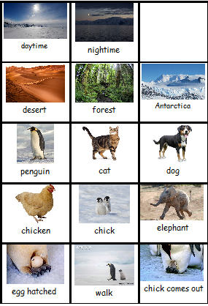
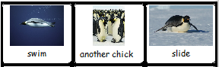

When?

Where?

Who?

Who?

What happened?

What happened?

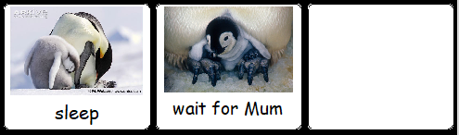

The end

