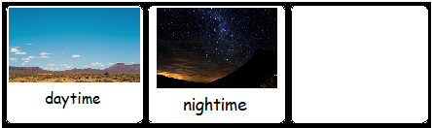

When?

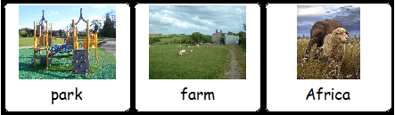

Where?

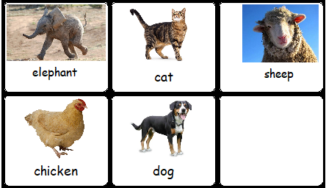

Who?

Who?

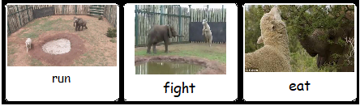

What
happened?

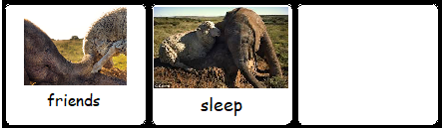

The end

