Upper 6th Class - Monday and Tuesday
Weeks beginning: 4th & 11th May 2020
Subject | Activity | Links /Resources
Monday am (week 1)  Monday am  (week 2 ) | Shop, Cook and Eat  Choose a simple meal to make for lunch/dinner (soup and sandwiches). Find all the food items needed and the utensils and make the snack with appropriate support. Tidy up, clean and wash up at the end of your lunch. Work on independence skills from the previous week.  Choose another simple meal to make for lunch/dinner (spaghetti bolognese). Find all the food items needed and the utensils and make the snack with appropriate support. Tidy up, clean and wash up at the end of your lunch. Work on independence skills from the previous week. | When setting the table:  - Wash your hands  - Clean the table  - Decide which cutlery you will need and find the cutlery from the drawer  - Count out the people in your family - count out individually how many knifes/spoons/forks you will need  - Count out the mats and place them on the table with the cutlery  - Count how many drinks you will need for each family member and make the drinks. Maybe you could take an order for drinks? Like in a café.  - What else do you need for the table? Sauces/ spoons to serve food out etc  Making your meal  - Wash your hands  - Look at your recipe or chosen lunch  - Decide what items you will need to make it  - Find all the ingredients in your kitchen  - Find all the utensils you will need – knifes/chopping board/graters etc  - Make your chosen lunch with support from a family member  Once everyone has finished, don’t forget to wash up and clean the table!!
Monday pm  (week 1 )  Monday pm  (week 2) | Enterprise  Continue working in your garden, planting, digging, weeding or watering your seeds. Make sure your bird feeders that you made from last week are full up with seeds for our feathered friends.  Alternatively, plan a party for VE day on 8th of May. Make decorations in red, white and blue and plan a picnic to have in your garden.  From your household recycling, find a glass jam jar. Design your jam jar first, then using paint, decorate the outside of the glass from your design. These will look beautiful in the garden with a tea light in… or inside if you prefer. | 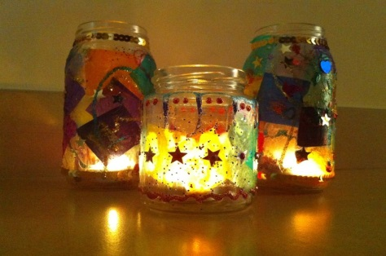
Tuesday am  (week 1)  Tuesday am  (week 2) | Vocational – Recycling  Sort your families recycling into different sections (e.g plastic, tins, food, cardboard). Then place them in the correct bins.  Continue to sort your families recycling into different sections (e.g plastic, tins, food, cardboard). Then place them in the correct bins.
Tuesday pm  (week 1)  Tuesday pm  (week 2) | Gym /Sensory  Gym – You should now have your own workout from 10 exercises that you have chosen and put together. Keep practising them and see if you can improve your fitness levels. Continue to do the routine with your family. Remember, you are the teacher! Remember to warm down and stretch after your work out.  Sensory –It is Wesak – The Buddist festival on the 7th of May.Start your activity by finding some relaxing music you can listen too. You tube has lots of different ones. Then explore Mandala art – a combination of art, math and natural materials and focusses on circles. Collect some natural materials and see if you can create your own piece of Mandala art.  Gym – Find another fitness work out on You tube of your choice or continue with your own. Complete the routine with your family or on your own if you prefer…. But don’t forget to warm down and stretch after your work out.  Sensory –Follow the link to make some sensory art. Using shaving foam and paint, you can print onto paper or card or just explore the texture. You can add glitter or any other sensory things you may like to explore. | 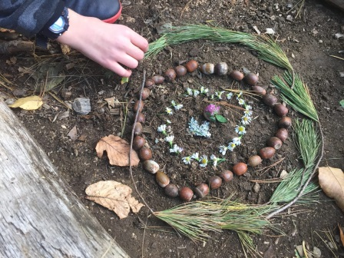  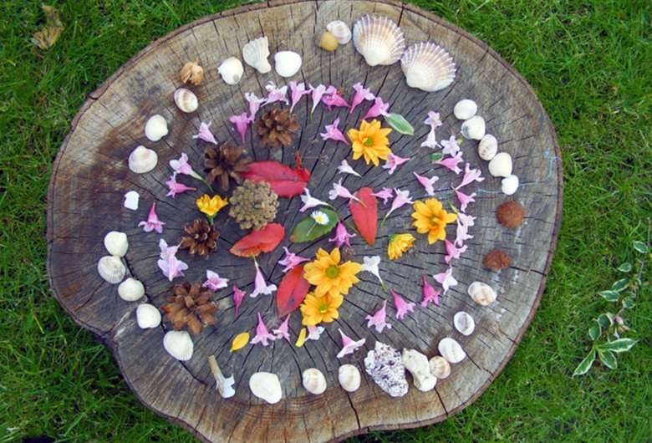  https://www.youtube.com/watch?v=oi9BH_7EOxY
- Please refer to annual reviews for your child’s personalised targets.

We would love to see and hear about what you have been doing, feel free to email Beth and Emma – upper6th@parklane.cheshire.sch.uk

