English Food

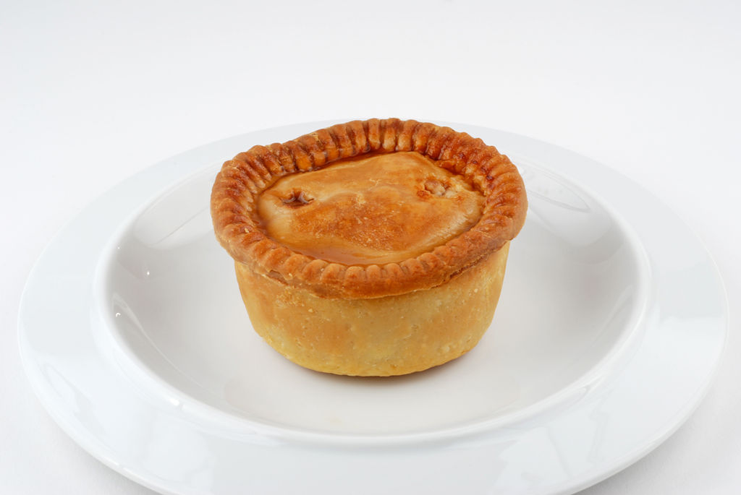

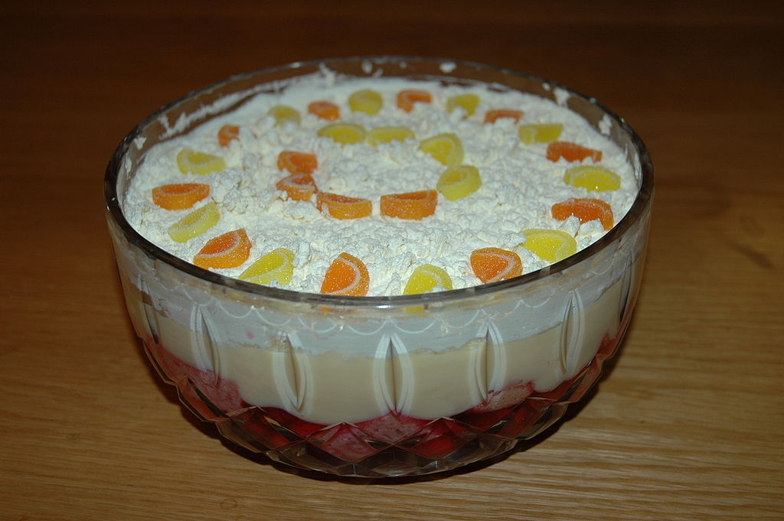

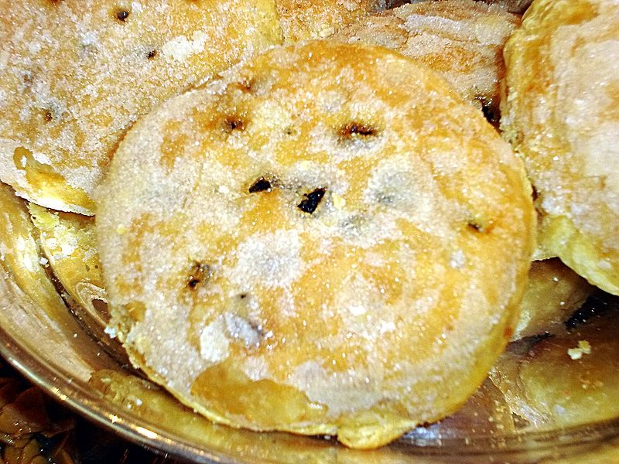

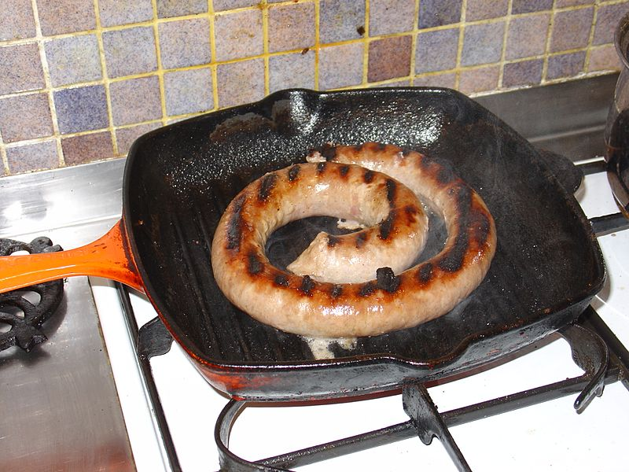

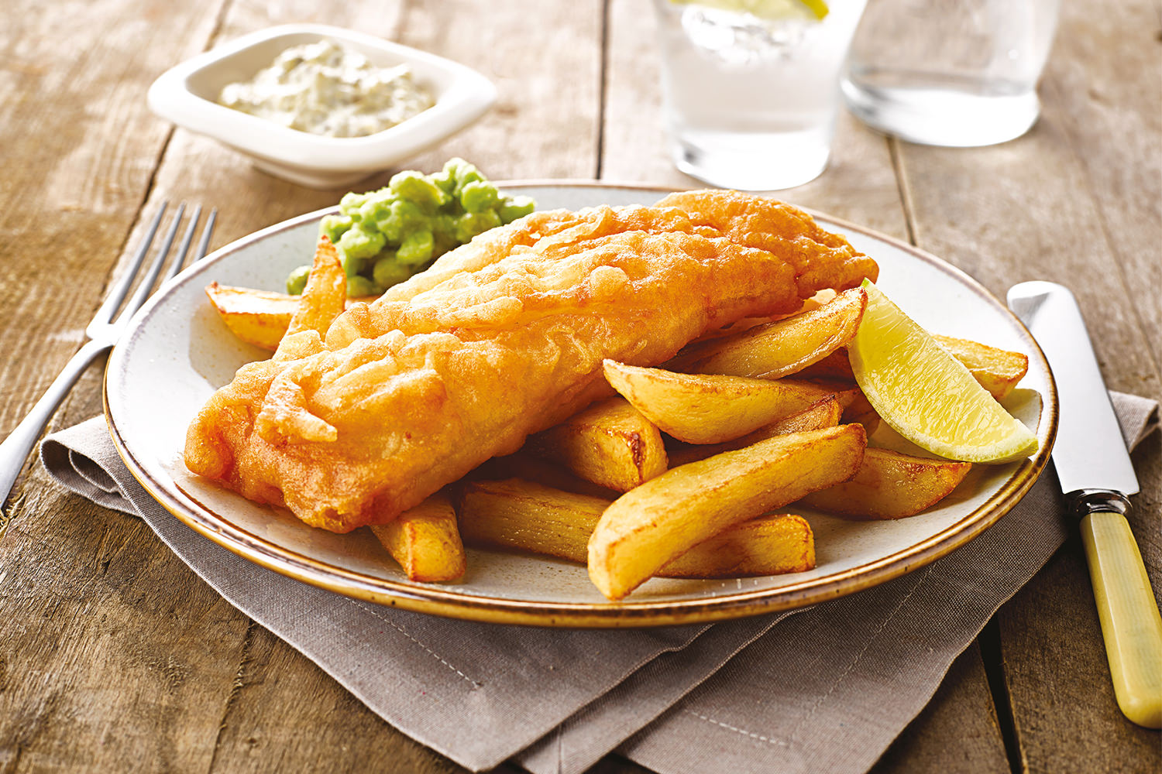[](http://www.google.co.uk/url?sa=i&rct=j&q=&esrc=s&source=images&cd=&cad=rja&docid=e2Vjy5tdzRpP6M&tbnid=psZncBpHiXZThM:&ved=0CAUQjRw&url=http://www.fizafamilydiner.com/?_escaped_fragment_=samosa/zoom/mainPage/image1xil&ei=eujOUvDbMoGs0QWl6YHQBg&bvm=bv.59026428,d.ZG4&psig=AFQjCNFkGT3_JB-XWsgwx8d9UeNASa41VA&ust=1389378021347080)

[](http://www.google.co.uk/url?sa=i&rct=j&q=&esrc=s&source=images&cd=&cad=rja&docid=e2Vjy5tdzRpP6M&tbnid=psZncBpHiXZThM:&ved=0CAUQjRw&url=http://www.fizafamilydiner.com/?_escaped_fragment_=samosa/zoom/mainPage/image1xil&ei=eujOUvDbMoGs0QWl6YHQBg&bvm=bv.59026428,d.ZG4&psig=AFQjCNFkGT3_JB-XWsgwx8d9UeNASa41VA&ust=1389378021347080)

[](http://www.google.co.uk/url?sa=i&rct=j&q=&esrc=s&source=images&cd=&cad=rja&docid=e2Vjy5tdzRpP6M&tbnid=psZncBpHiXZThM:&ved=0CAUQjRw&url=http://www.fizafamilydiner.com/?_escaped_fragment_=samosa/zoom/mainPage/image1xil&ei=eujOUvDbMoGs0QWl6YHQBg&bvm=bv.59026428,d.ZG4&psig=AFQjCNFkGT3_JB-XWsgwx8d9UeNASa41VA&ust=1389378021347080)

