[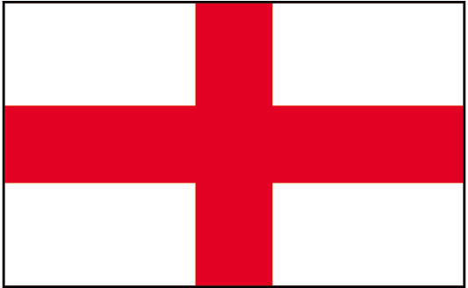](http://www.google.co.uk/url?sa=i&rct=j&q=english%20flag&source=images&cd=&cad=rja&docid=e6-xUcCQFB8fcM&tbnid=NBGhj5IifrR4CM:&ved=0CAUQjRw&url=http%3A%2F%2Fwww.theflagshop.co.uk%2Fst-george-england-flag-659-p.asp&ei=Cg8rUpO6JoKl0wWxhoGgAQ&psig=AFQjCNHEC6GuQHAVH3WT1-GFG9BTTp0c0w&ust=1378640006936214)

[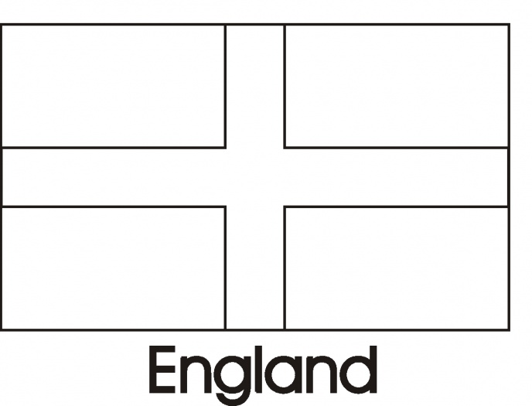](http://www.google.co.uk/url?sa=i&rct=j&q=flag%20of%20england%20coloring%20page&source=images&cd=&docid=urVKDesmony44M&tbnid=8E0su1VvF4yfFM:&ved=0CAUQjRw&url=http%3A%2F%2Fwww.supercoloring.com%2Fpages%2Fflag-day-29%2F&ei=VQ4rUu7TFImI0AXT-4HQBA&bvm=bv.51773540,d.ZGU&psig=AFQjCNE6WxETqunCXBpAyq7H3vb1ZLBa8Q&ust=1378639824695723)

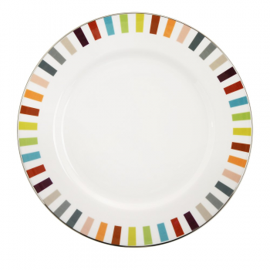

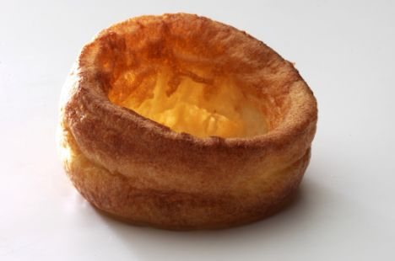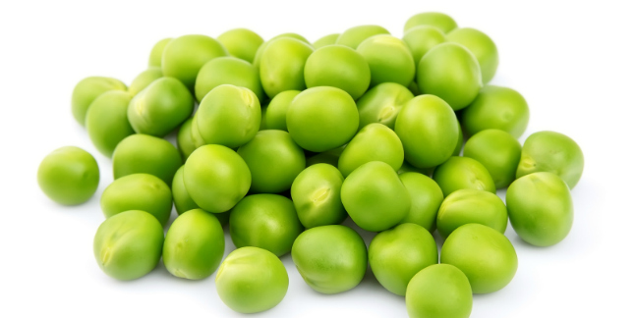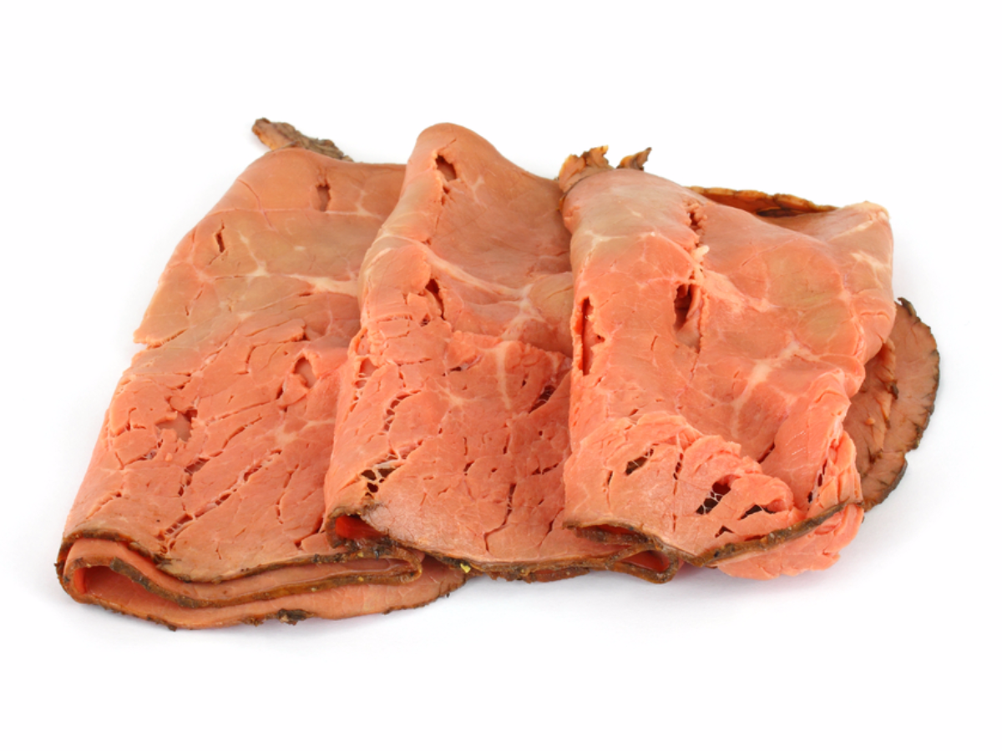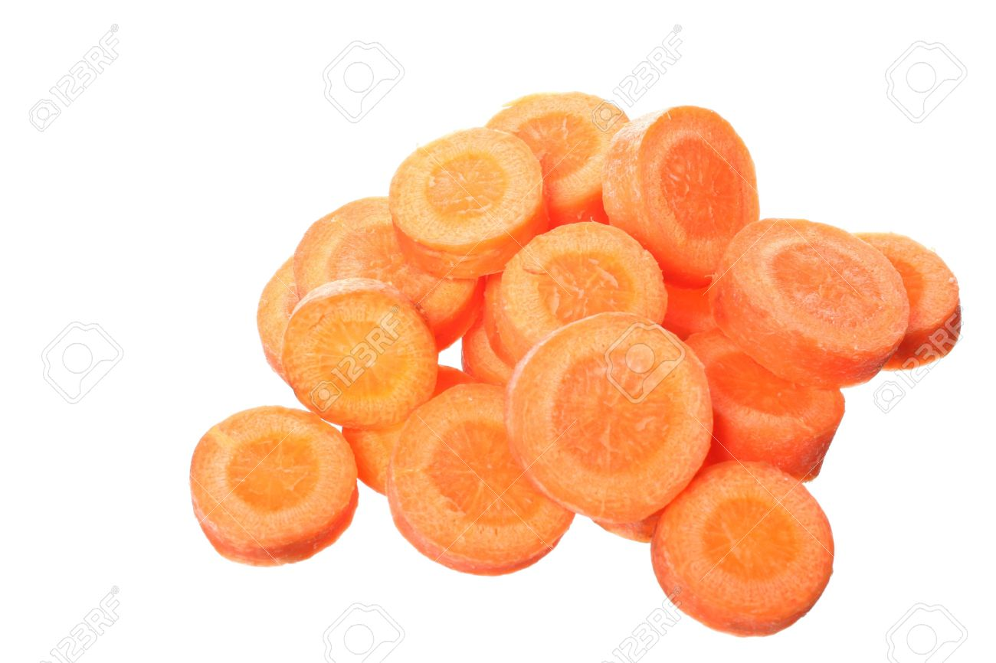

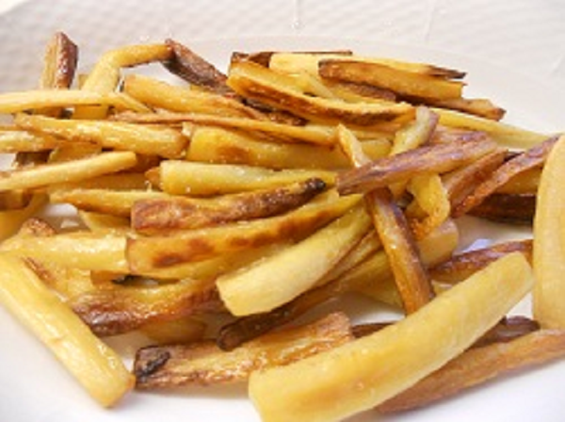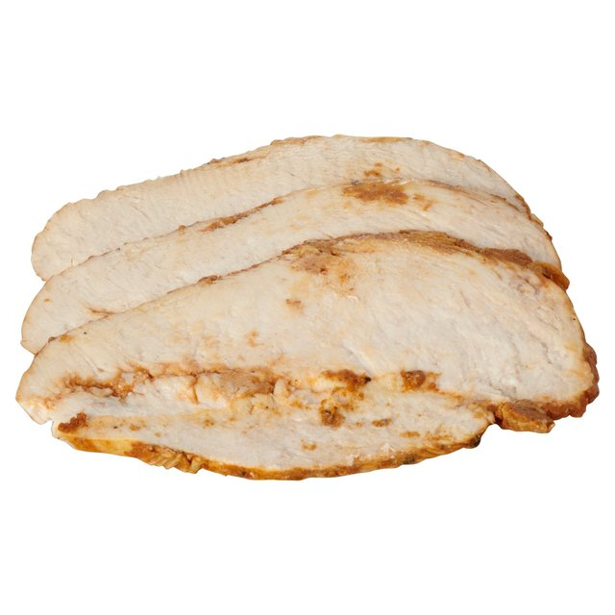

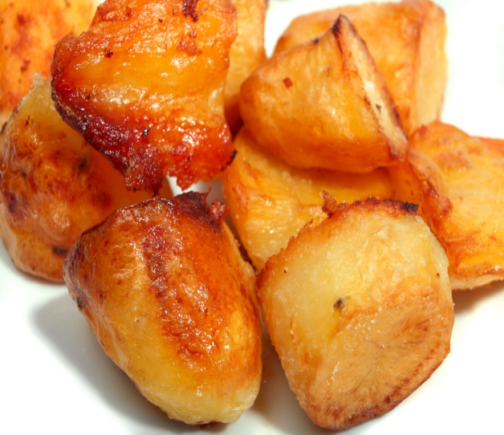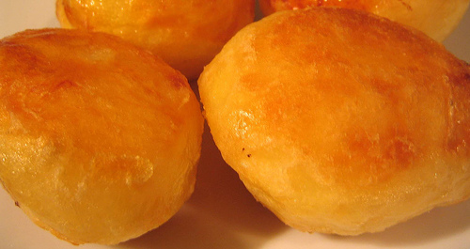

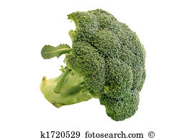

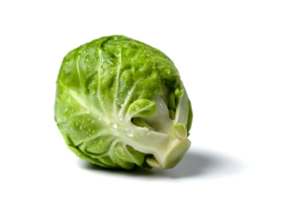

[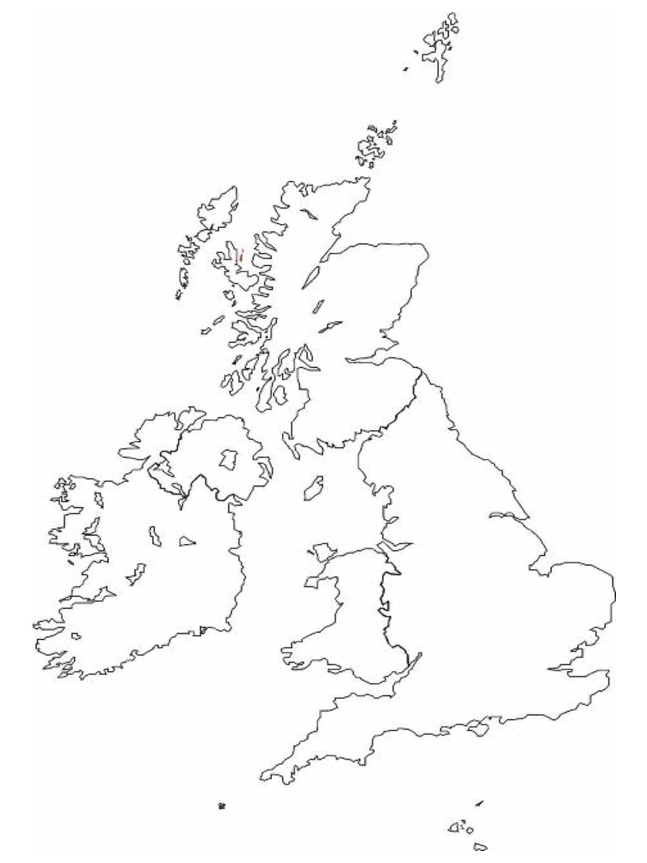](http://www.google.co.uk/url?sa=i&rct=j&q=british+isles+template&source=images&cd=&cad=rja&docid=8-mce3yo5wD1OM&tbnid=2p3EOHGIemMUTM:&ved=0CAUQjRw&url=http%3A%2F%2Fwww.docstoc.com%2Fdocs%2F129643691%2FBritish-Isles-Outline-Label-Task&ei=Ug0rUqq7OMXW0gWir4GABg&bvm=bv.51773540,d.ZGU&psig=AFQjCNEXCWJEEhA_B8ZBTxQLEzj4WCXPLQ&ust=1378639567487309)

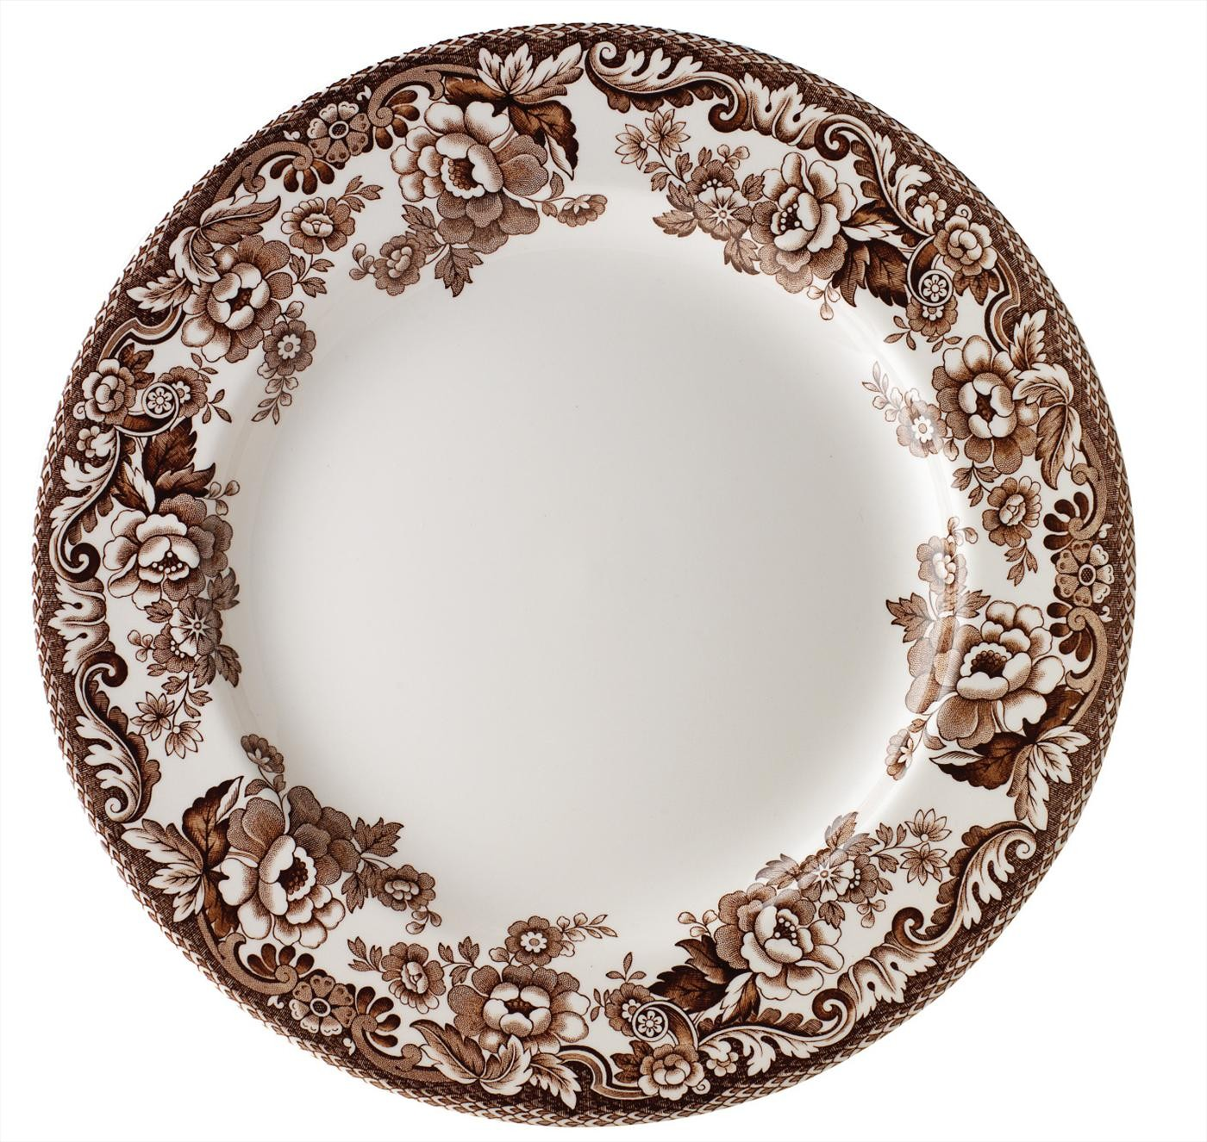

[](http://www.google.co.uk/url?sa=i&rct=j&q=british+isles+template&source=images&cd=&cad=rja&docid=8-mce3yo5wD1OM&tbnid=2p3EOHGIemMUTM:&ved=0CAUQjRw&url=http%3A%2F%2Fwww.docstoc.com%2Fdocs%2F129643691%2FBritish-Isles-Outline-Label-Task&ei=Ug0rUqq7OMXW0gWir4GABg&bvm=bv.51773540,d.ZGU&psig=AFQjCNEXCWJEEhA_B8ZBTxQLEzj4WCXPLQ&ust=1378639567487309)

England

|  |  |  |  |
| --- | --- | --- | --- |
| _________________________________ | _______________________________ | ______________________________ | ______________________________ |
| ________________________________ | _______________________________ | ______________________________ | *_______________________________* |

The Queen Boris Johnson

Fish and chips

Football

Cream tea

Morris dancing

Flag

London

Handkerchief