Upper 6th Form
WK: 20th & 27th April 2020
Area | Activity | Links
PE/ Healthy Living  (Weekly) | Go for a walk/cycle.  Take part in on online fitness session. Joe wicks  Fitness work out using household objects  Common Household Items You Can Use for Workout Weights  - Gallon of water or milk. Water and milk jugs are great because they have handles — making them easy to grip, curl and swing. ...  - Large bottle of laundry detergent. ...  - Backpack filled with books or cans. ...  - Bag of pet food. ...  - Standard bag of potatoes. ...  - Heavy Book. ...  - Towel.  How to Make a Homemade Weight Set  Complete the yoga session. See link | Yoga link  https://www.youtube.com/watch?v=ho9uttOZdOQ  https://www.thrillist.com/home/10-ways-you-can-use-household-objects-to-work-out-diy-home-gym  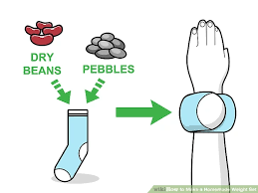  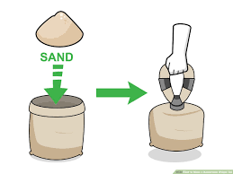  https://www.wikihow.com/Make-a-Homemade-Weight-Set  https://www.kidsyogastories.com/kids-yoga-poses/
Cookery/Daily living skills | Take part in a cookery session. Sausage rolls/quiche for your picnic.  Make your own sandwiches for a picnic lunch. Choose your own fillings. Use the symbols provided to help you.  Help around the house. Helping to wash and dry up, dusting, hoovering, making your own bed etc. | https://www.bbcgoodfood.com/recipes/mini-sausage-rolls  https://www.jusrol.co.uk/pastry-recipes/quiche-lorraine  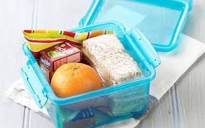  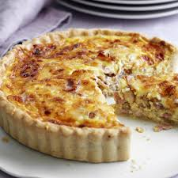
Vocational Studies | Vocational – Recycling  Sort your families recycling into different sections (e.g. plastic, tins, food, and cardboard). Then place them in the correct bins.
Countries and Cultures | This term the class will also be learning about England. Here are some things you could do. (see separate English file for work sheets)  - You tube examples of Morris dancing.  - Learn how to do the Lambeth walk. Listen to and sing the national anthem etc.  - Look at other traditional English things. The queen.  - Taste some examples of Traditional English food. Fish and chips, roast dinner, pies etc.  - Find where England on the map of Great Britain  - Enjoy a cream tea.  - Colour a template of the English flag (see England File)  - Make a trifle  - Draw or make a collage your perfect roast dinner. Use food magazine pictures. | 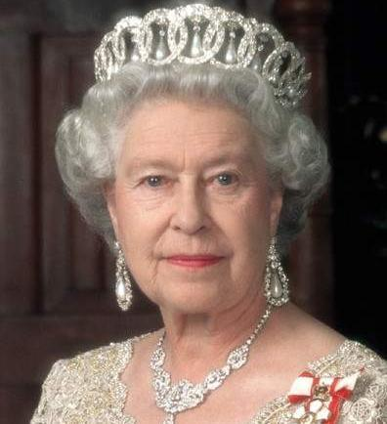  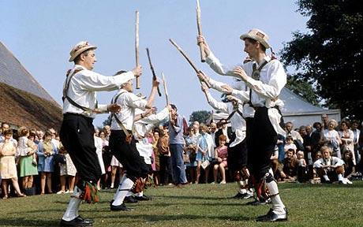  https://www.youtube.com/watch?v=sArAC2_ow2k  https://www.youtube.com/watch?v=6fgKn3SbCYQ  Lambeth walk  https://www.youtube.com/watch?v=H42VL7EIaIg  https://www.youtube.com/watch?v=bdSvLV-EgSA  National anthem  https://www.youtube.com/watch?v=Gedkn3jh7Gs  Making trifle  https://www.bbcgoodfood.com/recipes/classic-trifle  Making a Victoria sponge  https://www.bbcgoodfood.com/recipes/classic-victoria-sandwich-recipe
Community  Community visit | Look at photographs, name friends & family members;  Go for a walk around your local area/ park. Return to your garden and enjoy the picnic lunch you made for yourself.  These are some of the places we hope to visit at some point this term.  Find photos and some information about these places.  - Buxton Town and pavilion gardens  - Bramhall Hall and park  - Fernillee Reservoir  - The Goyt Valley  - Rudyard lake  - Carsington Waters | Carsington Waters Buxton  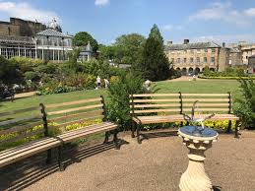  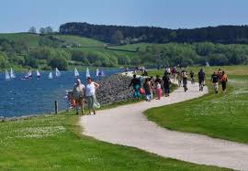
Art and  Extra | Watch and measure the sunflowers growth. Continue to Plot the growth of each sunflower on a homemade Sunflower design-measuring chart and a recording table.  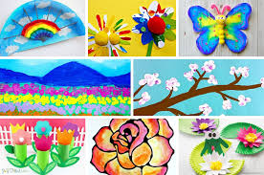  Spring Art ideas | 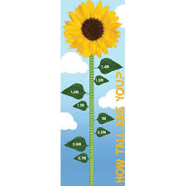  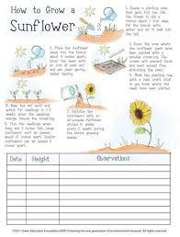  https://www.google.com/search?q=sunflower+measuring+chart  https://www.projectswithkids.com/spring-art-projects/  https://www.pinterest.co.uk/kidssteamlab/spring-art-projects-for-kids/
- Please refer to annual reviews for your child’s personalised targets.

I would love to see and hear about what you have been doing, feel free to email myself anytime – eshaw@parklane,cheshire.sch.uk

