Upper 6th Class - Monday and Tuesday
Weeks beginning: 20th & 27th April 2020
Subject | Activity | Links /Resources
Monday am (week 1)  Monday am  (week 2 ) | Shop, Cook and Eat  Choose a simple meal to make for lunch/dinner (pizza and salad). Find all the food items needed and the utensils and make the snack with appropriate support. Tidy up, clean and wash up at the end of your lunch. Work on independence skills from the previous week.  Choose another simple meal to make for lunch/dinner (pasta bake). Find all the food items needed and the utensils and make the snack with appropriate support. Tidy up, clean and wash up at the end of your lunch. Work on independence skills from the previous week. | When setting the table:  - Wash your hands  - Clean the table  - Decide which cutlery you will need and find the cutlery from the drawer  - Count out the people in your family - count out individually how many knifes/spoons/forks you will need  - Count out the mats and place them on the table with the cutlery  - Count how many drinks you will need for each family member and make the drinks. Maybe you could take an order for drinks? Like in a café.  - What else do you need for the table? Sauces/ spoons to serve food out etc  Making your meal  - Wash your hands  - Look at your recipe or chosen lunch  - Decide what items you will need to make it  - Find all the ingredients in your kitchen  - Find all the utensils you will need – knifes/chopping board/graters etc  - Make your chosen lunch with support from a family member  Once everyone has finished, don’t forget to wash up and clean the table!!
Monday pm  (week 1 )  Monday pm  (week 2) | Enterprise  Continue working in your garden, planting, digging, weeding or sowing seeds. Check on your seeds/plants from the previous week. Make sure they are watered regularly.  From your household recycling, find a milk bottle or any plastic bottle. Follow the instructions on the link to make a bird feeder. You can hang it outside your window or in your garden. | https://www.youtube.com/watch?v=7yV6V6rtpyc
Tuesday am  (week 1)  Tuesday am  (week 2) | Vocational – Recycling  Sort your families recycling into different sections (e.g plastic, tins, food, cardboard). Then place them in the correct bins.  Continue to sort your families recycling into different sections (e.g plastic, tins, food, cardboard). Then place them in the correct bins.
Tuesday pm  (week 1)  Tuesday pm  (week 2) | Gym /Sensory  Gym – participate in another Joe Wicks workout on You tube.  Then, choose 5 exercises that you want to do and put them together to make up your own routine. Teach your family your own routine. Remember to warm down and stretch after your work out.  Sensory –It is St Georges Day on 23rd April. Have a St Georges day party! You can make flags and maybe some rice krispe cakes like the ones shown and decorate the cakes like flags.  Gym – choose another Joe Wicks workout on You tube .  Then, practice your 5 exercises from last week and see if you can add another 5 to your routine. Teach your family the extra exercises and see if they can put it all together. Remember to warm down and stretch after your work out.  Sensory –Follow the link to make a sensory bottle. Choose any items you like, pompoms, glitter or sequence. | https://www.youtube.com/watch?v=RqBn08RywaE  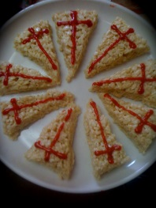  https://www.youtube.com/watch?v=mQRnmHEGaoI  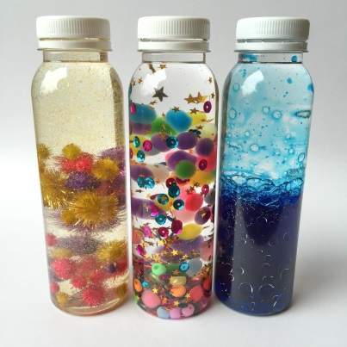
- Please refer to annual reviews for your child’s personalised targets.

We would love to see and hear about what you have been doing, feel free to email Beth and Emma – upper6th@parklane.cheshire.sch.uk

