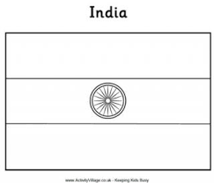

[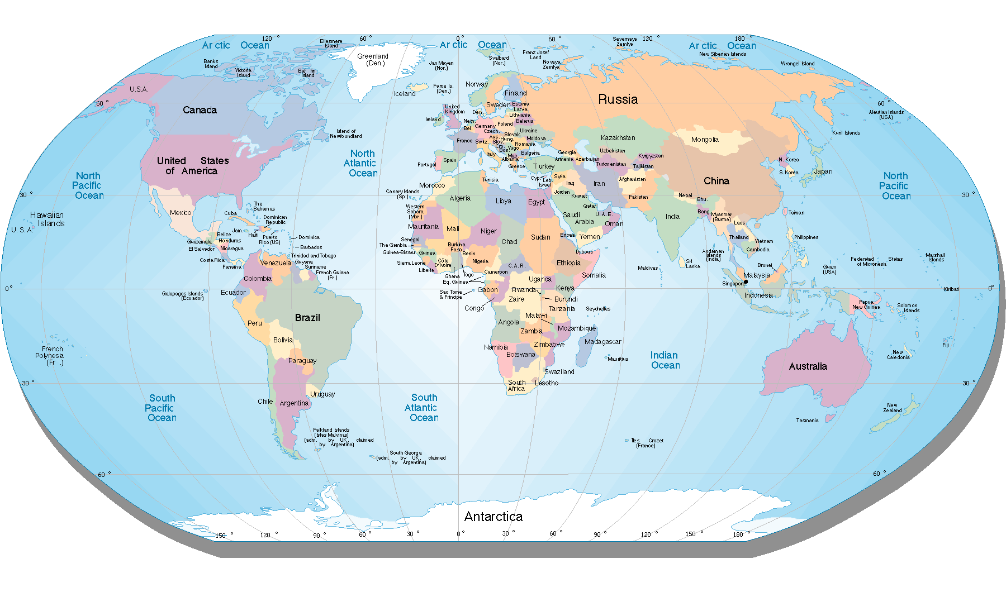](http://www.google.co.uk/url?sa=i&rct=j&q=&esrc=s&source=images&cd=&docid=4-ppusGL-42xVM&tbnid=YwhnU9Ar51UyJM:&ved=0CAUQjRw&url=http%3A%2F%2Fwww.hdwallpapers3d.com%2Fworld-map%2F&ei=RQHLUvGjOaad0QWMsoGoDg&psig=AFQjCNETMdv0HdQ1oeqivhP_F8XnPYAsnw&ust=1389122173774624)









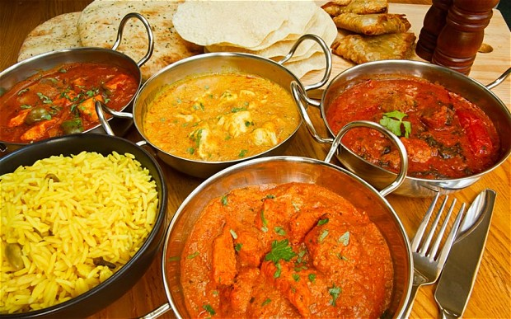







--------------------------------------...   
Mango Lassi   
  
1 cup plain yogurt   
1/2 cup mango pulp (fresh or canned)   
1 cup crushed ice   
3 table spoons sugar / Use sugar substitute if desired   
  
Blend all of the above. Add a little water if the consistency is too thick. Keep refrigerated. Serve chilled

[](http://www.google.co.uk/imgres?hl=en&biw=1366&bih=595&tbm=isch&tbnid=jnFanDB_JffAZM:&imgrefurl=http://en.wikipedia.org/wiki/File:Flag_of_India.svg&docid=aw282tKevDm4cM&imgurl=http://upload.wikimedia.org/wikipedia/en/thumb/4/41/Flag_of_India.svg/640px-Flag_of_India.svg.png&w=640&h=427&ei=bqDFUtO6FOy07QbOvoCICw&zoom=1&ved=1t:3588,r:9,s:0,i:131&iact=rc&page=1&tbnh=183&tbnw=275&start=0&ndsp=10&tx=176&ty=70)

Indian food

[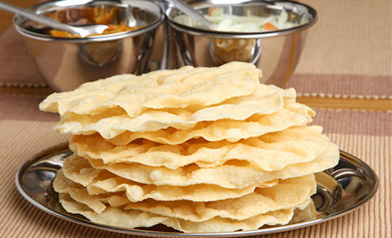](http://www.google.co.uk/url?sa=i&rct=j&q=&esrc=s&source=images&cd=&cad=rja&docid=fWCobLmo20y26M&tbnid=Wb0NGxYeF21U1M:&ved=0CAUQjRw&url=http%3A%2F%2Fwww.graboneni.co.uk%2Fbelfast%2Fthe-himalaya-lisburn&ei=RejOUo27D82d0wXknoAo&bvm=bv.59026428,d.ZG4&psig=AFQjCNG7pEYXdhbKmd8mM77NDKUxNH1JTA&ust=1389377917981139)

[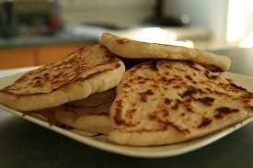](http://www.google.co.uk/url?sa=i&rct=j&q=&esrc=s&source=images&cd=&cad=rja&docid=Vkmnp0CxUuXiuM&tbnid=v9JXqGRNgPgNzM:&ved=0CAUQjRw&url=http%3A%2F%2Fspiltmartini.com%2F2008%2F11%2F02%2Fnaan-bread%2F&ei=PurOUp3tA6WX0AXQpYDADg&psig=AFQjCNFgObnK1LxRGChNOM9R74-2I3DG1g&ust=1389378466673211)

[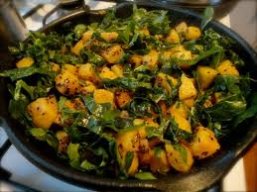](http://www.google.co.uk/url?sa=i&rct=j&q=&esrc=s&source=images&cd=&cad=rja&docid=GsNr3EekERAmqM&tbnid=do1YaYayhW4sOM:&ved=0CAUQjRw&url=http%3A%2F%2Fthebloomingtales.blogspot.com%2F2010%2F06%2Ffruits-of-my-labour-silverbeet-into-sag.html&ei=_unOUp2JOsT70gWXs4GAAQ&psig=AFQjCNGljXrhLE5RYr86nGyFjQcT9zsUfw&ust=1389378412062434)

[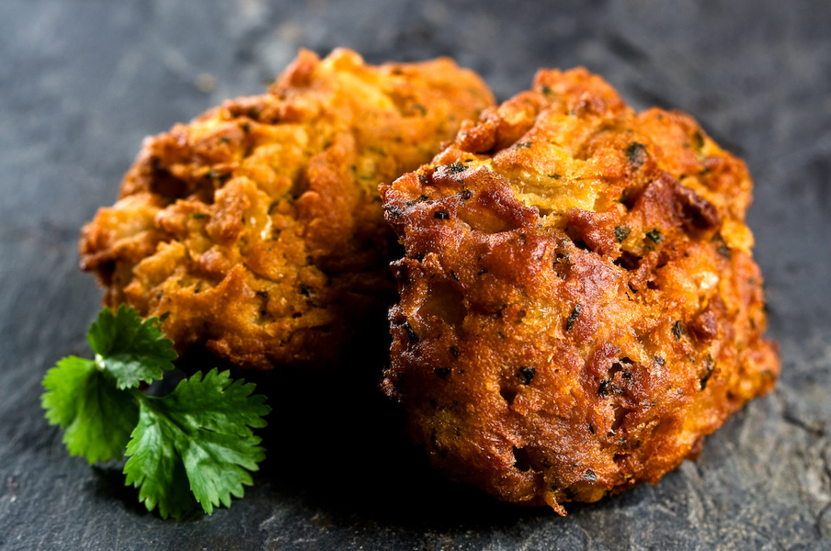](http://www.google.co.uk/url?sa=i&rct=j&q=&esrc=s&source=images&cd=&docid=W75c_TLy4TnViM&tbnid=x100FJVNuQfeAM:&ved=0CAUQjRw&url=http%3A%2F%2Fwww.lloydjennings.com%2Frecipe%2Fgarlic-and-caramelised-onion-bhajis%2F&ei=3ujOUoe_HYHL0QXWyIGQAg&bvm=bv.59026428,d.ZG4&psig=AFQjCNEMDpZ3a_dL36IxzPYzjXYTdoH4qA&ust=1389378139018560)

[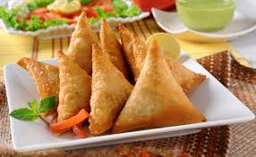](http://www.google.co.uk/url?sa=i&rct=j&q=&esrc=s&source=images&cd=&cad=rja&docid=e2Vjy5tdzRpP6M&tbnid=psZncBpHiXZThM:&ved=0CAUQjRw&url=http%3A%2F%2Fwww.fizafamilydiner.com%2F%3F_escaped_fragment_%3Dsamosa%2Fzoom%2FmainPage%2Fimage1xil&ei=eujOUvDbMoGs0QWl6YHQBg&bvm=bv.59026428,d.ZG4&psig=AFQjCNFkGT3_JB-XWsgwx8d9UeNASa41VA&ust=1389378021347080)

[](http://www.google.co.uk/url?sa=i&rct=j&q=&esrc=s&source=images&cd=&cad=rja&docid=e2Vjy5tdzRpP6M&tbnid=psZncBpHiXZThM:&ved=0CAUQjRw&url=http%3A%2F%2Fwww.fizafamilydiner.com%2F%3F_escaped_fragment_%3Dsamosa%2Fzoom%2FmainPage%2Fimage1xil&ei=eujOUvDbMoGs0QWl6YHQBg&bvm=bv.59026428,d.ZG4&psig=AFQjCNFkGT3_JB-XWsgwx8d9UeNASa41VA&ust=1389378021347080)

[](http://www.google.co.uk/url?sa=i&rct=j&q=&esrc=s&source=images&cd=&cad=rja&docid=e2Vjy5tdzRpP6M&tbnid=psZncBpHiXZThM:&ved=0CAUQjRw&url=http%3A%2F%2Fwww.fizafamilydiner.com%2F%3F_escaped_fragment_%3Dsamosa%2Fzoom%2FmainPage%2Fimage1xil&ei=eujOUvDbMoGs0QWl6YHQBg&bvm=bv.59026428,d.ZG4&psig=AFQjCNFkGT3_JB-XWsgwx8d9UeNASa41VA&ust=1389378021347080)

[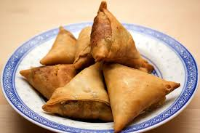](http://www.google.co.uk/url?sa=i&rct=j&q=&esrc=s&source=images&cd=&docid=gTR9zZMHbjkAxM&tbnid=GAPCVqYLs6bO-M:&ved=0CAUQjRw&url=http%3A%2F%2Fkeralakichen.com%2Fsamosa%2F&ei=sujOUtLwN8Kw0AWJq4CADw&bvm=bv.59026428,d.ZG4&psig=AFQjCNFkGT3_JB-XWsgwx8d9UeNASa41VA&ust=1389378021347080)

[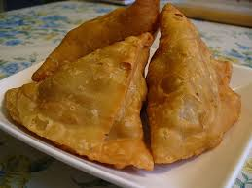](http://www.google.co.uk/url?sa=i&rct=j&q=&esrc=s&source=images&cd=&cad=rja&docid=XjmQ5u4B13v2pM&tbnid=JjrvLMEvZOdt3M:&ved=0CAUQjRw&url=http%3A%2F%2Fsamosa.webs.com%2F&ei=mOjOUq6mN8Or0gXpooCABA&bvm=bv.59026428,d.ZG4&psig=AFQjCNFkGT3_JB-XWsgwx8d9UeNASa41VA&ust=1389378021347080)

[](http://www.hennatattoodesign.com/2013/02/henna-tattooing.html)

[](http://www.google.co.uk/url?sa=i&rct=j&q=&esrc=s&source=images&cd=&cad=rja&docid=PPKM5vS7KDxtkM&tbnid=ZikuSdhOlW4EQM:&ved=0CAUQjRw&url=http://bestmhendidesigns.blogspot.com/2013/07/floral-henna-tattoo-new-designs-and.html&ei=LrLFUtf3G_Ka1AWq04Aw&psig=AFQjCNETLKFHWWwkLmgPrRKlFegxN1edPA&ust=1388774293477807)