Upper 6th Form
WK: 6th & 13th April 2020 (Easter Activities)
Area | Activity | Links
PE/ Healthy Living  (Weekly) | Go for a walk/cycle.  Take part in on online fitness session. Joe wicks  Complete the yoga session. See link  Wild garden bug hunt. Ideal for getting out into the outdoors but remaining in your garden. | Yoga link  https://www.youtube.com/watch?v=ho9uttOZdOQ  https://www.kidsyogastories.com/kids-yoga-poses/  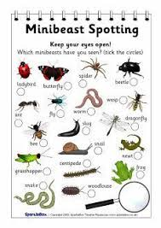  Minbeasts  https://www.twinkl.co.uk/resource/t-t-5270-minibeast-hunt-tally-sheet  https://www.sparklebox.co.uk/2201-2205/sb2204.html
Cookery/Daily living skills | Take part in a cookery session. E.g., Easter treats. See link  Make your own sandwiches for a picnic lunch. Choose your own fillings. Use the symbols provided to help you.  Next week as well as sandwiches look at other things you could make for your packed lunch. Eg flapjack, quiche, sausage rolls, cake  Help around the house. Helping to wash and dry up, dusting, hoovering, making your own bed etc. | https://www.bbcgoodfood.com/recipes/collection/easter-kids  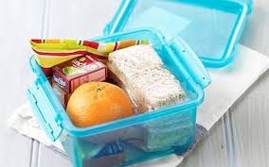
Vocational Studies | Vocational – Recycling  Sort your families recycling into different sections (e.g plastic, tins, food, cardboard). Then place them in the correct bins.
Countries and Cultures | This term the class would have been learning about India. Here are some things you could do. (see separate India file for work sheets)  - You tube examples of Indian food and dance (Bollywood).  - Taste some examples of Indian food. Curry, pakoras, onion bhajis, poppadum’s  - Find where India is on the world map.  - Complete some Mehndi artwork.  - Colour a template of the Indian flag (see India File)  - Make a mango lassie (See India File) | https://www.youtube.com/watch?v=TBAj4nbdLEU  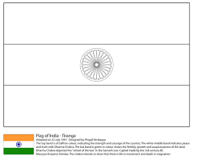
Community  Community visit | Look at photographs, name friends & family members; do you have any Easter pictures from last year?  Go on an egg hunt around the house or in your garden – explore rooms in your house or places in your garden and find eggs from clues. Can you follow one or two instructions to find the eggs?  Go for a walk around your local area/ park. Return to your garden and enjoy the picnic lunch you made for yourself.
Extra | All members of your family fill a pot with compost and plant a sunflower seed. Watch and measure the flowers growth. Plot the growth of each sunflower on a homemade Sunflower design-measuring chart.
- Please refer to annual reviews for your child’s personalised targets.

I would love to see and hear about what you have been doing, feel free to email myself anytime – eshaw@parklane,cheshire.sch.uk

