Lower 6th Form – Weekly Planner
Weeks beginning: 6th & 13th April 2020
Subject | Activity | Links
Monday am | Community Visit  Go outside, either for a walk, or in the garden. Investigate signs of spring – using the sense of sight – look for plants/trees sprouting new leaves/blossom, see what flowers are open and take photos or record any colours seen with pens. Try drawing what flowers/plants you can see, either whilst outside, or if on a walk, from the photos you have taken once you get back home. Or, you could use the phoos you have taken of flowers and try and match them to the same picture or colour.  See what animals you can find/see. Try being very still and quiet and see if you can spot any birds. Try and get photos of them and compare to a garden bird identification chart to see what they are. Go on a minibeast hunt in the garden – turn over stones and logs and take photos of what you find. Try and identify them using a minibeast identification chart. Try and draw what you can see, either whilst outside, or from photos you have taken. | You can record the birds you have seen as well as identifying them on this RSPB site  https://www.rspb.org.uk/birds-and-wildlife/wildlife-guides/identify-a-bird/  This site has lovely photos of British birds to help with identification  https://www.birdspot.co.uk/british-garden-birds  This pack has some ideas of how to do a minibeast hunt as well as having identification sheets – keep scrolling down to find them!  https://www.rbkc.gov.uk/PDF/Minbeasts%20pack.pdf  This sheet has some photos of common minibeasts  https://www.woodlandtrust.org.uk/media/48349/minibeast-hunt.pdf
Monday pm | Enterprise  Follow the symbol recipe to make our famous Rocky Road. Do this as independently as you can. Don’t forget to wash your hands before you start and to wear an apron. Also, remember to wash up and tidy up after yourself when you have finished.  See if your family would like to buy a piece. This could be extended to include using the supermarket website to price up ingredients and work out how much you have spent using a calculator.  You could also work out how much you could make if you charged 50p for each piece, using calculator.
Tuesday am | Key Skills  Maths  Play Easter Bunny Beetle with you family – use the rules, demonstration picture and recording sheet. Make sure everyone knows the rules and look at your dice carefully, counting the dots so you know which number you have rolled. Don’t forget, you have to roll a 6 to start – no cheating! Draw the correct parts of your bunny as you roll the right numbers. The first person to complete drawing their Easter bunny, must shout out ‘Easter Bunny!’ so everyone knows to stop playing. Count up your points – 6 for a body, 5 for a head, one for each whisker you have drawn etc. If you play more than one game, add your scores up at the end of the game using a calculator, to find out who has scored the most. Traditionally the highest and lowest scores receive a prize!  English  - Create Easter cards for you family. Draw and colour/print or collage pictures/designs on the front of your cards and write messages inside. Don’t forget to write who the card is to and who it is from. These messages could be printed out for you and you could stick them into the inside of your card.  - Draw/colour/print or collage the front of a postcard. Write a simple message on the back and send it to a friend/family member.
Tuesday  pm | Vocational Studies  Café Skills  Take on the role of waiter/waitress or cook and invite you family to come to your café. Ask one member of your family to help you by being either cook to your waiter/waitress, or waiter/waitress to your cook. Make a simple menu using pictures from the internet or your own drawings & labels. Take each person’s orders for drinks and snacks and go into the kitchen to make them. See if you can remember what to do and try to be as independent as you can. Remember to wash your hands and wear an apron before starting and remember and follow the safety rules when making hot drinks and toast.  Gardening  Watch the power point of gardeing jobs, to remind you os the different things you maight do as a gardener. Make sure you are appropriateky dressed and wearing safe shoes/boots. Go out into the garden and decide which job you are going to do – digging, planting, weeding, watering, cutitng the grass, composting etc. make sure you wear gardening gloves before you start and hold and use gardening equipment safely. Make sure your hair is tied up if it is long and remember not to run in the garden. Take photos of the jobs you have done or ask someone to take photos of you whilst you are working. Don’t forget to wash your hands with lots of soap when you have finished.
Wednesday am & pm | Recreation & Leisure  Physical activity – play ball games in the garden – kick/throw or push the ball to each other  Go on you trampoline & see how many jumps you can do  Put your favourite music on and dance around – rock it out!  Go for a walk with your family  Go out in the garden on your scooter or take your scooter out when your family go out for their exercise – remember the road safety rules!  Use chalk to make a hop scotch on the path in the garden – see if your mum, dad or siblings will teach you how to play it – hop, step, jump or move into the number you have thrown/dropped the stone into.  Watch and follow Jo Wick’s fitness routine | This link will take you to a sit where you can revisit all of Jo Wick’s PE sessions  https://www.t3.com/features/how-to-re-watch-joe-wicks-pe-lesson-on-youtube-april-7  This siet has a video of how to set up and play hopscotch  https://learnenglishkids.britishcouncil.org/how-videos/how-play-hopscotch
Thursday am | Daily Living Skills  Plan and make your own meal for lunch. For example, sandwiches and soup, beans on toast, jacket potato, beans and cheese. Cheese on toast, tuna & cheese melt sandwiches, sandwiches and crisps.  Plan your meal – List or select what ingredients you will need and collect or choose what equipment you will need e.g. chopping board, grater, knife, can opener  Can you remember what you need to do to make your meal? Try to be as indepe3ndent as you can. Remember to wash your hands with soap and put an apron on before starting to make your meal. Remember the safety rules when using any sharp/hot equipment. Don’t forget to tidy up, wash up, dry and put away everything you have used when you have finished. Take a photo of what you have made or ask someone to take photos of you making your meal.
Thursday pm | Personal Care  Watch a you tube clip about how to wash your hands properly with soap and water. Practise the movements for washing each part of your hands without soap and water first. You can do this yourself, or let a family member do it for you. Once you have practised these for a while, go into the bathroom and practise washing your hands correctly, using soap. Make sure you wash all parts of your hands and remember to sing happy birthday through twice as you wash your hands. You can either do this yourself, or accept having your hands washed by a family member. You could use the photos on the NHS site to either make a poster for your family on how to wash your hands correctly, or you can sequence the photos to make a hand-washing schedule for everyone in your house to use.  You can extend this activity to make a list of when you should wash your hands. Use pictures form the internet or your own drawings and writing to make a list of when you should wash your hands | This link will take you the NHS site where there is a video of how to wash hands properly as well as step by step photos.  https://www.nhs.uk/live-well/healthy-body/best-way-to-wash-your-hands/  This video clip talks about why 7 how you should wash your hands  https://www.youtube.com/watch?v=LQ24EfM7sEw
Friday am | Art  Make an Easter decoration. Print out or draw a large Easter egg shape. Either draw your own patterns on it, or ask someone to draw patterns for you. Use whatever you have to colour in the design – pens, pencil crayons, paints, collage/sensory materials. When your decoration is finished, cut it out and either put in your front window for other people to see when out on an Easter egg hunt, or hang it up somewhere in the house.  Use paints and a plastic or metal fork to make a picture of a sunflower. Use your finger dipped in brown paint to make the centre of the flower, Dip the fork into yellow paint and make fork prints all the way round the centre, to make the petals. You can add a green stalk and leaves using paint or pens.  If you don’t have paint, use coloured pens and try to look at the shape of the centre of a sunflower and copy it and then the shape of the petals and try drawing them. | 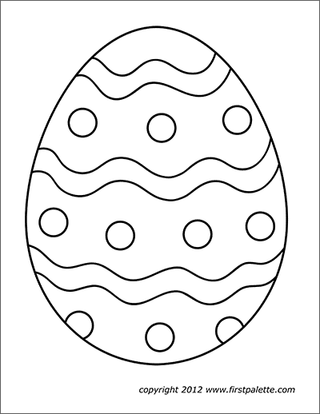  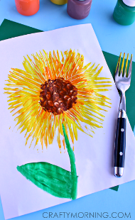
Friday pm | ICT  Look at photos of yourself on the screen (phone, iPad, computer or TV) doing any of the activities during the week. Share these with your family – look at them, talk about them and choose symbols or say how you feel about them.  Compose an email with support to send Andrée photos/information on some of the activities you have been doing this week. Even if it something completely different from the planner, it doesn’t matter, she would love to see what you have been up to.  Use one of the free educational apps on the school Face Book page on your iPad. Let Andrée know how you’ve got on with it – ask someone to help you send an email about it.
- Please refer to annual reviews for your child’s personalised targets.

We would love to see and hear about what you have been doing, feel free to email Andrée – abarnard@parklane.cheshire.sch.uk

