Hovis Class
WK: 6th & 13th April 2020 (Easter Activities)
Area | Activity | Links
English | Story, song or rhyme: Choose a story to share either a physical book, or an interactive book on Vooks or Twinkl or alternatively, if you are feeling energetic, you can choose a story from Cosmic Yoga- and complete the actions to each story you read.  Reading & Phonics: – Reading books / Education City login for phonics songs and letter recognition activities.  Also use Letters and Sounds website to access online games. Ask Laura if you need to know what Phase your child is specifically working at.  Fine motor skills: Practice mark making, overwriting letters from your name or writing Easter related words. Complete some of the Fine Motor Challenges on Twinkl site .  Communication: Learn the signs (posted on Facebook) and symbols for the days of the week. Use any opportunity to make and confirm choices using personalised communication systems. Practice signs on Signalong Facebook group. | https://www.youtube.com/user/CosmicKidsYoga  https://www.twinkl.co.uk/resource/the-zoo-vet-ebook-t-or-1115  https://www.vooks.com/  https://www.educationcity.com/  http://www.letters-and-sounds.com/  https://www.twinkl.co.uk/resource/t-l-51980-fine-motor-skills-activity-cards  https://en-gb.facebook.com/signalongcharity/  https://en-gb.facebook.com/pages/category/Elementary-School/Park-Lane-Special-School-1641122062807137/
Maths | Easter egg hunts –Go on an Easter related hunt, around your house/garden - find hidden rabbits, eggs, chicks etc ( you can print these off and cut them out) . then count all the items you have found, how many rabbits? How many eggs? etc- use number symbols or create your own number line. Alternatively a number line can be printed off Twinkl.  Design an Easter egg. Recognise and request the different coloured pencils/paints. Templates for eggs can be found on Twinkl if you don’t want to draw your own designs. | https://www.twinkl.co.uk/resource/t-tp-6296-easter-small-world-characters  https://www.twinkl.co.uk/resource/t-n-269-numbers-1-10-numbertrack  https://www.twinkl.co.uk/resource/T-T-002-Easter-Egg-Templates
Creativity | Singing Easter songs, join in with actions and play along to songs using instruments – instruments could be anything in your home e.g. pans and spoons, bottles filled with rice for shakers.  Make your own Easter chick – see link  Design and make Easter Cards for your family and friends. Choose a design you like off the internet and replicate. | https://www.youtube.com/watch?v=wEEeq4eX8os  https://www.twinkl.co.uk/resource/t-t-2546559-chick-2d-shape-activity-sheets
Individuality | Egg and spoon races, throwing and catching skills using balloons (easier and safer inside!)  Balancing balloon eggs on kitchen roll tubes  Independent living skills – developing independence in self dressing, helping out with jobs around the house e.g dusting, brushing etc  Work on independence in personal care routines ( See Annual reviews for up to date targets) | 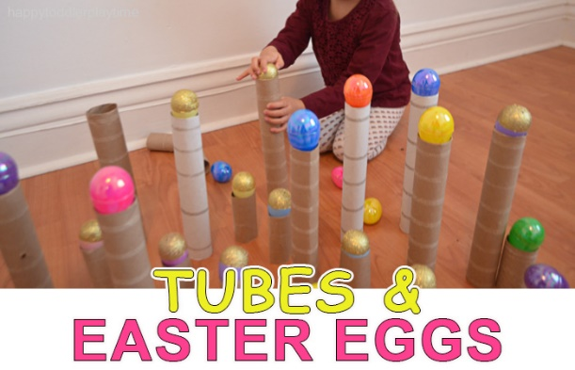
Community | Easter Story- Look at the interactive Story on Twinkl- how and why do Christians celebrate Easter.  Post your Easter Cards to family and friends on your daily walk/exercise. | https://www.twinkl.co.uk/resource/t-t-18162-why-do-we-celebrate-easter-powerpoint
Challenge | Cooking – Make Easter Nests – follow instruction to make some yummy Easter cakes  Complete some Easter themed Science Experiments – see link | https://www.twinkl.co.uk/resource/t-t-11438-easter-egg-nests-recipe-sheets  https://www.twinkl.co.uk/resource/t-t-26945-eyfs-easter-themed-science-experiments-resource-pack
- Please refer to annual reviews for your child’s personalised targets. You should be receiving the latest Annual Review in the post over the next two days.

Please feel free to email me anytime if you have any questions, if you would like more specific targets or resources, or if you want to send pictures or an email to update me on your progress. I would love to see what you are getting up to. My email address is lrashleigh@parklane.cheshire.sch.uk

