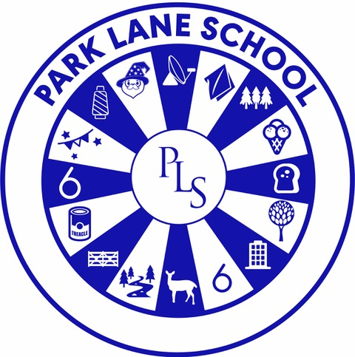

Early Years Foundation Stage Policy

|  |  |
| --- | --- |
| **Person responsible for policy:** | Chelsie Osbaldiston |
| **Date approved:** | September 2025 |
| **Review date:** | September 2026 |

# Aims

This policy aims to ensure:

* That children access a broad and balanced curriculum that gives them the broad range of knowledge and skills needed for good progress through school and life
* Quality and consistency in teaching and learning so that every child makes good progress, and no child gets left behind
* A close working partnership between staff and parents and/or carers
* Every child is included and supported through equality of opportunity and anti-discriminatory practice

# Legislation

This policy is based on requirements set out in the [EYFS Framework 2025.](https://assets.publishing.service.gov.uk/media/68c024cb8c6d992f23edd79c/Early_years_foundation_stage_statutory_framework_-_for_group_and_school-based_providers.pdf.pdf)

In Park Lane School the EYFS setting is made up of 3 classes: Silk, Forest and Cotton class. These classes can take pupils from nursery age and pupils can stay until Year 1, depending upon their age at entry, previous pre-school experience and levels of development. There are up to 10 places in these classes. These classes are staffed by a qualified and experienced class teacher and a team of teaching assistants.

All pupils require an EHCP to have been finalised before they are able to attend Park Lane EYFS setting.

Pupils at nursery age usually attend part time initially and the rate at which their time in school increases is agreed between parents/carers and school. Pupils at reception age are expected to attend on a full-time basis. However, a part time timetable can be agreed initially if it is in the best interest of the child.

Park Lane is a Maintained Special School and there are no charges for a placement. Parents and carers may be asked for voluntary contributions for extra activities such as educational visits/snacks.

# Curriculum

Our early years setting follows the curriculum as outlined in the latest version of the EYFS statutory framework that applies from September 2025. It is differentiated to meet the learning and developmental needs of the pupils.

The EYFS framework includes 7 areas of learning and development that are equally important and inter-connected. However, 3 areas known as the prime areas are seen as particularly important for igniting curiosity and enthusiasm for learning, and for building children’s capacity to learn, form relationships and thrive.

The prime areas are:

* Communication and language
* Physical development
* Personal, social and emotional development

The prime areas are strengthened and applied through the 4 specific areas:

* Literacy
* Mathematics
* Understanding the world
* Expressive arts and design

## Planning

Staff plan activities and experiences for children that enable children to develop and learn effectively. In order to do this, staff working with all children focus strongly on the 3 prime areas.

Staff also take into account the individual needs, interests, and stage of development of each child in their care and use this information to plan a challenging and enjoyable experience. Pupils are assessed during the first half term and this assessment is used to plan individual learning goals for all pupils. Pupils are then assessed termly on Evidence for Learning (EFL). Specialist support, such as Physiotherapy, Speech and Language Therapy and Occupational Therapy programs are assimilated into the child’s learning goals as appropriate.

In planning and guiding children’s activities, staff reflect on the different ways that children learn and include these in their practice, ensuring resources, communication methods and any specialised equipment is used to enable pupils to progress.

## Teaching

Each area of learning and development is implemented through planned, purposeful play through well planned and resourced activities. Staff respond to each child’s emerging needs and interests, guiding their development through warm, positive interaction. Staff use a total communication approach in their teaching, this includes sign language, symbols and Objects of Reference to support pupils' understanding and expression. Communication books are developed for individual pupils to help aid their communication with the support of speech and language.

As children grow older, and as their development allows, pupils are encouraged to be more independent in their learning and development including personal, social and emotional development, physical development and communication and language.

# Assessment

At Park Lane School, ongoing assessment is an integral part of the learning and development processes. Staff observe pupils to identify their level of achievement, interests and learning styles. These observations are used to shape future planning. Staff also use observations shared by parents and/or carers.

Within the first 6 weeks that a child **starts reception**, staff will administer the Reception Baseline Assessment (RBA), however due to the nature of the children and their additional needs professional judgements will be made as to whether the children are withdrawn from the RBA when they attend Park Lane School.

At the **end of the EYFS**, staff complete the EYFS profile for each child. Pupils are assessed against the 17 early learning goals, indicating whether they are:

* Meeting expected levels of development
* Not yet reaching expected levels (‘emerging’)

The profile is moderated internally (referring to the Development Matters [guidance](https://www.gov.uk/government/publications/development-matters--2)) and in partnership with other local schools, to ensure consistent assessment judgements. EYFS profile data is submitted to the local authority.

EYFS staff meet with the teachers in the Key Stage One class when the pupils are due to move up and they will transfer their end assessments into the Park Lane assessment system ‘Lanes’ so that there is a smooth transition from EYFS and the pupils can continue to show progress through their achievements.

Pupil progress is reported to parents formally through Parents Evenings and the report which accompanies the annual review of their EHCP. The EHCP is reviewed and amended to reflect pupil progress and to record learning targets for the coming year. Parents, class teacher and other professionals are invited to the annual review meeting to share their views and provide relevant information supporting the child’s learning and progress.

# Working with parents

We recognise that children learn and develop well when there is a strong partnership between staff and parents and/or carers.

Parents and/or carers are kept up to date with their child’s progress and development. The progress check and EYFS profile helps to provide parents and/or carers with a well-rounded picture of their child’s knowledge, understanding and abilities.

The class teacher acts as the key person and is the main point of contact. Teaching Assistants work as a team and are given the training to support all children within the EYFS setting. This ensures all staff are able to teach each child, regardless of if a member of staff is absent. The class teacher supports parents and/or carers in guiding their child’s development at home. The class teacher is also able to help families to engage with more specialist support, if appropriate.

As well as transition meetings, the families are invited to several ‘stay and play’ sessions before their child starts at

Park Lane.

# Safeguarding and welfare procedures

We promote good health, in the early years by:

* Promoting healthy eating through the school Food Policy.
* Promoting good hygiene practices, e.g., hand washing, teeth cleaning, toilet training.
* Providing opportunities for physical exercise through outside play, weekly park trip, ball pool session, swimming and PE lessons.

The rest of our safeguarding and welfare procedures are outlined in our safeguarding policy.

# Monitoring arrangements

This policy will be reviewed and approved by Emma Shaw in discussion with the Early Years lead teacher Chelsie Osbaldiston annually.

**Appendix 1. List of statutory policies and procedures for the EYFS**

|  |  |
| --- | --- |
| Statutory policy or procedure for the EYFS | Where can it be found? |
| Safeguarding policy and procedures | See child protection and safeguarding policy |
| Procedure for responding to illness | See health and safety policy |
| Administering medicines policy | See supporting pupils with medical conditions policy |
| Emergency evacuation procedure | See health and safety policy |
| Procedure for checking the identity of visitors | See child protection and safeguarding policy |
| Procedures for a parent failing to collect a child and for missing children | See child protection and safeguarding policy |
| Procedure for dealing with concerns and complaints | See complaints policy |